

Lesson 3 – Worksheet
 | Activity 1: Mitigation and Adaption Strategies  Complete the following activity in pairs.

Identify whether the following strategies are mitigation or adaptation efforts by placing a checkmark in the appropriate column.
Strategy | Mitigation | Adaptation
1.1 Plant a tree
1.2 Use public transportation
1.3 Install solar panels
1.4 Build a flood barrier
1.5 Reduce plastic waste
1.6 Create a rainwater harvesting system
1.7 Switch to energy-efficient light bulbs
1.8 Educate others about climate change
1.9 Grow drought-resistant crops
1.10 Build a green roof
1.11 Support local farmers
1.12 Adopt sustainable fishing practices
1.13 Reduce meat consumption
1.14 Create a community garden
1.15 Install a wind turbine
1.16 Install water-efficient appliances
1.17 Recycle
1.18 Use a clothesline instead of a dryer
1.19 Create flood-resistant infrastructure
1.20 Use biodegradable products
1.21 Create wildlife corridors
1.22 Support renewable energy initiatives
1.23 Reduce water usage
1.24 Plant a coastal buffer zone
1.25 Switch to a plant-based diet
Activity 2: Individual Activity
Complete the following activity individually.

Question 1
1.1 Choose the correct answer and write only the letter (A–D) next to the question numbers (1.1.1 to 1.1.3), for example, 1.1.4. D.
1.1.1 Global warming leads to:
A. Overfishing
B. Inhumane farming methods
C. Pollution
D. Climate change

1.1.2 Depletion of land for agriculture can cause:
- Food insecurity
- Food biodiversity
- Food production
- Food fertility

1.1.3 The degradation of society due to inhumane farming methods refers to…
A. the negative impact on community well-being due to unsustainable farming practices.
B. the negative impact of technological agricultural techniques on societal growth.
C. the negative impact on public health caused by eco-friendly farming methods.
D. the negative impact on community productivity due to sustainable farming techniques.
(3 x 1) (3)

1.2 Give ONE word/term for EACH of the following descriptions. Write only the word/term next to the question numbers (1.2.1 to 1.2.5).

1.2.1 Agricultural practices that prioritise profit over the well-being of animals, the environment, and society.
_________________________________________________________________________________

1.2.2 Substances added to food, beverages, or other products to preserve freshness, enhance flavour, improve texture, or add colour.
_________________________________________________________________________________

1.2.3 The process by which the top layer of soil is worn away or removed by natural forces such as wind, water, or human activity.
_________________________________________________________________________________ (3 x 1) (3)

[6]

Question 2
Study the image below and answer the questions that follow. Write your answers in full sentences.
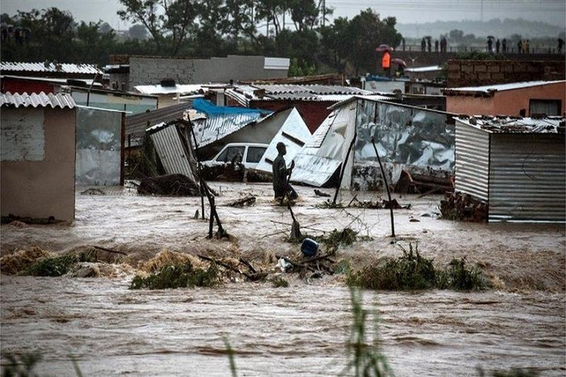

[Taken from: https://english.ahram.org.eg/News/454884.aspx Accessed on: 19 February 2025]

2.1 Define the term 'environmental disaster'. (1 x 2) (2)

_____________________________________________________________________________________________________________________________________________________________________________________________________________________________________________________________________

2.2 Mention TWO ways in which communities can be negatively affected by a flood. (2 x 1) (2)

_____________________________________________________________________________________________________________________________________________________________________________________________________________________________________________________________________
_____________________________________________________________________________________________________________________________________________________________________________________________________________________________________________________________________

2.3 Discuss ONE important factor to include in a family emergency plan for a flood. (1 x 2) (2)

_____________________________________________________________________________________________________________________________________________________________________________________________________________________________________________________________________
_____________________________________________________________________________________________________________________________________________________________________________________________________________________________________________________________________

[6]

Question 3
Study the image below and answer the questions that follow.
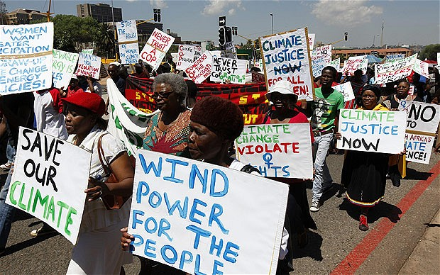

[Taken from: https://cer.org.za/news Accessed on: 19 February 2025]

Write paragraphs on climate change.

Use the following as a guideline:

- State FOUR human activities involving the burning of fossil fuels that contribute to
global warming. (4 x 1) (4)

_____________________________________________________________________________________________________________________________________________________________________________________________________________________________________________________________________
_____________________________________________________________________________________________________________________________________________________________________________________________________________________________________________________________________

- Analyse how climate change can impact individuals psychologically. (2 x 4) (8)
_____________________________________________________________________________________________________________________________________________________________________________________________________________________________________________________________________
_____________________________________________________________________________________________________________________________________________________________________________________________________________________________________________________________________
_____________________________________________________________________________________________________________________________________________________________________________________________________________________________________________________________________
_____________________________________________________________________________________________________________________________________________________________________________________________________________________________________________________________________

- Evaluate the effectiveness of campaigns that address climate change. (2 x 4) (8)
_____________________________________________________________________________________________________________________________________________________________________________________________________________________________________________________________________
_____________________________________________________________________________________________________________________________________________________________________________________________________________________________________________________________________
_____________________________________________________________________________________________________________________________________________________________________________________________________________________________________________________________________
_____________________________________________________________________________________________________________________________________________________________________________________________________________________________________________________________________

[10]

[Grand Total: 26]

