
Content Summary
LESSON 1:
Awareness of trends and demands in the job market
- Research emerging demands or changing patterns of careers and scarce skills, and the job market
- Reading the market for trends regarding jobs and identifying niches
- Growth and decline of various occupations and fields of work and competencies linked to these jobs

Key Concepts
- Trends refer to patterns or changes in employment, skills, industries or roles that are emerging over time.
- Demands refer to the specific needs or requirements of employers for certain skills, qualifications, roles, or job types. It reflects what the market is actively seeking.
- A niche refers to a specialised segment or area within an industry where specific skills, expertise, or roles are required.

As you think about your future career, understanding trends and demands in the job market is essential. The world of work is constantly evolving, with new industries emerging and others changing or declining.

Research demands and patterns
Researching the job market can help you discover which careers are in demand and which skills are considered scarce. Scarce skills refer to abilities that very few people possess but are highly needed by employers. For example, careers in technology, healthcare, and renewable energy are often in high demand due to their importance in modern society. By identifying these opportunities, you can prepare yourself for a career that is both fulfilling and relevant.

Reading market trends
Another key step is learning how to “read” the job market for trends. Trends are patterns or developments that indicate where the job market is heading. For example, many industries are adopting automation and digital technologies, creating demand for people skilled in coding, data analysis, and artificial intelligence.

At the same time, it is important to identify niches, which are specialised areas within industries. Finding a niche can set you apart from others and help you stand out in the job market. For example, within the field of technology, specialising in cybersecurity or virtual reality development could be a niche worth exploring.

Growth and decline of various occupations and fields of work
Finally, it is important to consider the growth and decline of different occupations. Some careers, like those in green energy, are growing rapidly because of the global push toward sustainability. Other careers, such as certain manual labour jobs, may decline as industries automate their processes. Understanding these shifts can help you align your skills and interests with careers that have long-term potential.

Additionally, knowing the competencies linked to specific jobs – such as problem-solving, teamwork, or technical skills – will help you build the right foundation for your chosen career path. By staying informed and adaptable, you can make career decisions that align with the ever-changing job market.

LESSON 2:
- South African Qualifications Authority (SAQA) and the
- National Qualifications Framework (NQF) and Recognition of Prior Learning (RPL)

Key Concepts
- SAQA (South African Qualifications Authority): A government body responsible for overseeing the quality and recognition of qualifications in South Africa. It ensures that qualifications meet national standards and are accredited.
- NQF (National Qualifications Framework): A system that classifies and structures qualifications in South Africa into 10 levels, providing a clear pathway for learners to progress from basic education to higher education and specialised qualifications.
- RPL (Recognition of Prior Learning): A process that allows individuals to gain formal recognition for skills, knowledge, and experience acquired outside of formal education, enabling them to earn credits or qualifications based on their past learning and work experience.

Once you have identified the career you are interested in, it is essential to investigate the path you need to take from high school to becoming qualified for your chosen profession. Understanding key concepts like the South African Qualifications Authority (SAQA), the National Qualifications Framework (NQF), and Recognition of Prior Learning (RPL) will help you navigate this journey and ensure you’re on the right track towards your career goals.

National Qualifications Framework (NQF)
Imagine your career as a ladder, with each step representing a stage of qualifications you'll need to reach the top. To achieve your goals, you'll climb these steps one by one.

In South Africa, we have the South African Qualifications Authority (SAQA), which oversees the National Qualifications Framework (NQF) – your "ladder" to success. The NQF is structured as a 10-level framework. Since you passed Grade 9 last year, you currently hold an NQF Level 1. As a Grade 10 learner, you are now working towards completing your FET (Further Education and Training) phase of education and achieving an NQF Level 4 by passing Grade 12 and obtaining your National Senior Certificate (NSC).

It is important to understand the different NQF levels, as some careers require a specific NQF level as a minimum entry requirement. Each level of the NQF represents a different level of knowledge, skills, and learning outcomes, which will prepare you for more advanced work or study.

In some cases, you may need to study further after obtaining your NSC. Depending on your results, this certificate allows you to apply for further studies. For example, a Higher Diploma is NQF Level 5, a first degree is NQF Level 6, an Honours degree is NQF Level 7, a professional qualification is NQF Level 8, a Master’s degree is NQF Level 9, and a Doctorate is NQF Level 10. It is also important to note that the higher your NQF level, the more specialised your knowledge and expertise will become in your chosen field.

Generally, the higher your qualification, the greater your earning potential – depending, of course, on your chosen field of study.

Illustration of the National Qualifications Framework
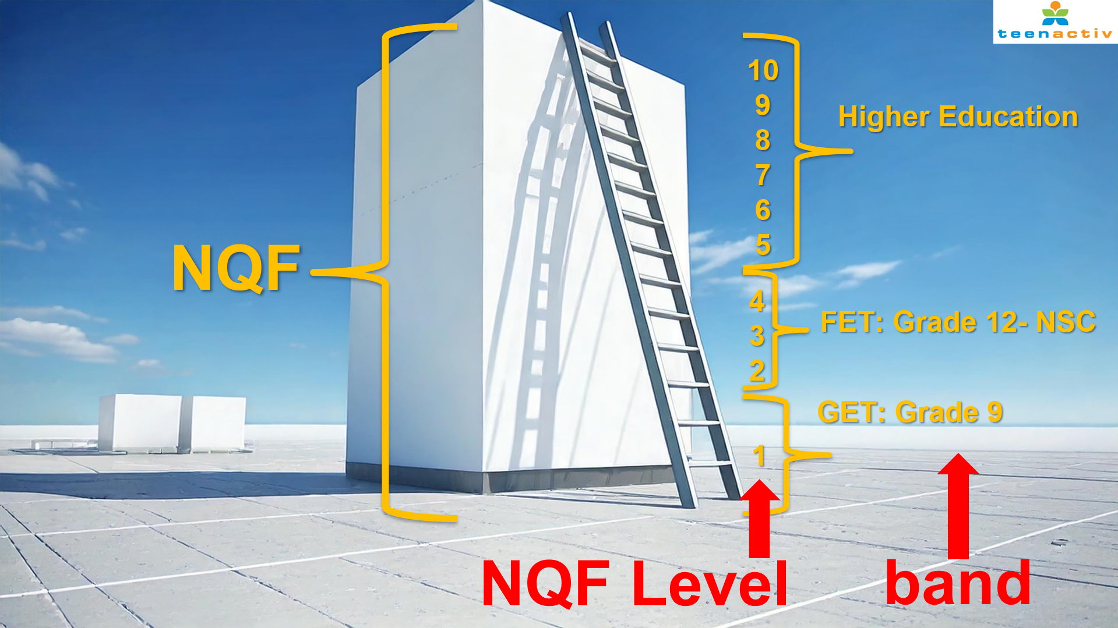

South African Qualifications Authority (SAQA)
It is important to understand the role of SAQA. SAQA ensures that the qualifications you aim to achieve in South Africa are valid and credible:
- They oversee qualifications offered by various institutions, ensuring they align with NQF-level standards. This means that any qualification you pursue must meet specific criteria to ensure it provides you with the necessary skills and knowledge for the workforce.
- They coordinate qualifications for General Education and Training (GET, Grade 9), Further Education and Training (FET, Grades 10-12), as well as higher education and trades or occupations. This includes making sure that all qualifications at these levels are properly structured and accredited.
- Tertiary institutions must register new degrees with SAQA. This ensures that any new academic programmes meet national standards and are recognised both locally and internationally.
- SAQA also works with quality councils that are responsible for maintaining the overall standard of accreditation for education and training in South Africa.
- At the school level (NQF Levels 1-4), Umalusi is the quality council, while for higher education, it is the Council on Higher Education (CHE).

The institutions you choose to study at must be registered with SAQA for their qualifications to be recognised as valid. If an institution is not registered with SAQA, your qualification may not be accepted by employers or other institutions, affecting your future career prospects. It is important to verify this before investing significant amounts of money in an institution that may not be officially accredited.

Recognition of Prior Learning (RPL)
Recognition of Prior Learning (RPL) allows individuals to earn credits based on the skills, knowledge, and experience they have accumulated over time. This process recognises the value of non-formal and informal learning, giving people the opportunity to receive formal qualifications even if they haven't followed the traditional education route. RPL provides a way for individuals to demonstrate their competence and gain recognition for learning gained through work, life experiences, and self-study.

To qualify for RPL, you must be at least 23 years old and have a minimum of 3 years of work-related experience. This ensures that candidates have developed a significant level of expertise and knowledge in their field.

It is important to recognise that RPL is not the most common path to obtaining qualifications. While RPL provides opportunities for those with significant work experience, it is still recommended that you pursue formal education through a technical college or university to ensure a comprehensive understanding of your field. While university or college isn’t the only path to success, formal qualifications offer structured, in-depth learning and open more doors in your career.

LESSON 3:
- The need for lifelong learning: Ability to change, re-train, flexibility and ongoing development of the self
- Different kinds of learning: Formal, informal and non-formal

Key Concepts
- Fixed mindset: The belief that abilities, intelligence, and talents are innate and unchangeable, leading to avoidance of challenges and fear of failure.
- Growth mindset: The belief that abilities and intelligence can be developed through effort, learning, and perseverance, fostering resilience and a willingness to embrace challenges.

The need for lifelong learning
There are many things in life that we should know but we don’t always learn them in school. That is why we need to develop an attitude of being a lifelong learner. This means recognising that we will always need ongoing learning and self-development. Sometimes this learning will take place in formal settings like university or college, and other times it will come from people, experiences or doing short courses. It could also involve exploring new hobbies, staying curious and seeking knowledge in everyday situations. Just remember, being a lifelong learner is something everyone can and should strive for.

Being a lifelong learner is a powerful way to ensure that you keep improving yourself. This continual growth increases your potential (your ability to adapt and handle the challenges life throws your way).

Ability to change
Sometimes it could be difficult to adapt or change when a situation doesn’t quite work the way you planned it. For example: Imagine you plan to make hamburgers for supper. You've bought buns and chips to go with my burgers, but just as you're about to start, you realise you forgot the burger patties. Your initial reaction might be irritation, but instead, you have to problem-solve and adjust your plans for supper. This is a simple example, but it rings true for bigger challenges in life – like having to adapt your study plans if you’re not accepted into a specific course you applied for

This is where adopting a growth mindset comes in – choosing to view challenges as opportunities to grow rather than roadblocks. Read through the below examples that illustrate the difference between fixed and growth mindsets.
Fixed Mindset | Growth Mindset
Jane has always struggled with mathematics and believes she is just "not a math person." When she receives a poor grade on a test, she feels discouraged and avoids asking for help or practising more because she thinks no amount of effort will change her abilities. | Mark finds math challenging but believes he can improve with practice. When he gets a low grade on a test, he reviews his mistakes, asks his teacher for extra help, and dedicates time to practising problems. Over time, his grades and confidence improve.

Being retrainable
Being retrainable means having the ability to learn a new skill, often out of necessity or to improve your opportunities in your job or personal life.

For example, you might need to learn how to use a new program on your computer for work. It could also involve upskilling to stay competitive in your field or even transitioning into a completely new career path.

Being flexible
Being flexible means having the ability to adapt to different situations and perspectives. If you are flexible, you will:
- be open to new ideas.
- recognise that someone else’s ideas might be better or more effective than yours.
- be able to work collaboratively with colleagues from diverse cultures and backgrounds.

Flexibility also allows you to approach challenges with a problem-solving mindset and embrace change as an opportunity for growth. For example, Lebo is part of a group project at school. She initially suggests creating a poster for their presentation, but another group member proposes making a short video instead. Although Lebo has never made a video before, she listens to their ideas and agrees to try it. She learns new video-editing skills, and the group’s presentation turns out to be a success.

Different kinds of learning
Formal
Formal learning refers to structured, curriculum-based education that typically takes place in schools, colleges, universities, or other recognised institutions. It is characterised by specific objectives and leads towards certification or qualification upon completion. Formal learning often culminates in academic degrees or professional qualifications.

Informal
Informal learning happens outside of structured, formal educational settings. It is often self-directed, spontaneous, and occurs through day-to-day experiences, interactions, and activities. For example: Clara is passionate about photography and follows several photography pages on Instagram. She learns new techniques by watching tutorials posted by professional photographers, reading tips in the comments, and participating in online photography challenges.

Non-formal
Non-formal learning takes place outside of traditional formal education systems but still follows some level of structure. This type of learning often occurs in settings like community programmes, workshops, seminars, or sports activities, and can complement or supplement formal education. For example: Sarah enrols in a free online course about sustainable gardening. She learns new techniques for growing plants in an environmentally friendly way, including composting, water-saving methods, and permaculture. Although she doesn’t earn any official certification, she gains valuable knowledge.

