
Lesson 3 – Worksheet MEMO

Activity 1: Individual Activity

Read the list of statements below and answer the questions that follow.
The ability to change and adapt in the two different mindsets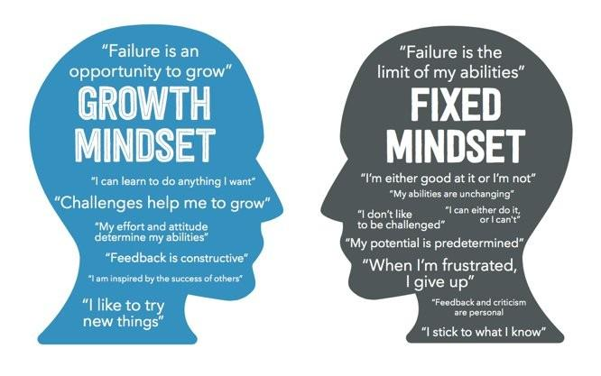
[Taken from www.big-change.org Accessed on: 5 December 2024]

  - Identify TWO growth mindset phrases that you feel reflect you. For each phrase, give ONE example
of how you have applied this mindset.

Model answers:
- I can learn to do anything I want – I enjoy learning new things, for example, I am presently learning to play the piano.
- I am inspired by the success of others – I enjoy listening to the stories of how others have achieved in education. It inspires me to study harder and try to improve.

1.2 Provide TWO reasons why having a fixed mindset would be limiting to your self-development.

Model answers:
- People with a fixed mindset believe they can't change their abilities, so they avoid difficult tasks to prevent failure.
- If you have a fixed mindset, you may see failure as a sign that you're not good enough. This fear of failure can stop you from trying new things or taking risks.

Activity 2: My Life Game (Group Activity)

Your teacher will hand out SIX “life” cards to your group. On each card is a short description of a situation that warrants change in the school environment or workplace.

How to Play:
- Each person in the group will take turns drawing a card.
- The person who draws the card will read the “problem” aloud to the group without showing the card.
- The group will have 30 seconds to brainstorm and suggest ways the character can adapt to the situation.
- Once the group has discussed their ideas, they will try to guess the suggested solution or answer on the card.

Learners will have personal responses to this activity.

Activity 3: Reflection

We’ve come to the end of this series of lessons. It would be appropriate to end off by thinking of a quote to inspire other classes to become lifelong learners. Your teacher will give you a small piece of paper and show you a space in the class to put up your “Inspiration Quote” before you leave the classroom.

Plan your quote in the space below before you put it up on the wall.

Some inspirational quotes as examples:
- "The more that you read, the more things you will know. The more that you learn, the more places you'll go." — Dr. Seuss
- "Education is the most powerful weapon which you can use to change the world." — Nelson Mandela
- "The beautiful thing about learning is that no one can take it away from you." — B.B. King
- "You are never too old to set another goal or to dream a new dream." — C.S. Lewis

Learners will have personal responses to this activity.

