
Lesson 2 – Worksheet MEMO

Activity 1: Group Discussion
Study the statistics below and briefly discuss the questions that follow.
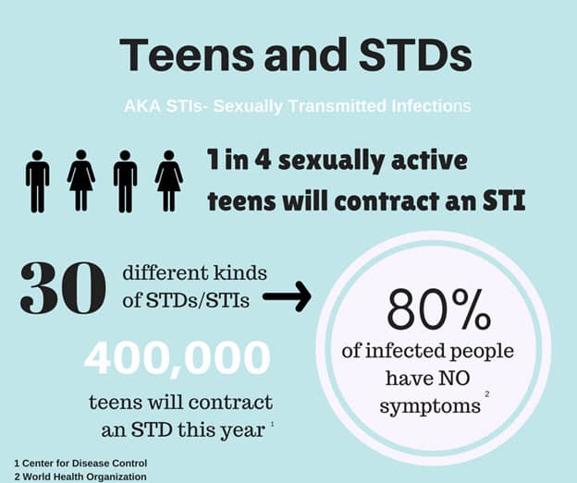
[Source: https://www.facebook.com/gyrlsinthehood/photos/a.185751288293087/1435619716639565/?type=3
Accessed on: 30 July 2024]
Possible Answers
1.1 Why do you think so many sexually active teens will contract an STI?
- Some teenagers have unhealthy sexual habits and think they will not contract an STI, so they don’t take any precautions.
- Some teenagers are unaware that these diseases are so prevalent and easily transmitted.

1.2 Give TWO reasons why teens would not easily seek help.
- Some might feel embarrassed, afraid, ashamed or even scared and prefer to ignore the symptoms, thinking it will go away.
- Some might think it’s not serious at all.
1.3 Provide TWO ways that a teenager could prevent contracting an STI.
- A teenager could use a condom to prevent an STI but it is not 100% guaranteed that it will work. The most effective form of prevention is still abstinence.
- Regular STI testing for yourself and your partners.
- Reduce the number of sexual partners.
- Have open and honest discussions about sexual health with partners.
- Get vaccinated for preventable STIs like HPV and Hepatitis B.

Learners may have varying responses to these questions.

 Activity 2: Write a Speech

Refer to the extract on Slide 5 (Lesson 2 – PowerPoint): SA teen to equip young girls with knowledge about HIV in the US.
Imagine you are a young teenager representing your school and country in the United States. In the space below, write a brief 5-line speech on how you would raise awareness among teenage girls about HIV and AIDS and how you would encourage them to take steps to prevent infection.
Model Answer
Firstly, I would tell the young ladies that they are valuable. They are nobody's property and they get to choose their own future. Their decision about their sexual behaviour will impact their future. They can prevent the chance of contracting HIV. Say NO to Sex without contraception. Say NO if you’re not interested in having sex. Finish school, and enjoy your youth!

Learners will have personal responses to this activity.

Activity 3: Individual Reflection
Write the name of a person from each influence category who has POSITIVELY impacted you. For each person, provide one reason explaining how they have influenced you.
 | Family  ________________________________________________________________________  ________________________________________________________________________
 | Community  ________________________________________________________________________  ________________________________________________________________________
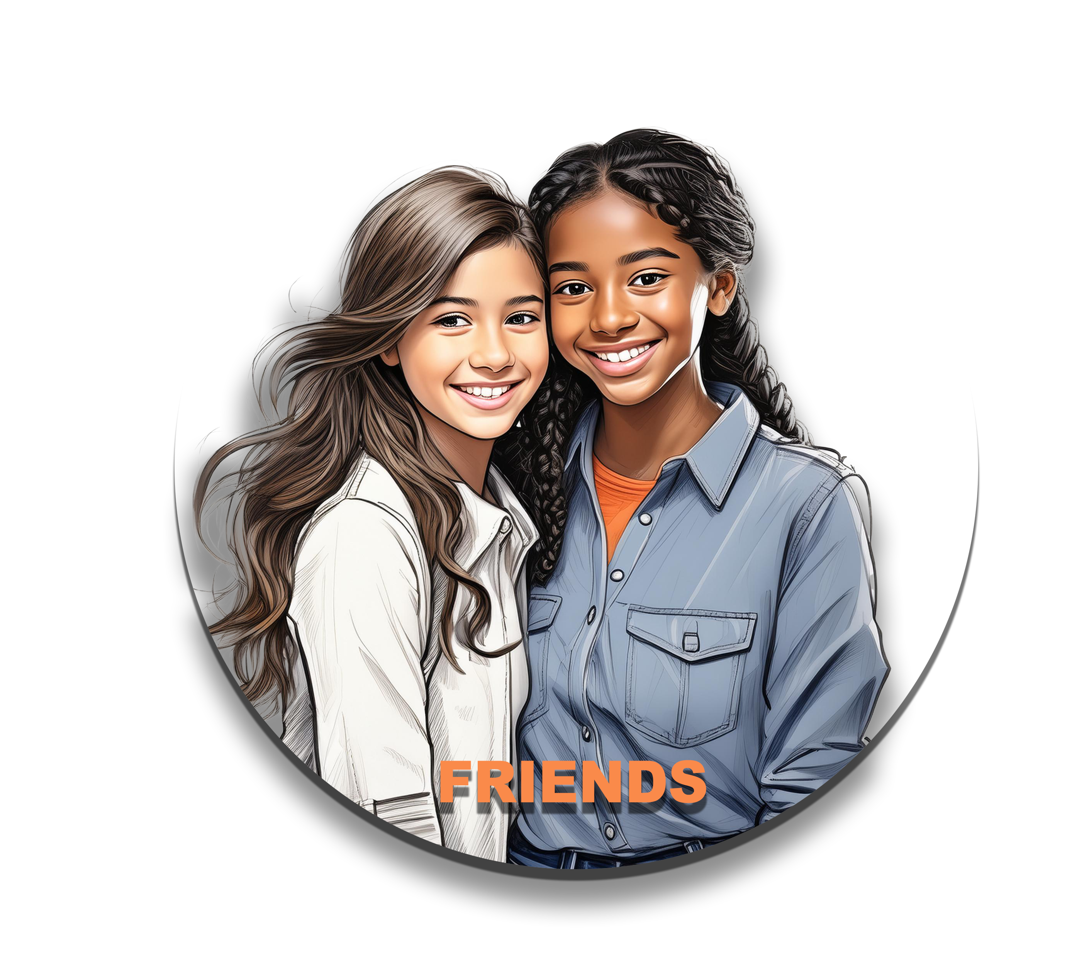 | Friends  ________________________________________________________________________  ________________________________________________________________________
 | Peers  ________________________________________________________________________  ________________________________________________________________________

Learners will have personal responses to this activity.

