
Lesson 2 – Worksheet

Activity 1: Group Discussion
Study the statistics below and briefly discuss the questions that follow.
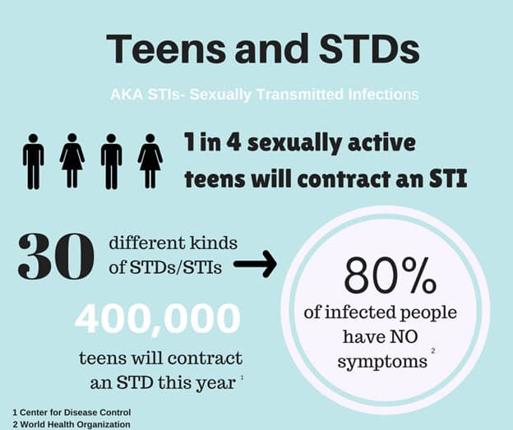
[Source: https://www.facebook.com/gyrlsinthehood/photos/a.185751288293087/1435619716639565/?type=3
Accessed on: 30 July 2024]

1.1 Why do you think so many sexually active teens will contract an STI?
______________________________________________________________________________________________________________________________________________________________________________
1.2 Give TWO reasons why teens would not easily seek help.
______________________________________________________________________________________________________________________________________________________________________________

1.3 Provide TWO ways that a teenager could prevent contracting an STI.
______________________________________________________________________________________________________________________________________________________________________________
 Activity 2: Write a Speech

Refer to the extract on Slide 5 (Lesson 2 – PowerPoint): SA teen to equip young girls with knowledge about HIV in the US.
Imagine you are a young teenager representing your school and country in the United States. In the space below, write a brief 5-line speech on how you would raise awareness among teenage girls about HIV and AIDS and how you would encourage them to take steps to prevent infection.


Activity 3: Individual Reflection
Write the name of a person from each influence category who has POSITIVELY impacted you. For each person, provide ONE reason explaining how they have influenced you.
 | Family  ________________________________________________________________________  ________________________________________________________________________
 | Community  ________________________________________________________________________  ________________________________________________________________________
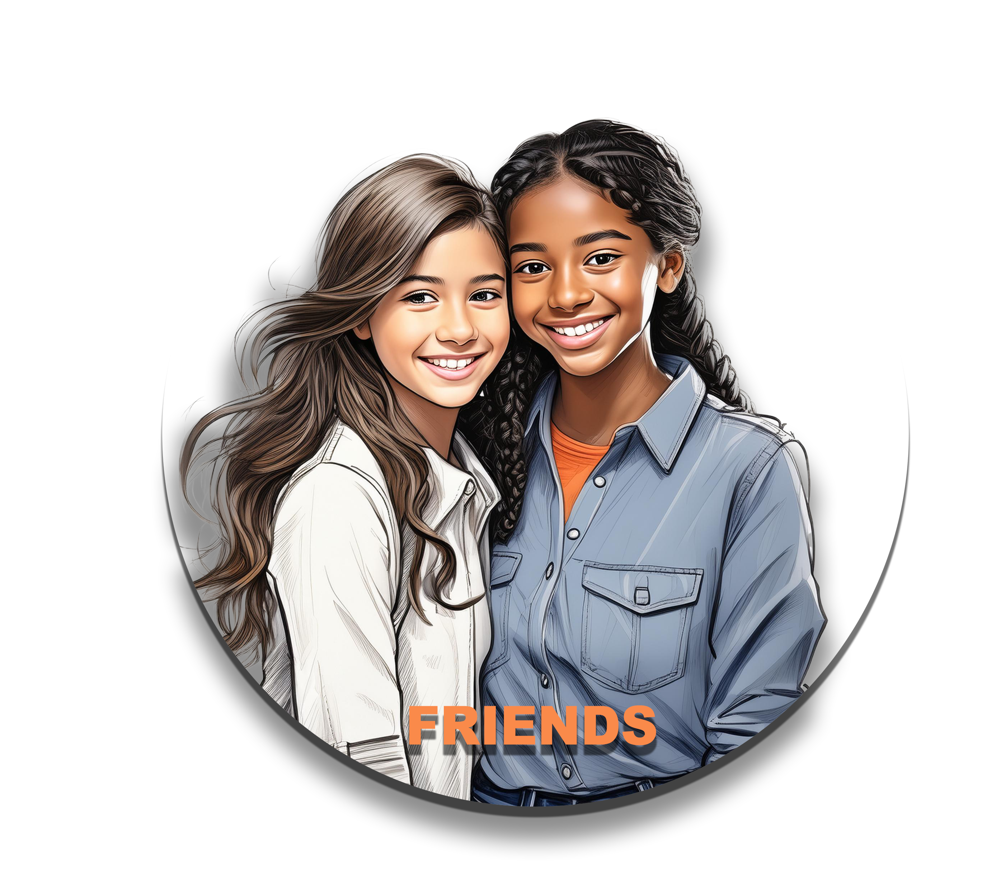 | Friends  ________________________________________________________________________  ________________________________________________________________________
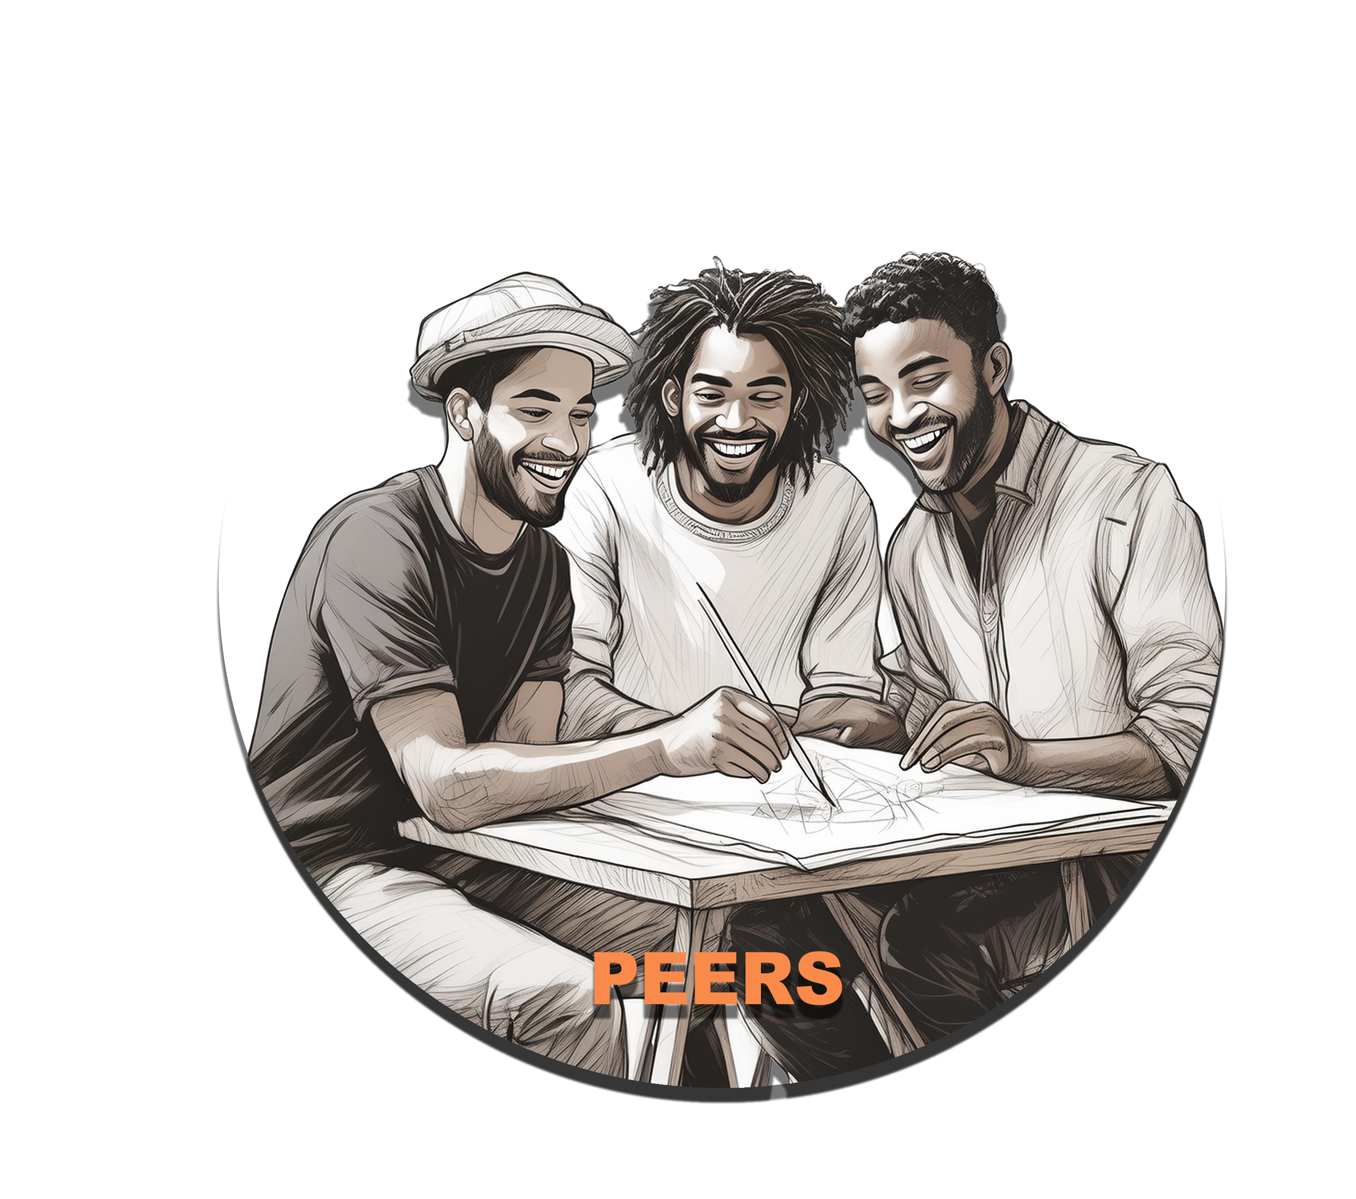 | Peers  ________________________________________________________________________  ________________________________________________________________________

