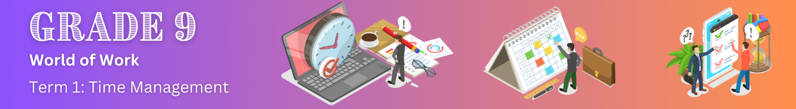
Lesson 2 – Worksheet
 | Activity 1: Concept Map  Complete the following questions as the lesson progresses.
How can you be accountable on a daily basis?
What does accountable mean?

ORGANISATION means:

EFFICIENT vs EFFECTIVE:

How are the two different?

Why should you plan your time?
TIPS to be efficient & effective:

NOTES:


Activity 2: Individual Activity
Complete the following questions individually.

Read the extract below and answer the questions that follow.
THREE TIME-MANAGEMENT TIPS EVERY TEEN SHOULD KNOW

Between your dance class, hockey practice, and piano lessons, there never seems to be enough time to study for that test, finish that assignment, do those chores, and still have time to spend with your friends and do your favourite things. But there are ways to make sure you won’t have to worry about being too busy and still make time for fun. Here are three sure-fire tips to help you manage your time so you can do all the stuff you have to do and have plenty of time left for the stuff you want to do.

Prioritise your activities: You have a lot of responsibilities, and they all need your time. But some tasks are more important than others. Figure out the most important parts of each day and write them down. Then, make it your priority to do those things before starting on anything else.

Prioritising helps you finish the most important things right away, so you don’t find yourself worried or stressed about them at the last minute. It might seem less fun to get home from school, work, or practice and get started on homework or chores right away. But getting those things out of the way first will free up your time later to do the things you like and keep you from stressing.

Create a schedule: Each day, you have certain things you must do, like go to school, help with chores, or do homework. Then there are the things you do a few times a week, like going to soccer practice, working at your part-time job, or tutoring a younger learner. It all seems like a lot but, before you start each day, you can make a list of things you have to do and estimate how much time each task or activity will take.

Do everything you can to schedule the most important things earlier in the day. If you have a big test to study for, schedule your study time for as soon as you get home. Decide how much time you want to spend and write it into your schedule. For example, you could decide to spend one hour studying before setting the table for dinner. If you write that into your schedule, you’re more likely to get it done and feel good when it’s out of the way. Plus, it’ll mean you have time to do the stuff you want to do later.

Avoid distractions: Now that you have a schedule, you can get to work. Unfortunately, when you have homework to do, nothing is more tempting than texting, Snapchat and Netflix. Find a place to work that’s quiet and where people won’t distract you. It’s easy to get into a conversation with friends when studying in the school library or cafeteria, but you might find it helpful to have a study buddy who will keep you on track to work hard. Choose that person carefully or pick a place that keeps you away from distractions.

Make sure your phone, iPad, or tablet is on silent, then put it somewhere that you won’t be able to see it. If you’re at home, this could be in another room, under your pillow, or somewhere behind you. If you’re at school or somewhere public, hide it in a safe place, like inside your locker or book bag. Not being able to see or hear your phone will help keep you from being distracted by it.

When you need to use a computer for homework, make sure you keep your school-related tabs open and nothing else. Keeping your favourite apps and websites closed is a great way to focus on the work you must do and get it done more quickly, which will give you more time for fun stuff later.

[Adapted from: https://sossafetymagazine.com/health-and-well-being/5-time-management-tips-every-teen-should-know/ Accessed on: 25 November 2024]
2.1 Which TWO of the tips in the extract would be most beneficial for YOU in managing your time? Motivate your answer.
________________________________________________________________________________________________________________________________________________________________________________________________________________________________________________________________________________________________________________________________________________________________________________________________________________________________________________________________________________________________________________________________________________________________________________
2.2 Why did you choose those two in particular?
________________________________________________________________________________________________________________________________________________________________________________________________________________________________________________________________________________________________________________________________________________________________________________________________________________________________________________________________________________________________
2.3 List any additional ways to better manage your time.
____________________________________________________________________________________________________________________________________________________________________________________________________________________________________________________________________________________________________________________________________

