Exit Ticket
Answer the following questions in the space below. Hand your exit ticket to your teacher as you leave the classroom. Do NOT write your name on the page.
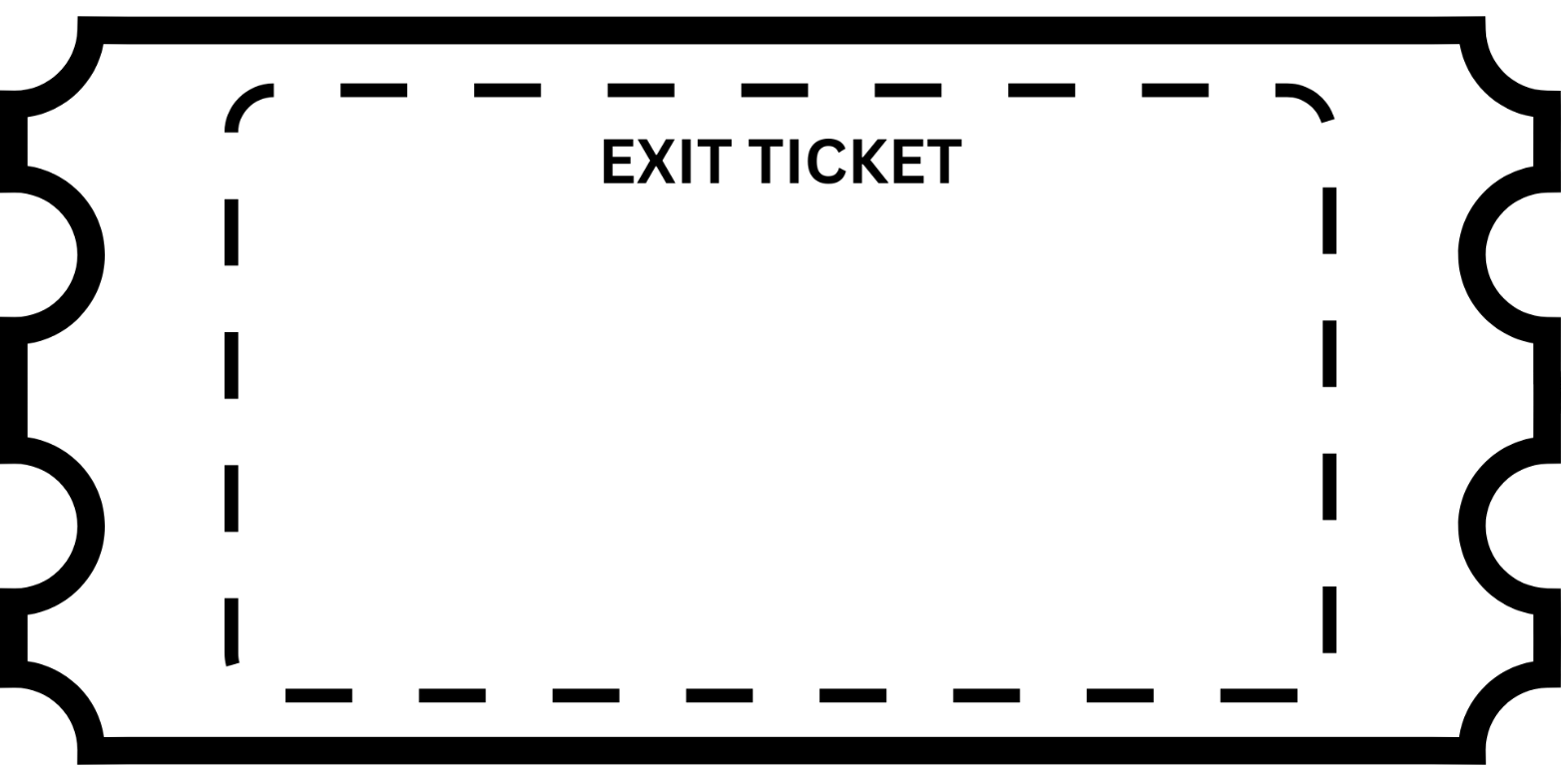

- Write down ONE question you would like answered about sexuality.
_______________________________________________________________________________________________________________________________________________________________________________________________________________
- Write down ONE interesting or new fact you learnt in this lesson.
_______________________________________________________________________________________________________________________________________________________________________________________________________________

Exit Ticket
Answer the following questions in the space below. Hand your exit ticket to your teacher as you leave the classroom. Do NOT write your name on the page.

- Write down ONE question you would like answered about sexuality.
_______________________________________________________________________________________________________________________________________________________________________________________________________________
- Write down ONE interesting or new fact you learnt in this lesson.
_______________________________________________________________________________________________________________________________________________________________________________________________________________

