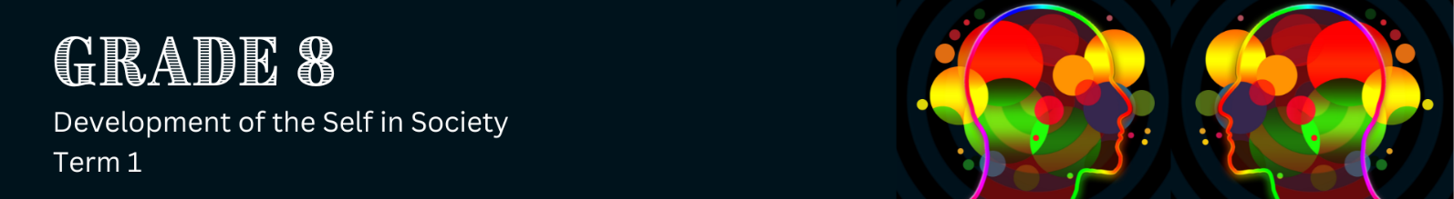

Lesson 1 – Worksheet MEMO
 | Activity 1: Self-Concept Shield  Complete the following activity individually.

Complete the Self-Concept Shield below by using words, drawings or symbols.

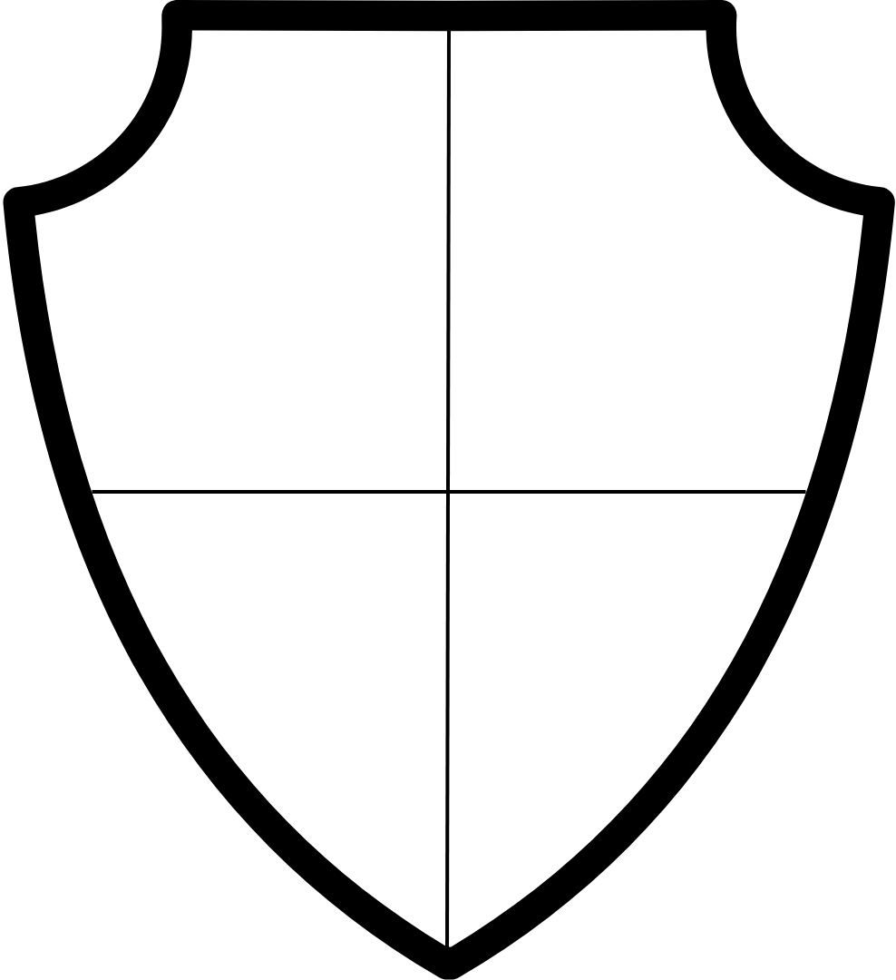

One thing I'm good at (skill/talent)
One thing I enjoy doing (hobby/interest)

One quality/trait I like about myself
One goal/dream for my future

Learners will have personal responses to this activity.

