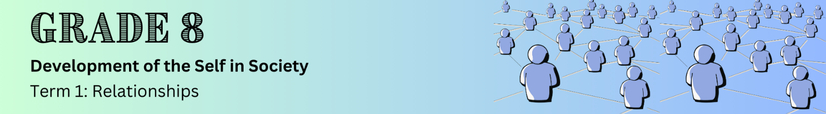

Lesson 1 – Worksheet
 | Activity 1: Brainstorming  Complete the following activity in groups.

In the space below, brainstorm ways to sustain relationships.




Ways to sustain RELATIONSHIPS

Activity 2: Reflection
Complete the following activity individually.

Based on what you have learnt in today's lesson, answer the following question.

2.1 Reflect on a relationship you currently have or had in the past. What are some key factors that
helped you initiate and sustain this relationship?
___________________________________________________________________________________________________________________________________________________________________________________________________________________________________________________________________________________________________________________________________________________________________________________________________________________________________________________

