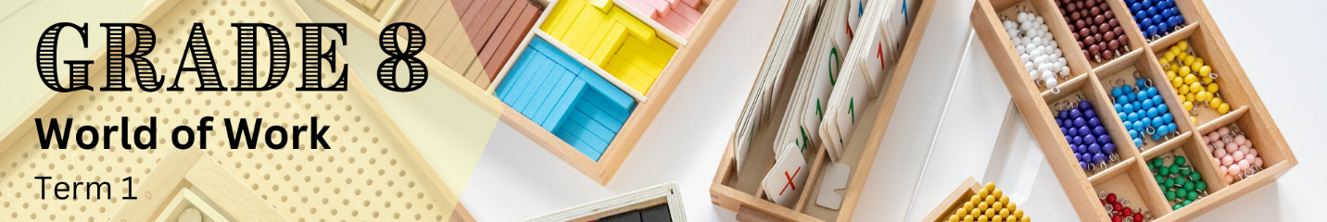

Lesson 1 – Worksheet
 | Activity 1: Learning Style Quiz  Complete the following activity individually.

1.1 Complete the learning style quiz below to identify your preferred learning style(s). Circle your answers as you go through the quiz.

Top of Form
1.1.1 You're helping at a holiday camp and need to complete eight different tasks by the end of each day. How do you keep track of them?
A. Ask your supervisor to explain each task to you.
B. Do the tasks in the same order every time and remember the routine.
C. Write down a list and keep it handy as a reference.
D. Draw a map of the camp and label where each task needs to be done.

1.1.2 In your Natural Sciences class, you're learning about the water cycle. How do you prefer to organise your notes on this topic?
A. Recall the teacher's description and jot down what you remember.
B. Use index cards for each step and arrange them as needed.
C. Write out the steps of the cycle in a list format.
D. Create a diagram to visualise the cycle.

1.1.3 You’re reading a novel with a complex cast of characters. How do you remember all of them?
A. Listen to the audiobook version.
B. Use examples from the book to remember how characters are related.
C. Bookmark the pages where each character first appears for quick reference.
D. Draw a family tree to track the characters.

1.1.4 You're going on a school camp and can only bring a backpack. How do you plan your clothing?
A. Discuss with a friend going on the camp about their packing list.
B. Try on each outfit to see what fits best.
C. Write down a list of the outfits and their components.
D. Lay out everything on your bed in the order you’ll wear it.

1.1.5 You need to write a review on the tuckshop and must remember what you ate last week, which memory helps you the most?
A. What others said about the food.
B. The taste of the food.
C. Descriptions of the food from the menu.
D. What the food looked like.

1.1.6 You are doing a Coding and Robotics course, which task from the course do you enjoy the most?
A. Recording a short video presentation.
B. Completing a virtual exercise with your classmates.
C. Writing a summary of key points from an article.
D. Creating a flowchart to outline concepts.

1.1.7 You’re learning a new dance routine. What’s the best way for you to learn it?
A. Discussing the routine with a classmate.
B. Taking a class with an experienced instructor.
C. Reading the written instructions.
D. Reviewing diagrams that explain the steps.

1.1.8 Think about your favourite classes. What type of lesson do you enjoy the most?
A. Engaging lectures where the teacher does most of the talking.
B. Lessons with interactive activities or case studies.
C. Detailed printed outlines of the topics.
D. Lessons with helpful diagrams.

1.1.9 You’re babysitting younger cousins for half an hour. What activity would you choose to do with them?
A. Reciting a nursery rhyme.
B. Teaching them a dance routine.
C. Reading a book aloud.
D. Drawing together.

1.2 Once you have finished the quiz, transfer your answers to the answer grid below.

ANSWER GRID
1.1.1 | A | B | C | D
1.1.2 | A | B | C | D
1.1.3 | A | B | C | D
1.1.4 | A | B | C | D
1.1.5 | A | B | C | D
1.1.6 | A | B | C | D
1.1.7 | A | B | C | D
1.1.8 | A | B | C | D
1.1.9 | A | B | C | D

1.3 Count how many times each letter (A, B, C, D) appears in your answer grid. Use the table
below to identify which learning style is dominant for you.

My Learning Style(s)
Mostly A: | AUDITORY
Mostly B: | KINAESTHETIC
Mostly C: | READING & WRITING
Mostly D: | VISUAL

Activity 2: Reflection
Complete the following activity individually.

2.1 Do you agree with your identified learning style? Why or why not?

2.2 Did you find that more than one learning style was dominant for you? If so, which ones?

2.3 What strategies do you currently use that align with your identified learning style?

2.4 How can you use your identified learning style to enhance your learning at school? What specific actions could you take?

