

Lesson 1 – Worksheet
Activity 1: Individual Activity

1.1. Study the image below. Identify unhealthy habits (use your imagination) and describe the negative
and unwanted sexual experiences that could result from them.

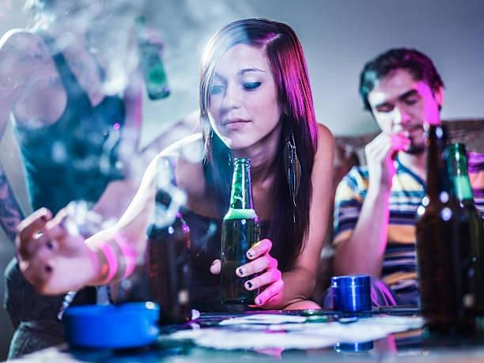

[Source: https://www.brightfutures.org/development/adolescence/substance-abuse.html Accessed on: 29 July 2024]
 Activity 2: Individual Activity

2.1 Identify the following consequences of risky sexual behaviour by writing them next to the images
below:
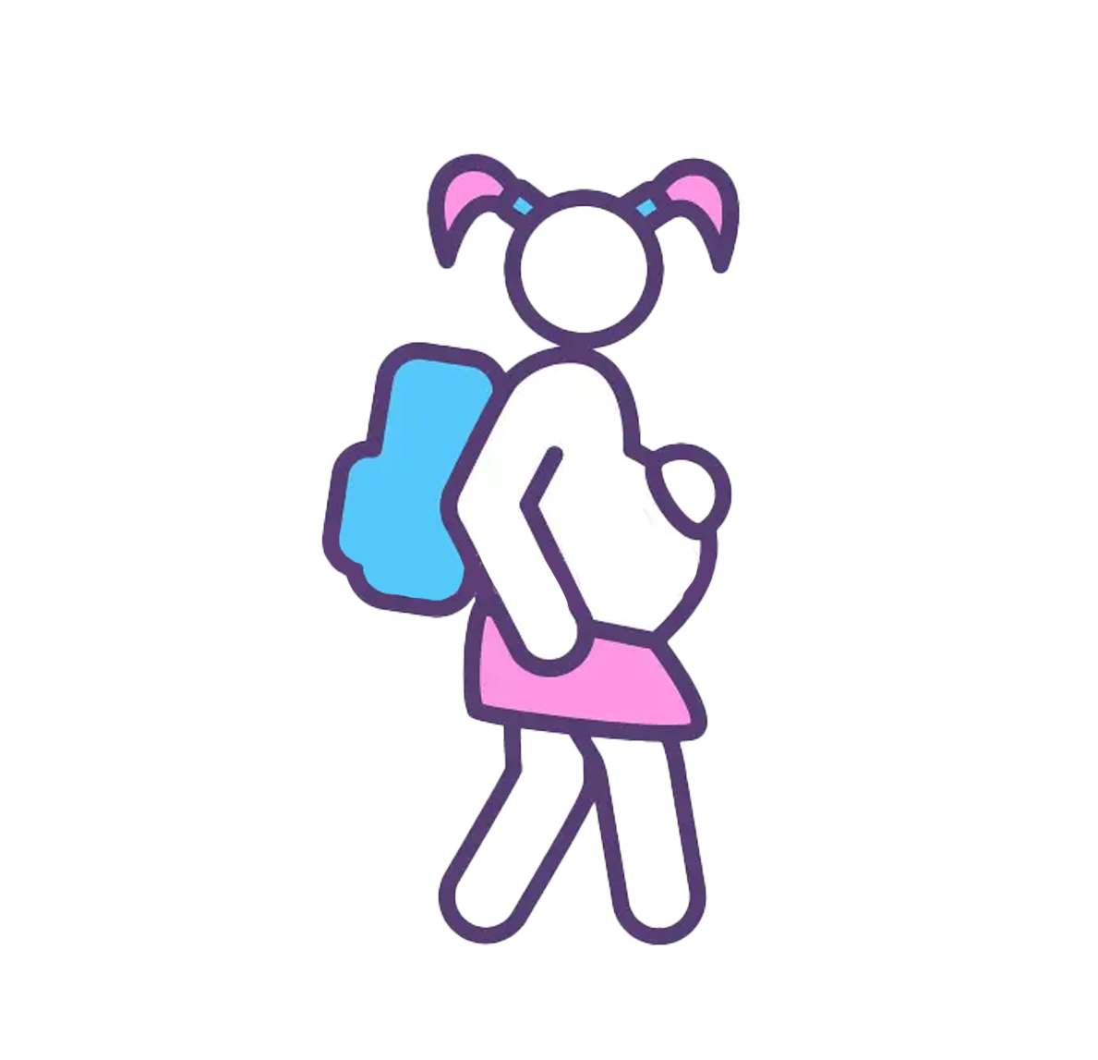

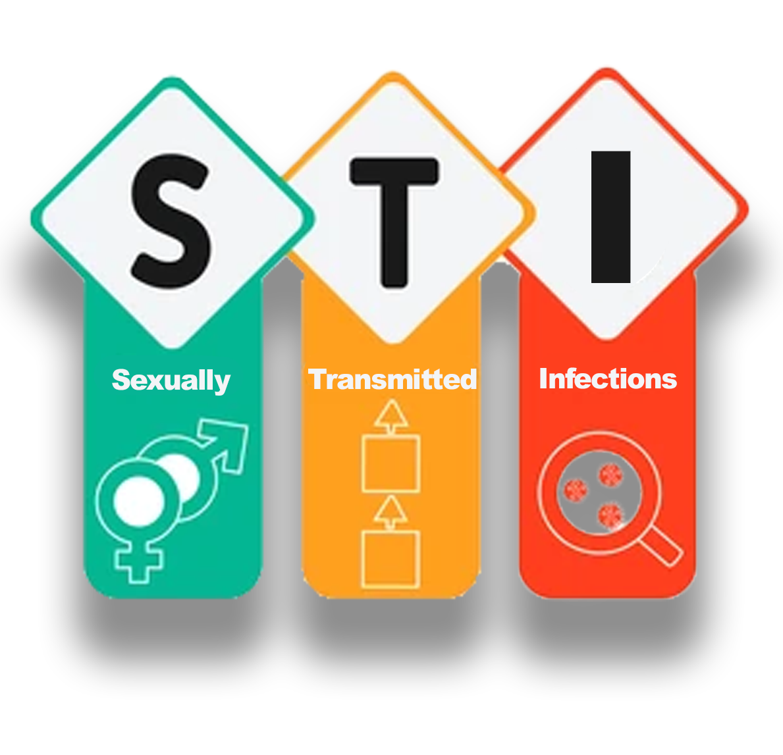

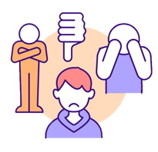
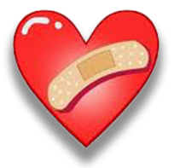

Activity 3: Group Discussion

3.1 Discuss the following questions as a group. Write your answers in the space below and choose a spokesperson to give feedback to the class.

3.1.1 Give THREE reasons for the increase in teen pregnancy since 2015.
______________________________________________________________________________________________________________________________________________________________________________________________________________________________________________________________________________________________________________________________________________________________________________________________________________________________________________________________________________________________________________________________

3.1.2 Discuss THREE reasons why many teen moms drop out of school after their baby is born.
______________________________________________________________________________________________________________________________________________________________________________________________________________________________________________________________________________________________________________________________________________________________________________________________________________________________________________________________________________________________________________________________

3.1.3 Suggest TWO ways schools could support teen moms in finishing their school education.
______________________________________________________________________________________________________________________________________________________________________________________________________________________________________________________________________________________________________________________________________________________________________________________________________________________________________________________________________________________________________________________________

