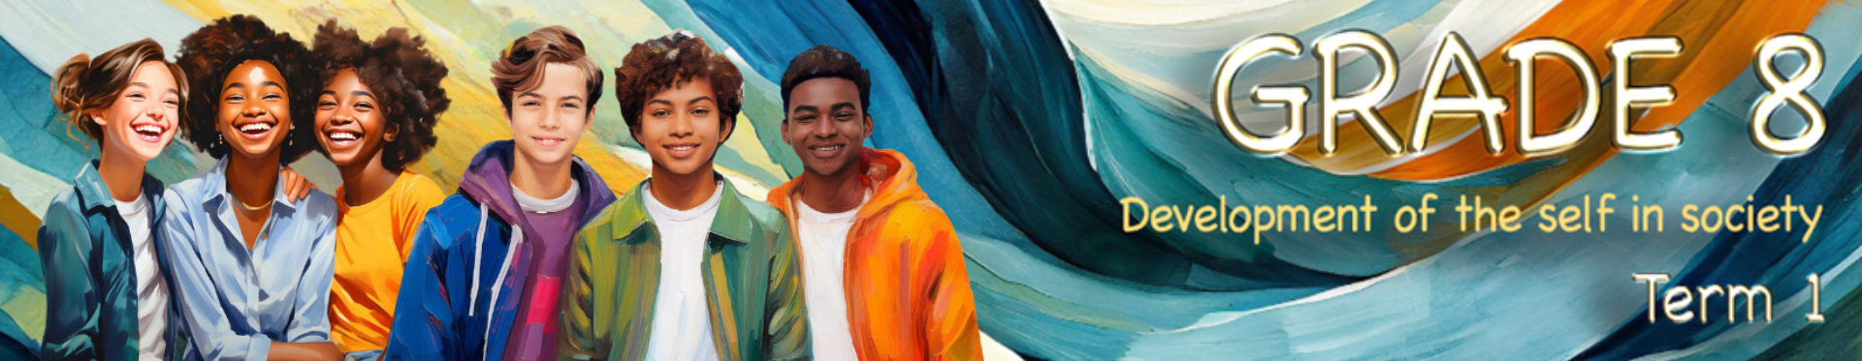
Lesson 3 – Worksheet MEMO

Activity 1: Group Activity
Study the selfie statistics below and then discuss the following questions in your group.
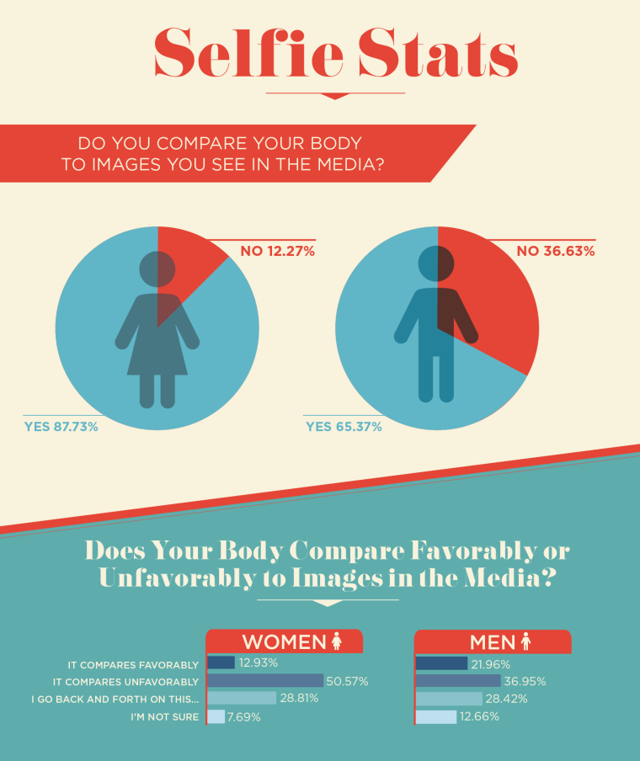
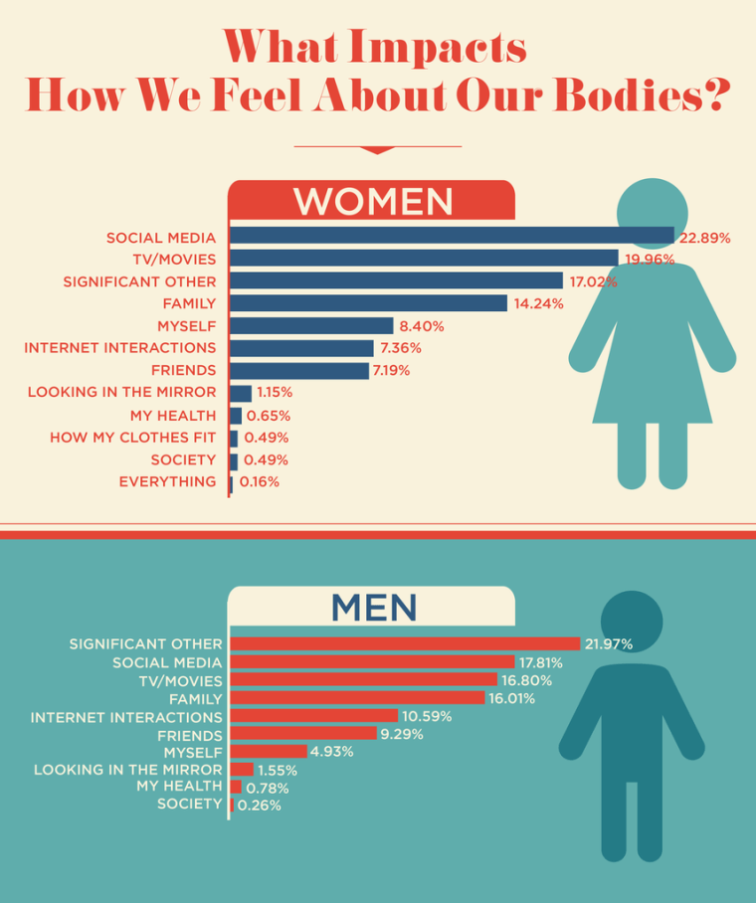
[Source: https://www.today.com/style/social-media-affecting-way-we-view-our-bodies-it-s-t128500
Accessed on: 9 July 2024)
Model Answers
1.1 Why do you think more girls compare their bodies on social media than boys?
- Many girls are concerned about being beautiful and want to appear attractive.
- Girls follow certain models or famous people and want to look or dress like them.
- Many girls are obsessed with being a certain weight. Boys are also aware of their appearance, but not as concerned about something like their weight as girls.

1.2 Look at the top influence on body image of men and women. Why do you think they are so
different?

- Men prefer a face-to-face connection with their friends or the special person in their life. People on social media are not as real to them as someone they know. The influence of their peers would be more important than some famous person that they don’t know personally.

1.3 What advice would you give a friend who feels despondent because their body does not match what they see on social media?

- You are a unique individual with a healthy body. Learn to celebrate the effectiveness of your body rather than how it looks.
- Celebrate doing sports or going for a walk so you can enjoy life and not get obsessed about what people think of how you look.
- Identify the people in your life whose opinions you truly value – those who are close to you. Remember, social media can be superficial and should hold less importance in your life.

Learners will have varying responses to these questions.

 Activity 2: Individual Activity

Read the following scenario and complete the following activity.
Background: Thabo, a 14-year-old learner in Grade 8, has become anxious and withdrawn lately. His marks are dropping and he’s avoiding all his friends except for you. His parents, Maria and David, notice these changes and don’t know how to help.
Situation: Thabo reveals he’s been bullied at school, which he believes is because he might be gay. Though he hasn’t officially come out, he feels targeted by teasing, social exclusion, and hurtful messages online. Thabo is scared that confirming his sexuality will make the bullying worse.
[Source: Created by Teenactiv. 13 August 2024]

Model Answers
2.1 What advice would you give Thabo to help him solve this problem? (Write your answers in the grid below.)

2.1.1. Describe the problem. Separate the different parts of the problem. You could also make a mind
map.
Emotional Impact:
- Thabo is feeling depressed and isolated due to bullying.
- His school performance is suffering.

Social Dynamics:
- The bullying seems connected to Thabo’s sexuality.
- There may be a lack of support and understanding at school about sexuality.

2.1.2. What information do you need to help you come up with a solution?
I need to find out if any teachers could help protect Thabo. Would he be willing to speak to his parents and/or the school counsellor?

2.1.3. List the possible solutions. | 2.1.4. List the possible effects of each solution.
Speak to an older learner on the RCL and ask for advice. | They could know the bullies and get you into more trouble OR they could escalate the issue by talking to the class/grade head on your behalf.
Go directly to a teacher and tell them what has been happening. | The bully could make your life difficult at school for going to a teacher OR they will be punished and you will feel safe.
Talk to your parents about what has been happening. | The parents could report this to the school and the teacher/counsellor would investigate the allegations. This might result in more information coming to the light, like other learners that are also being bullied.
2.1.5. Describe the best solution:
Talk to your parents about what has been happening and get them to talk to the school on your behalf. Arrange to meet with the school counsellor to work through your questions and insecurities.

Learners will have varying responses to this activity.
Activity 3: Reflection
Take a moment to reflect on the content that was covered in today's lesson. Create a catchy phrase for a bumper sticker to put in your room that reminds you of your value and that your body and sexuality belong to YOU!
Learners will have personal responses to this activity.

