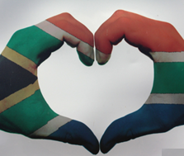
Constitutional Rights and Responsibilities
Lesson 1 - Worksheet
Term 2: Week 1 - 3
Complete this worksheet as the lesson progresses:
Questions I have from this lesson:
____________________________________________________________________________________________________________________________________________________________________________________
What RIGHTS are most important for YOUTH in South Africa?
________________________________________________________________________________________________________________________________________________________________________________________________________________________________________________________________________________________________________________
Why are HUMAN RIGHTS important?
________________________________________________________________________________________________________________________________________________________________________
What do you understand by the term HUMAN RIGHTS?
________________________________________________________________________________________________________________________________________________________________________
What are RIGHTS and RESPONSIBILITIES?
Give an example of each.
________________________________________________________________________________________________________________________________________________________________________________________________________________________________________________________________________________________________________________________________________________________________________________________________________________________________________________________________________________________________


Activity 1: Informal Assessment

Question 1:

- Define the terms ‘discrimination’ and ‘human right’ (2x1) (2)

- Discuss the relationship between rights and responsibilities. (2x2) (4)

