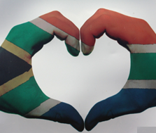
Constitutional Rights and Responsibilities
CONTENT SUMMARY
Term 2: Week 1 - 3

Lesson 1
Issues relating to citizens’ rights & responsibilities:

- While some dictionaries define the word right as “a privilege,” when used in the context of “human rights,” we are talking about something more basic.
- Every person is entitled to basic and fundamental rights, simply because they are human beings.
- These are called “human rights” rather than a privilege.
- They are “rights” because they are things you are entitled to. These rights allow for your protection against people who might want to harm or hurt you. They are also there to help us get along with each other and live in peace.

What are Rights & Responsibilities?
A right is a choice to make your own opinion and being entitled to things such as education, religion and freedom of speech.
Responsibilities are duties or something an individual should do, such as following the law and rules.

Tolerance is about respecting other people, being accommodating, seeing all as equal citizens and human beings, and respecting other viewpoints. Disagreements about our values and beliefs are inevitable, and they are acceptable, as long as we can maintain mutual respect toward others as equal citizens and fellow human beings.

Many South Africans have dedicated their lives to the fight for human rights and it's important that we honor their work and create a culture of human rights in South Africa.

Lesson 2
Respect for others’ rights: people living with different disabilities and HIV & AIDS
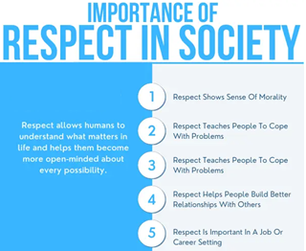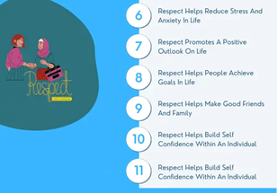
Taken from www.curiousdesire.com

Respect comes down to accepting somebody for who they are regardless of your differences. Even if you don’t agree with them.
Respect in any relationship builds feelings of trust, safety, and wellbeing.
Everyone wants to be respected, if you treat others with respect, they will do the same for you.

People who have never interacted with a person who has a mental or physical disability may feel intimidated or unsure of what to say or do. These concerns are understandable, but it’s important to understand people with disabilities should be treated the same as everyone else.
The most important part of interacting with someone who has a disability is seeing that person for who they are, and not what disability that person has. What it boils down to is having a sense of disability awareness and disability etiquette.

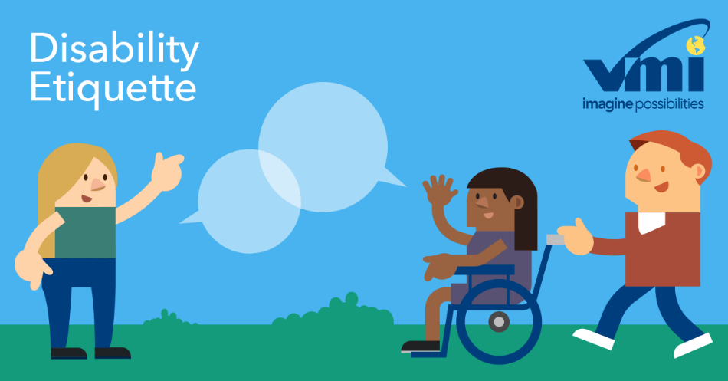

Disability etiquette promotes goodwill and respect among all people. It helps make society more inclusive for everyone.
At some point in our lives, most of us will develop a disability, know someone who has one, or both.

https://www.vantagemobility.com/wp-conte 1

Disability can affect anyone – all ages, genders, ethnic and cultural backgrounds.
People with disabilities have the same fundamental rights as anyone else to ensure full equality under the law. They have some additional rights to protect them from harm or discrimination.
They are no different from you and me, their abilities are just different.

Living with HIV and AIDS
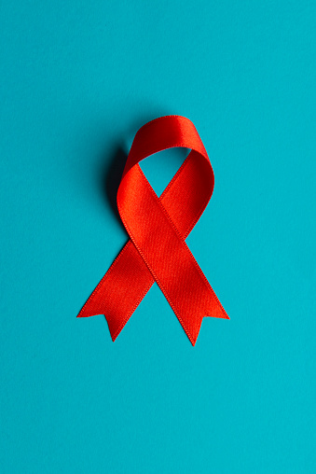
What is HIV?
HIV (human immunodeficiency virus) is a virus that attacks the immune system. The immune system becomes weaker, making it harder for the body to fight off infections.
Most people who are diagnosed early and take medicines for HIV can live long, healthy lives.
What is AIDS?
AIDS (acquired immune deficiency syndrome) happens after someone has had HIV for many years. In AIDS, the immune system is severely weakened. Serious infections and health problems happen. Medicines can help prevent HIV from developing into AIDS.

‘AIDS was a defining feature of the earlier years of the HIV epidemic, before antiretroviral therapy (ART) became available. Now, as more people access ART, the majority of people living with HIV will not progress to AIDS.’
[Taken from https://www.who.int/news-room/questions-and-answers/item/hiv-aids; Accessed on 10th March 2023]

HIV does not discriminate between gender, race, age, or wealth – it can happen to anyone. What we can do is support those around us and in our communities.

HIV and AIDS have an impact on the person living with the diagnosis, but also their families and loved ones.

However, people with HIV can live at home and maintain a normal social life. Since the virus is not spread by casual (day to day, nonsexual) household contact, family members, roommates, and visitors are not at risk of becoming infected.

Friends and family members may experience feelings of fear, confusion, and sadness. It is important for these people to seek expert counseling. There are counselors and many professionals available to listen and give advice for friends and family members of HIV infected persons. Your family doctor, local day clinic, local pharmacy or church leader may be other good sources of information.
There is no reason to cut someone off just because they have the virus or are living with HIV.

Stigma of HIV:
HIV stigma is negative attitudes and beliefs about people with HIV. It is these incorrect beliefs or ideas that lead to labeling an individual as part of a group that is believed to be socially unacceptable.

Here are a few examples:
- Believing that only certain groups of people can get HIV.
- Making moral judgments about people who take steps to prevent HIV transmission.
- Feeling that people deserve to get HIV because of their choices.
We can all help end HIV stigma through our words and actions in our everyday lives. Lead others with your supportive behaviors.

How can you provide support to a person who is HIV positive?
- Ask your friend / loved one what you can do to support them in establishing a medication routine and sticking to it.
- You can ask what other needs they might have and how you can help them stay healthy. Learn more about treatment and how to stick to a treatment plan.
- It is possible for people who are infected with HIV to live long healthy lives.

You can help those who are infected by:
- showing love, respect, and support.
- knowing the facts about HIV/AIDS and talking openly about the disease.
- helping to reduce stress and stressful situations.
- helping to provide balanced and nutritious meals.
- encouraging them to get treatment if they are sick. Most infections are easily treated and cured, even if a person is HIV positive.

Lesson 3
Celebrations of National and International Days

South Africans enjoy public holidays; we celebrate our constitution, landmarks in our political and cultural history. Public holidays serve as reminders of the struggles that South Africa has overcome and the sacrifices that were made by many.
We have national holidays to honour, memorialise and remember some of our country's most important sacrifices, and events.

Human Rights Day: 21st March
On this day in 1960, the police killed 69 people at Sharpeville who were participating in a protest against the pass laws. Many protesters were shot in the back. The carnage made world headlines. Four days later, the government banned Black political organizations and many leaders were arrested or went into exile.
During the Apartheid era, there were human rights abuses by all sides; the remembrance of Human Rights Day is but one step to ensure that the people of South Africa are aware of their human rights and to ensure that such abuses never again occur.

Freedom Day: 27th April
This was the day in 1994 when the first democratic election was held in South Africa, an election when all adults could vote irrespective of their race, as well as the day in 1997 when the new constitution took effect.

Heritage Day: 24th September
Nelson Mandela used the phrase "rainbow nation" to describe South Africa's diverse cultures, customs, traditions, histories, and languages. This day is a celebration of that diversity.
This day not only recognises but also celebrates the cultural wealth of our nation. South Africans celebrate the day by honouring cultural heritage and the exciting and diverse cultures that make up the population of South Africa.

Reconciliation Day: 16th December
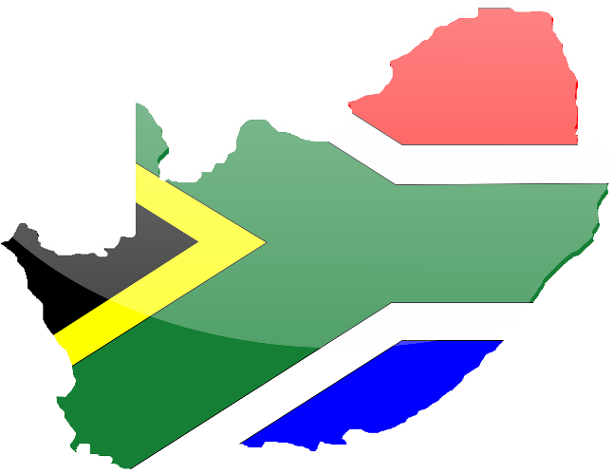
The Day of Reconciliation has been created to mark the end of apartheid. This day has been in existence since 1995. The purpose of this day was to show unity and reconciliation across the country. The reason the date was selected is that it is significant to both African and Afrikaans cultures.
Afrikaners traditionally celebrated December 16 as the Day of the Vow, remembering the day in 1838 when a group of Voortrekkers defeated a Zulu army at the Battle of Blood River, while ANC activists commemorated it as the day in 1961 when the ANC started to arm its soldiers to overthrow Apartheid.
In the new South Africa, it's, a day to focus on overcoming past conflicts and building a new nation.

Youth Day: 16th June
On June 16, 1976, students in Soweto rioted in protest against the introduction of Afrikaans as the language of instruction of half their school curriculum, sparking eight months of violent uprisings across the country. Youth Day is a national holiday in honour of all the young people who lost their lives in the struggle against Apartheid and Bantu Education.

Workers Day: 1st May
Originally born from the struggle for workers’ rights and social justice of the late 1800s, Workers’ Day has been an international holiday in many countries since 1891.
Workers’ Day has been officially recognised and observed since the first democratic elections in 1994.
Workers’ Day in South Africa holds its own cultural significance, as the public holiday has come to signify not only the sacrifices made on the long road toward fair employment standards but also the struggle against Apartheid.

Women’s Day: 9th August
On this day in 1956, some 20,000 women marched to the Union government Buildings in Pretoria to protest a law requiring Black women to carry passes. This day is celebrated as a reminder of the contribution made by women to society, the achievements that have been made for women's rights, and to acknowledge the difficulties and prejudices many women still face.

Africa Day: 25th May
Africa Day is celebrated every year on 25 May. It allows for celebration diversity of the African continent highlighting the cultural and economic potential that exists on the African continent.

Nelson Mandela Day: 18th July
Nelson Mandela International Day is an annual international day to honour of Nelson Mandela, celebrated each year on 18 July, Mandela's birthday. In 2009, it was decided that it would be an international day (by the United Nations) and the first Mandela Day was held on 18 July 2010.

Mandela Day is celebrated to inspire people to embrace values such as democracy and contribute towards the ideals of ensuring a just and fair society. President Jacob Zuma first introduced the concept of Nelson Mandela Day in 2009, to motivate a nationwide campaign to get the public involved in charitable activities
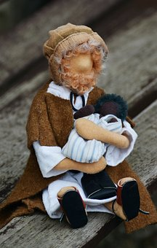
World Refugees Day: 20th June
An international day designated by the United Nations to honour refugees around the globe. It recognises the strength and courage of people who have had to leave their home country to escape conflict or persecution. World Refugee Day is an occasion to build empathy and understanding for their plight and to recognize their resilience in rebuilding their lives.
World Refugee Day is held every year on 20 June. It is a special day when the world takes time to recognise the resilience of forcibly displaced people throughout the world.
It is celebrated annually to honour the courage, strength and determination of women, men and children who are forced to flee their homes under threats of persecution, conflict and violence. On this day, the international community seeks to draw attention to the plight of refugees and celebrate their courage and resilience.

National Health Days:
What is the purpose of National health Days?
The purpose of World Health Day is to create awareness about health care and working conditions, and through training and support, aims to better equip health practitioners to provide better health services.
Awareness is essential for prevention, early detection, targeted therapy and is key to ensuring effective treatment. Being aware of a disease and its symptoms will allow people to take preventative action by going for screenings, testing and check-ups.
Examples include: World Cancer Day (4 February), International Epilepsy Day (13 February), World TB Day (24 March), World Malaria Day (25 April), World Hygiene Day (5 May), World Hypertension Day (17 May) etc [Taken from https://www.health.gov.za/wp-content/uploads/2023/01/Health-Awareness-Calendar-2023_compressed.pdf]

