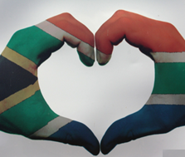
Constitutional Rights and Responsibilities
Final Reflection
Term 2: Week 1 - 3

Final Reflection
Answer these reflections as best you can:
What I learnt about in these lessons:

The most important thing I learnt about my country was…

How I feel I have performed in these lessons:

What can I do better next time?
Questions I still have:

