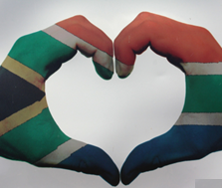
Activity 1:
Constitutional Rights and Responsibilities
Lesson 3 - Worksheet MEMORANDUM
Term 2: Week 1 - 3
South Africa has many public holidays. It also has other days that are not public holidays but are celebrated as national days. One example of this is the 18th of July. The 18th of July is now celebrated, both in South Africa and abroad, as Mandela Day, because it is Nelson Mandela’s birthday. The day was first celebrated in 2009, when Nelson Mandela celebrated his 91st birthday.
National days are important, because they celebrate an important part of the nation’s history.

Match the national day on the left with the concept it celebrates on the right. Then write the matching symbol in the grid below.

National day |  | Concept
1 | Human Rights Day 21 March | A | A newly created public holiday that recognises aspects of South African culture, such as creative expression, our historical inheritance, language, the food we eat and the land we live in.
2 | Freedom Day  27 April | B | The anniversary of the Soweto Uprising in 1976.
3 | Worker’s Day  1 May | C | The anniversary of the Sharpville Riots in 1961.
4 | Youth Day  16 June | D | Marks end of Apartheid and beginning of a new era for South Africa,
5 | National Women’s Day  9 August | E | The anniversary of the first democratic elections in 1994.
6 | Heritage Day  24 September | F | The anniversary of the march to Pretoria in 1952 by thousands of women who were protesting against the Pass laws.
7 | Day of Reconciliation  16 December | G | A national day throughout the world that celebrates workers everywhere. In America it is known as Labour Day.

Answer Grid:
Q | Answer:
1 | C
2 | E
3 | G
4 | B
5 | F
6 | A
7 | D

Activity 2:
Examine the list below, categorise each holiday into the block below. You can categorise each one as National, International or Health Days.

- African Traditional Medicine Day 31 August
- Christmas Day 15 December
- Day of Goodwill 26 December
- Day of Reconciliation 16 December
- Family Day 13 April
- Freedom Day 27 April
- Health Lifestyle Awareness Day 17 February
- Heritage Day 24 September
- Human Rights Day 21 March
- National Women’s Day 9 August
- New Year’s Day 1 January
- Worker’s Day 1 May
- World Alzheimer’s Day 21 September
- World Braille Day 4 January
- World Refugee Day 20 June
- World Stroke Day 29 October
- Youth Day 16 June

National Days | International Days | Health Days
Day of Reconciliation 16 December  Family Day 13 April  Freedom Day 27 April  Heritage Day 24 September  Human Rights Day 21 March  National Women’s Day 9 August  Worker’s Day 1 May  Youth Day 16 June | Christmas Day 15 December  Day of Goodwill 26 December  World Refugee Day 20 June  New Year’s Day 1 January | Health Lifestyle Awareness Day 17 February  African Traditional Medicine Day 31 August  World Alzheimer’s Day 21 September  World Braille Day 4 January  World Stroke Day 29 October

Activity 3:
Read the following extract from an article about the very first Nelson Mandela Day.
This article by Sashni Pather, Dominic Mahlangu and Gabisili Ndebele appeared in The Times on Friday 17July 2009.

Madiba rests while world works.
While the world marks the first Nelson Mandela Day, the former president will be resting at home. Tomorrow, July 18, marks Mandela’s 91st birthday.
People around the globe are encouraged – and many have already pledged – to spend 67 minutes of their time doing community work. The initiative was created by the 46664 campaign and the Nelson Mandela Foundation.
Ruth Rensburg, Resource Development Manager of the Nelson Mandela Foundation, said that Mandela was ‘honoured’ by the world-wide initiatives. “But he will be spending the day, as he has in recent years, at home surrounded by friends, family and comrades,” she said.
In a recorded interview, Madiba said: “It is in your hands to create a better world for all who live in it. Mandela Day will not be a holiday, but a day created to service.”

Answer the following questions, using your own words:

- Is Mandela Day a public holiday?
- What is your opinion of the way Mandela Day is to be celebrated?
- How would you spend your 67 minutes celebrating Mandela Day?

Solutions

- It was not to be a public holiday, but a day devoted to helping others.
- Learner will provide personal responses to this question
- Learner will provide personal responses to this question

Activity 4:
Study the image below and answer the questions that follow.

[Taken from https://medium.com/@sameerkang/the-
denial-of-choice-hiv-aids-and-stigma-b42fa0b30a57
Accessed 20 February 2022]
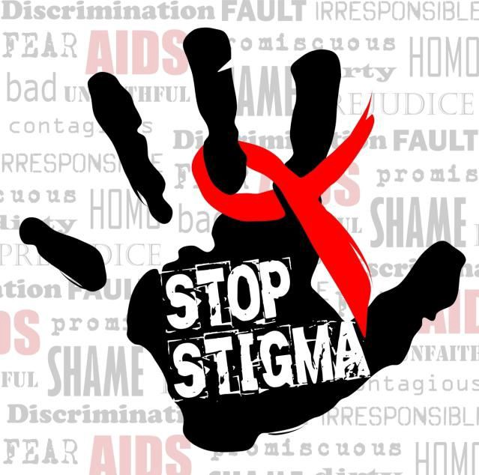

Write paragraphs on HIV discrimination.
Use the following as a guideline.
- Define the term ‘stigma”. Provide an example of a stigma related to HIV. (1+1) (2)

A mark of disgrace associated with a particular circumstance, quality, or person. ✔
Any ONE of the below for ONE mark

- Getting HIV is a punishment for bad behaviour✔
- People with HIV have themselves to blame✔
- Person with HIV must have done something wrong to deserve it✔
- People with HIV should be ashamed of themselves✔
- If you drink from a tap/share cutlery/crockery with person with HIV, you will
get it too✔
- HIV is a death sentence✔

- Explain TWO reasons why HIV discrimination can have dangerous health impacts. (2x2) (4)

Any TWO of the below for TWO marks each
(i.e. ONE mark for statement and ONE mark for qualifier / explanation)

- As people will keep their status quiet ✔and not get support they need ✔
- They may not get treatment ✔ and thus get sicker without ARVs ✔
- Denial may mean that they do not get tested ✔ this could mean that they infect other people✔

- Recommend TWO ways in which learners can challenge stigmas that relate to HIV discrimination.
(2x2) (4)
Any TWO of the below for TWO marks each
(i.e. ONE mark for statement and ONE mark for qualifier / explanation)
- Learn which words have negative meanings for people at risk for or living with HIV and which are empowering✔ this will ensure that we use supportive language rather than stigmatising ✔
- Reducing stigma and discrimination by offering support and speaking out to correct myths and stereotypes about HIV that you hear from others✔ This can assist you and others ✔
- Get the facts✔ This will help you know where to place your efforts and what to challenge✔
- Speak to people who are HIV positive ✔ This can give you a personal experience as well as challenge some of your preconceived ideas ✔
- Give your time to HIV-related efforts. ✔ This will help you to normalise HIV positive people and support of them✔
[10]

