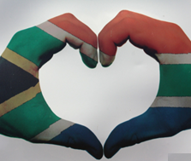
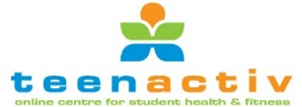
Constitutional Rights and Responsibilities
CRR
Term 2: Week 1 - 3

Dear Life Orientation Teachers,
This Lesson Plan covers the following subtopics as per the 2023-2024 ATP:
- Issues relating to citizens’ rights and responsibilities.
- Respect for others’ rights: People living with different disabilities and HIV & AIDS (infected and affected)
- Celebrations of national and international days: Human Rights Day, Freedom Day, Heritage Day, Reconciliation Day, Youth Day, Worker’s Day, Women’s Day, Africa Day, Nelson Mandela Day, World Refugees’ Day, and National health days.
- Plan and participate in a local celebration of a national day.

This Lesson Preparation is made up of the following documents:
- Lesson Preparation (including Teaching Notes)
- Lesson 1 - PowerPoint
- Lesson 1 – Worksheet
- Lesson 1 – Worksheet MEMO
- Lesson 2 - PowerPoint
- Lesson 2 - Worksheet
- Lesson 2 - Worksheet MEMO
- Lesson 3 - PowerPoint
- Lesson 3 - Worksheet
- Lesson 3 - Worksheet MEMO
- Lesson 3 - Reflection
- Content Summary

Lesson Breakdown:

Week 1 | Week 2 | Week 3
- Issues relating to citizens’ rights and responsibilities. | - Respect for others’ rights: People living with different disabilities and HIV & AIDS (infected and affected) | - Celebrations of national and international days: Human Rights Day, Freedom Day, Heritage Day, Reconciliation Day, Youth Day, Worker’s Day, Women’s Day, Africa Day, Nelson Mandela Day, World Refugees’ Day and National health days.

LESSON PREPARATION:
TERM 2: Week 1 – 3
3 x 40-minute lessons

Lesson Number | Content | Teaching Plan | Time Allocation | Resources | Assessment | Learner Activities
1 | Issues relating to citizens’  rights & responsibilities. | Introduction to new content | 2 min | Content Summary + Teacher Notes  Lesson 1 - PowerPoint (Slides 1 – 3) |  | Class Discussion with learner input
1 | Issues relating to citizens’  rights & responsibilities. | Body:  What are Human Rights?  In this video we will learn What are Human Rights and why Human Rights are important. | 5 min | Content Summary + Teacher Notes  Lesson 1 - PowerPoint (Slide 4)  https://www.youtube.com/watch?v=IOph2frvAPs (2 min 41 sec)  In this video we will learn What are Human Rights and why Human Rights are important.  This video explains in a simple and clear way what human rights are and why human rights are important. | Informal | Class Discussion with learner input
1 | Issues relating to citizens’  rights & responsibilities. | Why are Human Rights important? | 20 - 25 min | Content Summary + Teacher Notes  Lesson 1 - PowerPoint (Slide 5) |  | Class Discussion with learner input
1 | Issues relating to citizens’  rights & responsibilities. | Rights & responsibilities: | 20 - 25 min | Content Summary + Teacher Notes  Lesson 1 - PowerPoint (Slide 6) |  | Class Discussion with learner input
 |  |  |  |  |  | Class Discussion with learner input
1 | Issues relating to citizens’  rights & responsibilities. | SA Constitution - where rights come from | 20 - 25 min | Content Summary + Teacher Notes  Lesson 1 - PowerPoint (Slide 7)  South Africa’s Constitution:  https://www.youtube.com/watch?v=q7LKSns5TiU (3 min 29 sec)  Content Summary + Teacher Notes  Lesson 1 - PowerPoint (Slides 8 – 9) |  | Class Discussion with learner input
1 | Issues relating to citizens’  rights & responsibilities. | Tolerance | 20 - 25 min | Content Summary + Teacher Notes  Lesson 1 - PowerPoint (Slide 10) |  | Class Discussion with learner input
1 | Issues relating to citizens’  rights & responsibilities. | Conclusion | 5 – 10  min | Lesson 1 - PowerPoint (Slide 11)  Any Questions  Lesson 1 – Worksheet (Activity 1) | Informal | Lesson 1 -Worksheet

Lesson Number | Content | Teaching Plan | Time Allocation | Resources | Assessment | Learner Activities
2 | Respect for others’ rights: people living with different disabilities and HIV / AIDS (infected and affected) | Introduction to new content | 2 - 3  min | Content Summary + Teacher Notes  Lesson 2 - PowerPoint (Slide 1) |  | Class Discussion with learner input
2 |  | Body:  Respect – what it means, importance | 18-20  min | Content Summary + Teacher Notes  Lesson 2 - PowerPoint (Slides 2 – 5)  Watch: Respect and Tolerance:  https://www.youtube.com/watch?v=ArNrrmprUZ0 (1 min 39 sec) |  | Class Discussion with learner input
2 |  | Meaning of term “disability’” | 18-20  min | Content Summary + Teacher Notes  Lesson 2 - PowerPoint (Slides 6 – 7)  Disabilities: How to cope with them & support others:  https://www.youtube.com/watch?v=hjvmAUbfXdw (2 min 23 sec) |  | Class Discussion with learner input
2 |  | Class discussion – respect one another | 18-20  min | Content Summary + Teacher Notes  Lesson 2 - PowerPoint (Slide 8) |  | Class Discussion with learner input
2 |  | HIV / AIDS | 18-20  min | Content Summary + Teacher Notes  Lesson 2 - PowerPoint (Slides 9 -11)  Living with HIV:  https://www.youtube.com/watch?v=IfBPQrmBwbA (3 min 10 sec) |  | Class Discussion with learner input
2 |  | HIV Stigma | 18-20  min | Content Summary + Teacher Notes  Lesson 2 - PowerPoint (Slide 12) |  | Class Discussion with learner input
2 |  | Supporting people with HIV | 18-20  min | Content Summary + Teacher Notes  Lesson 2 - PowerPoint (Slide 13) |  | Class Discussion with learner input
2 |  | Conclusion – and questions | 10 min | Content Summary + Teacher Notes  Lesson 2 - PowerPoint (Slide 14)  Lesson 2 – Worksheet (Activity 1&2) | Informal | Lesson 2 -Worksheet

Lesson Number | Content | Teaching Plan | Time Allocation | Resources | Assessment | Learner Activities
3 | Celebrations of national and international days:  Plan and participate in a local celebration of a national day. | Introduction to new content and Class Discussion - Public Holidays | 3 – 5 min | Content Summary + Teacher Notes  Lesson 3 - PowerPoint (Slides 1 – 3) |  | Class Discussion with learner input
3 |  | Human Rights Day | 20 – 25 min | Content Summary + Teacher Notes  Lesson 3 - PowerPoint (Slide 4) |  | Class Discussion with learner input
3 |  | Freedom Day | 20 – 25 min | Content Summary + Teacher Notes  Lesson 3 - PowerPoint (Slide 5)  Know your history: Freedom Day:  https://www.youtube.com/watch?v=gCor9Gg-Vhw (1 min 19 sec) |  | Class Discussion with learner input
3 |  | Heritage Day | 20 – 25 min | Content Summary + Teacher Notes  Lesson 3 - PowerPoint (Slide 6) |  | Class Discussion with learner input
3 |  | Reconciliation Day | 20 – 25 min | Content Summary + Teacher Notes  Lesson 3 - PowerPoint (Slide 7) |  | Class Discussion with learner input
3 |  | Youth Day | 20 – 25 min | Content Summary + Teacher Notes  Lesson 3 - PowerPoint (Slide 8)  Why do we celebrate Youth Day?  https://www.youtube.com/watch?v=XxgqSWapzLo (2 min 09 sec) |  | Class Discussion with learner input
3 |  | Worker’s Day | 20 – 25 min | Content Summary + Teacher Notes  Lesson 3 - PowerPoint (Slide 9) |  | Class Discussion with learner input
3 |  | Women’s Day | 20 – 25 min | Content Summary + Teacher Notes  Lesson 3 - PowerPoint (Slide 10) |  | Class Discussion with learner input
3 |  | Africa Day | 20 – 25 min | Content Summary + Teacher Notes  Lesson 3 - PowerPoint (Slide 11) |  | Class Discussion with learner input
3 |  | Nelson Mandela Day | 20 – 25 min | Content Summary + Teacher Notes  Lesson 3 - PowerPoint (Slide 12)  Mandela Day:  https://www.youtube.com/watch?v=iiqFMx1_abc (2 min 39 sec) |  | Class Discussion with learner input
3 |  | World Refugee Day | 20 – 25 min | Content Summary + Teacher Notes  Lesson 3 - PowerPoint (Slide 13) |  | Class Discussion with learner input
3 |  | National Health Days | 20 – 25 min | Content Summary + Teacher Notes  Lesson 3 - PowerPoint (Slide 14) |  | Class Discussion with learner input
3 |  | Group Discussion – all the holidays and how learners celebrate different holidays in their families. | 10 – 15 min | Content Summary + Teacher Notes  Lesson 3 - PowerPoint (Slide 15)  South African Public Holidays in 2023:  https://www.youtube.com/watch?v=Ic4tdiETK78 (1 min 27 sec) |  | Class Discussion with learner input
3 |  | Informal Assessment Activity |  | Content Summary + Teacher Notes  Lesson 3 - PowerPoint (Slide 16)  Lesson 3 – Worksheet (Activity 1, 2, 3, 4) | Informal | Lesson 3 - Worksheet
3 |  |  |  | Lesson 3 - Reflection | Informal / Self-Assessment | Reflection Activity

INTRODUCTORY NOTES:

The Lesson 1 – PowerPoint, Lesson 2 – PowerPoint, Lesson 3 – PowerPoint and
documents together cover the THREE lessons and have detailed notes for each slide that will guide you (the teacher) through the activity. Use the below LESSON PREPARATION to assist regarding your time frame.

The following notes will be a summary of the THREE LESSONS:

These lessons have also been set up to create a lot of opportunity for learner interaction during the lessons. Learners can complete the worksheets while working through the respective PowerPoints.

Each Lesson Worksheet (e.g., Lesson 1 - Worksheet) serves as an informal assessment to determine if a learner understands the concepts covered in that lesson.

Before teaching this module, take time to watch the referenced YouTube clips (links below) and go through each PowerPoint Presentation, Worksheet, Worksheet Memo, and the Content Summary – to prepare yourself thoroughly to teach each lesson. The Content Summary along with the Lesson Preparation will be used to teach this section.

As the educator, make sure:
- Learners must know that the classroom is SAFE PLACE, and everyone must show respect for one another and their differences as well as questions that they may have.

- You could encourage learners to write down all questions that they may have and would like to know more about.

- Concepts must be used to consolidate your teaching and you should always monitor the learners’ understanding of the concepts.

- Manage this topic in such a way to accommodate barriers to learning and teaching, different age groups and experiences as well as language.
To accommodate all language levels of learners is not possible, the language competency levels of learners is too diverse, however, you should aim to facilitate in such a way that meaningful learning does take place.

** TEACHER NOTE: Please work through each lesson in such a way to leave sufficient time at
end of each lesson for learners to complete the activities in the Worksheets
(e.g. Lesson 1 – Worksheet).
These include opportunities for informal assessment.
MEMO with answers is provided for each Worksheet.


YouTube:
If you prefer, videos can be downloaded beforehand.
Use the link below - if you do not have a programme to download from YouTube: https://www.ytddownloader.com
The https://www.ytddownloader.com also cuts out ads if you are not using the paid version of YouTube.
[Alternatively, cue up the relevant videos so everything is ready to
go before the lesson.]

Links:
Lesson 1
What are human rights?
https://www.youtube.com/watch?v=IOph2frvAPs (2 min 41 sec)

What are rights and responsibilities?
https://www.youtube.com/watch?v=4IEzjE6hquc (3 min 46 sec)

South Africa’s Constitution:
https://www.youtube.com/watch?v=q7LKSns5TiU (3 min 29 sec)

Lesson 2
Disabilities: How to cope with them & support others:
https://www.youtube.com/watch?v=hjvmAUbfXdw (2 min 23 sec)

Respect and Tolerance:
https://www.youtube.com/watch?v=ArNrrmprUZ0 (1 min 39 sec)

Living with HIV:
https://www.youtube.com/watch?v=IfBPQrmBwbA (3 min 10 sec)

Lesson 3
Know your history: Freedom Day:
https://www.youtube.com/watch?v=gCor9Gg-Vhw (1 min 19 sec)

Why do we celebrate Youth Day?
https://www.youtube.com/watch?v=XxgqSWapzLo (2 min 09 sec)

Mandela Day:
https://www.youtube.com/watch?v=iiqFMx1_abc (2 min 39 sec)

South African Public Holidays in 2023:
https://www.youtube.com/watch?v=Ic4tdiETK78 (1 min 27 sec)

Lesson 1
Preparation (Prior to Lesson):
- Remind learners to have their notebooks available to make notes where relevant.
- Print copies of Lesson 1 - Worksheet for learners and Lesson 1 - Worksheet MEMO for yourself.
- Teacher can share with learners to work through on their own if learners are online.
- Familiarise yourself with the activity portions of the lesson beforehand.
- Watch suggested video clips to familiarise yourself with the content:
What are human rights?
https://www.youtube.com/watch?v=IOph2frvAPs (2 min 41 sec)
What are rights and responsibilities?
https://www.youtube.com/watch?v=4IEzjE6hquc (3 min 46 sec)
South Africa’s Constitution:
https://www.youtube.com/watch?v=q7LKSns5TiU (3 min 29 sec)

PowerPoint 1

Lesson | Breakdown | Slide
1  1  1  1 | Introduce the new topic: CONSTITUTIONAL RIGHTS AND RESPONSIBILITIES. | 1
1  1  1  1 | Lesson 1: Issues relating to citizens’ rights and responsibilities. | 2
1  1  1  1 | This lesson will start off with what these terms mean and checking to see if learners really understand what they mean.  Ask the class if they know what rights are, and more specifically human rights as well as responsibilities. This will give you an indication of what they already know and remember. | 3
1  1  1  1 | Watch video: What are human rights.  What are human rights?  https://www.youtube.com/watch?v=IOph2frvAPs (2 min 41 sec)  In this video we will learn What are Human Rights and Why Human Rights are important.  This video explains in a simple and clear way what human rights are and why human rights are important. | 4
1  1  1  1 | Ask the class what they thought of the video and if they agree with the statements made. Did they already have the right idea?  While some dictionaries define the word right as “a privilege,” when used in the context of “human rights,” we are talking about something more basic.  Every person is entitled to certain fundamental rights, simply by the fact of being human. These are called “human rights” rather than a privilege.  They are “rights” because they are things you are allowed to be, to do or to have. These rights are there for your protection against people who might want to harm or hurt you. They are also there to help us get along with each other and live in peace.  A discussion point is WHY ARE HUMAN RIGHTS IMPORTANT?  Teacher Note: Be mindful of time constraints – select how many of the below you decide to discuss.  Here are some answers:  Human rights ensure people have basic needs met:  Everyone needs access to medicine, food and water, clothes, and shelter. By including these in a person’s basic human rights, everyone has a baseline level of dignity. Unfortunately, there are still millions of people out there who don’t have these necessities, but saying it’s a matter of human rights allows activists and others to work towards getting those for everyone.  Human rights protect vulnerable groups from abuse:  The Declaration of Human Rights was created largely because of the Holocaust and the horrors of WII. During that time in history, the most vulnerable in society were targeted along with the Jewish population, including those with disabilities and LGBT.  Human rights encourage freedom of speech and expression:  It encompasses ideas and forms of expression that not everybody will like or agree with, but no one should ever feel like they are going to be in danger from their government because of what they think. It goes both ways, too, and protects people who want to debate or argue with certain ideas expressed in their society.  Human rights give people the freedom to practice their religion (or not practice any):  Religious violence and oppression occur over and over again all across history, from the Crusades to the Holocaust to modern terrorism in the name of religion. Human rights acknowledge the importance of a person’s religion and spiritual beliefs and lets them practice in peace.  Human rights allow people to love who they choose:  The importance of freedom to love cannot be understated. Being able to choose what one’s romantic life looks like is an essential human right. The consequences of not protecting this right are clear when you look at countries where LGBT people are oppressed and abused, or where women are forced into marriages they don’t want.  Human rights give people access to education:  Education is important for so many reasons and is crucial for societies where poverty is common. Organizations and governments concerned with human rights provide access to schooling, supplies, and more in order to halt the cycle of poverty. Seeing education as a right means everyone can get access, not just the elite.  Human rights protect the environment:  We live in the world, we need the land, so it makes sense that what happens to the environment impacts humanity. The right to clean air, clean soil, and clean water are all as important. | 5
1  1  1  1 | What are Rights & Responsibilities?  A right is a choice to make your own opinion and entitlement to things such as education, religion and freedom of speech.  Responsibilities are duties or something an individual should do such as following the law and rules.  Rights vs. Responsibilities  There is a common misconception about the interpretation of rights and responsibilities. At first glance, it may look like the two terms are interchangeable. However, they are not.  For example: You have a right to a neat classroom, BUT your responsibility would be not to litter in the classroom.  Learners need to understand that the TWO go hand in hand. Consider that rights give freedom, so our responsibility as a community would be to give access to people living with a disability to libraries (do we cater for blind people?)  Discussing Right and Responsibilities in the Classroom:  - Must a teacher accommodate a learner that have a disability in class?  - How do we respect a person living with HIV in our school?  - Can you think of times when a human's rights have been disrespected and why do people behave in this way?  - Can people avoid behaving unfairly and disrespecting people's rights?  - Do teachers and adults have different rights and responsibilities to adults?  You could ask learners what they think rights in the classroom could be:  Examples of Rights in the Classroom  - Receive a broad and balanced education.  - Receive good quality teaching materials.  - Receive a caring and kind education from teachers and adults.  - build friendships and work well with others.  The class could then collectively decide what their responsibilities should be within the classroom. | 6
1  1  1  1 | 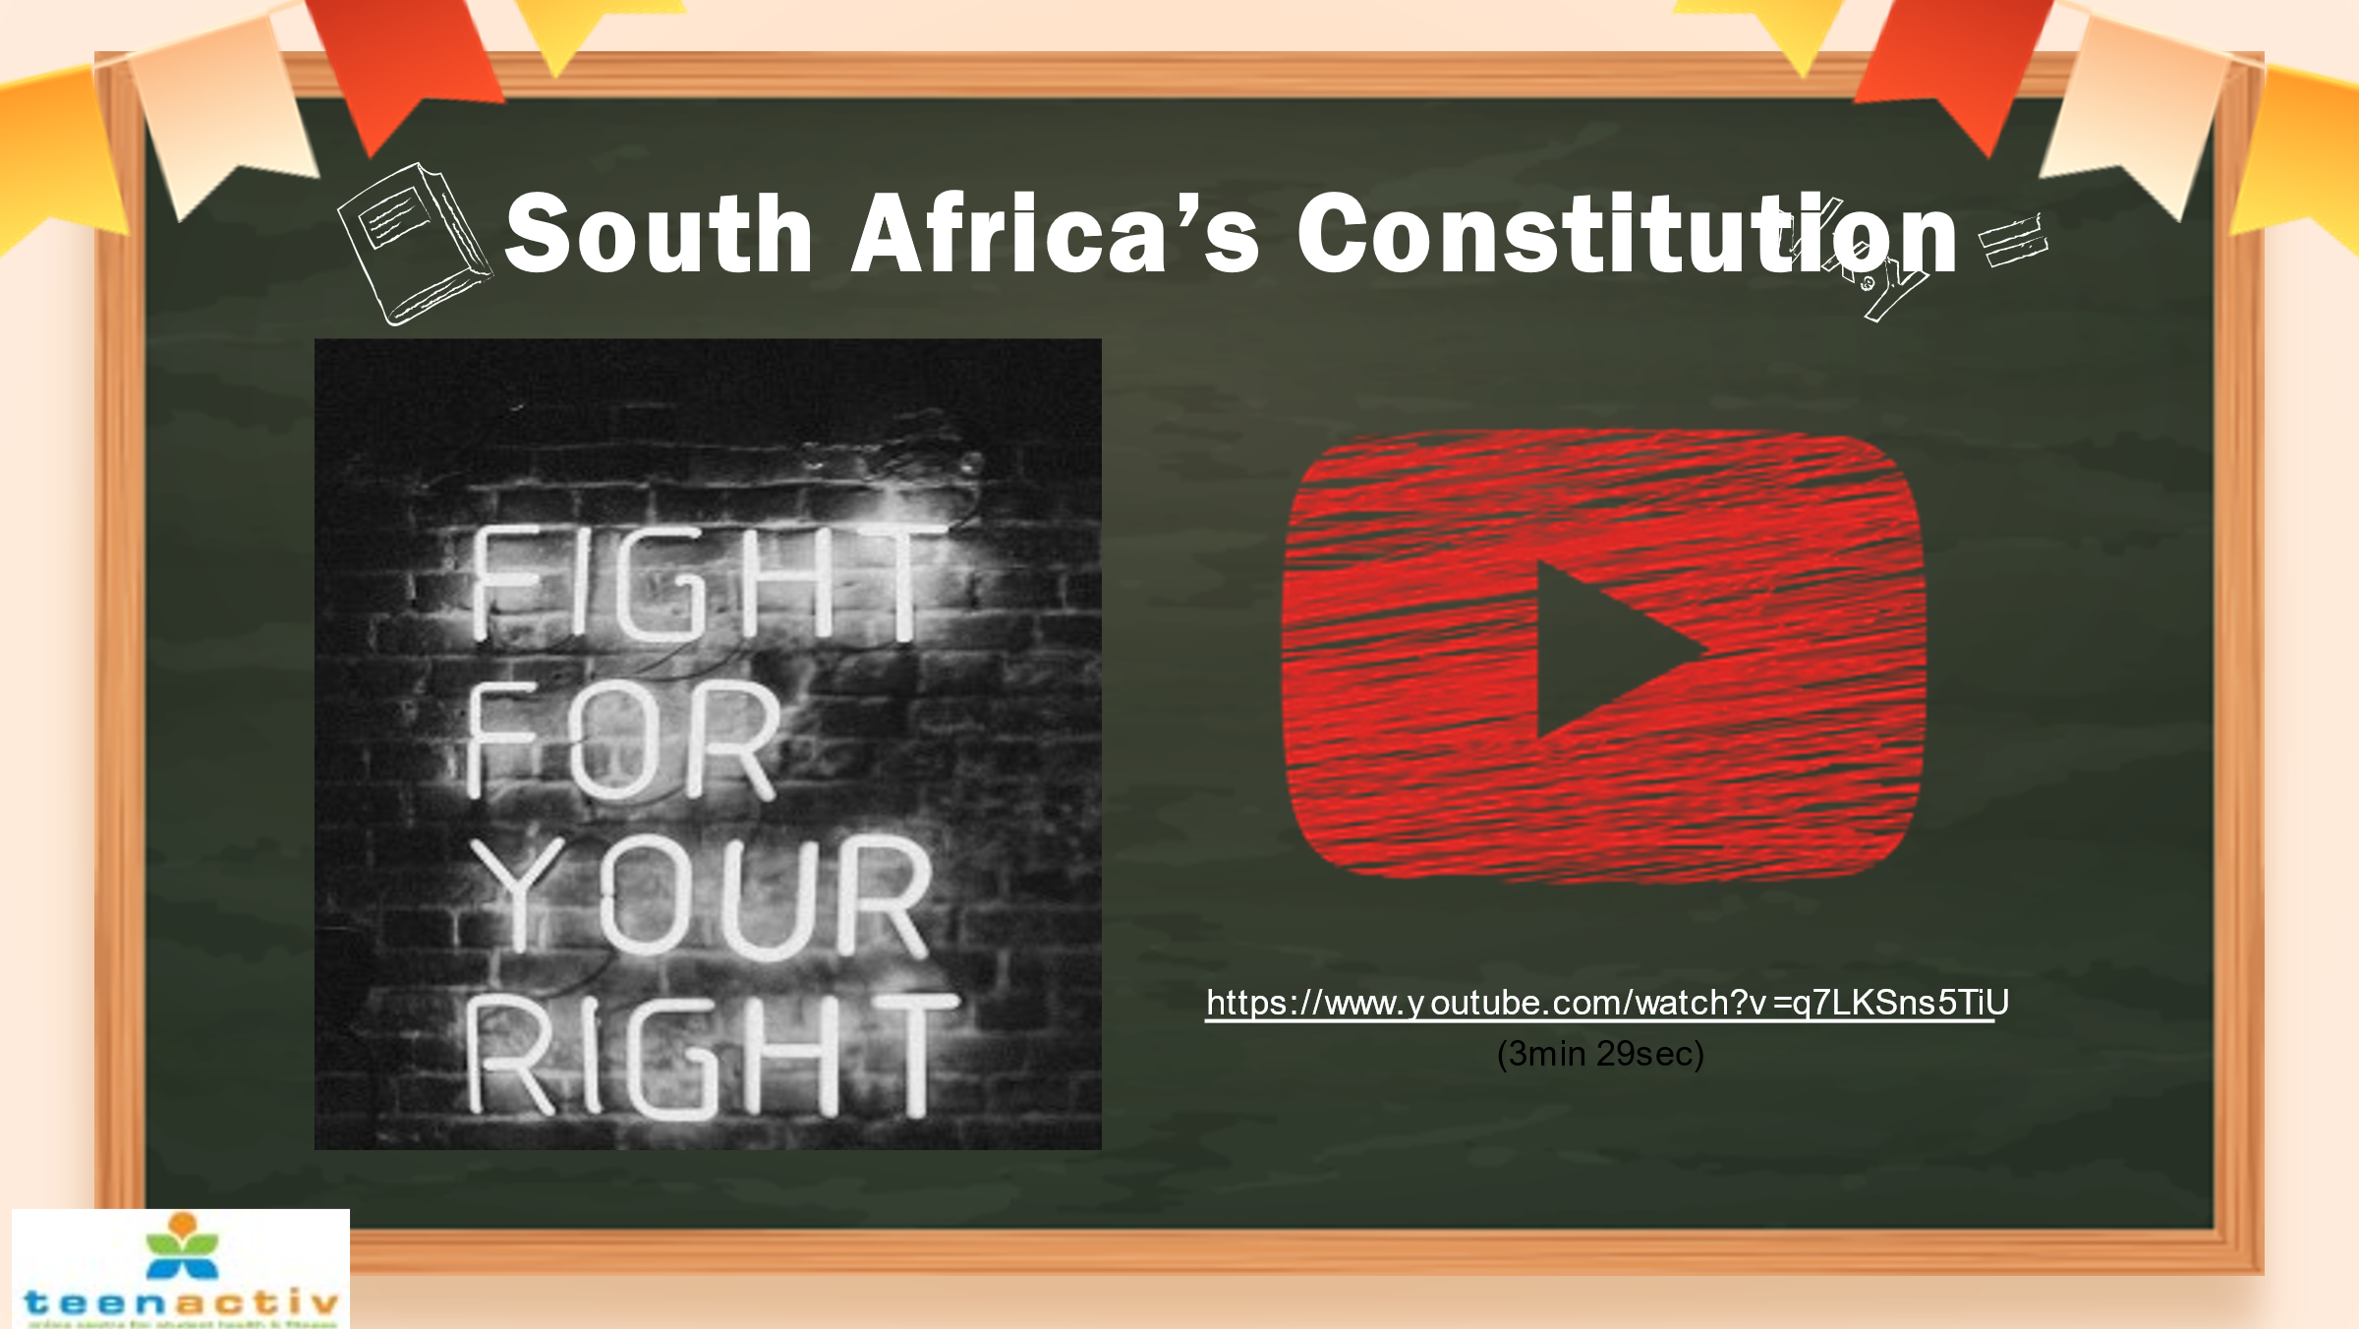  Watch video: South Africa’s Constitution (this will help with where rights come from).  (AND prepares well for the Grade 9 Term 2 Week 4-5 Topic)  South Africa’s Constitution:  https://www.youtube.com/watch?v=q7LKSns5TiU (3 min 29 sec) | 7
1  1  1  1 | The beginning of our Constitution starts with the following:  ‘We, the people of South Africa,  Recognise the injustices of our past;  Honour those who suffered for justice and freedom in our land;  Respect those who have worked to build and develop our country; and  Believe that South Africa belongs to all who live in it, united in our diversity.’  Ask the class which words in the preamble jump out? | 8
1  1  1  1 | It's important that we know and understand what rights and responsibilities are, what human rights are and where they come from.  It is of the utmost importance that we have respect for one another and for the rights of others and not only ourselves.  Respect is one of the most important elements in society. If people simply had a little more respect for themselves and each other, the world would be a better place to live in. | 9
1  1  1  1 | Tolerance  A word we know but again, what does it mean to be tolerant or practice tolerance? Is it the same as respect?  How can we be tolerant and respectful of others?  Tolerance is about respecting other people as equal citizens and human beings, and respecting their viewpoints. Disagreements about our values and beliefs are inevitable, and they are acceptable, so long as we can maintain mutual respect toward others as equal citizens and fellow human beings.  Many South Africans have dedicated their lives to the fight for human rights and it is important that we honor their work and create a culture of human rights in South Africa. We will learn about some of these people and what has happened in our history that lead to different public holidays. | 10
1  1  1  1 | Reflection Activity: Use this time to reflect on today’s lesson and complete the activities in Lesson 1 - Worksheet.  If you have any questions, you can write them down for me to answer. | 11

Lesson 2
Preparation (Prior to Lesson):
- Remind learners to have their notebooks available to make notes where relevant.
- Print copies Lesson 2 - Worksheet for learners and Lesson 2 - Worksheet MEMO for yourself.
- Teacher can share with learners to work through on their own if learners are online.
- Familiarise yourself with the activity portions of the lesson beforehand.
- Watch suggested video clips to familiarise yourself with the content:
Respect and Tolerance:
https://www.youtube.com/watch?v=ArNrrmprUZ0 (1 min 39 sec)
Disabilities: How to Cope With Them & Support Others:
https://www.youtube.com/watch?v=hjvmAUbfXdw (2 min 23 sec)
Living with HIV:
https://www.youtube.com/watch?v=IfBPQrmBwbA (3 min 10 sec)
HIV: How to Protect Yourself and Others:
https://www.youtube.com/watch?v=xK-VPgmn-18 (2 min 33 sec)

PowerPoint 2

Lesson | Breakdown | Slide
2  2  2  2  2 | Introduce the new lesson: Respect for others’ rights - People living with different disabilities and HIV & AIDS. | 1
2  2  2  2  2 | Last lesson, we looked at the importance of respect and tolerance. Lets unpack the word respect a bit more.  Respect means that you accept somebody for who they are regardless of your differences. Even if you don’t agree with them.  Respect in any relationship builds feelings of trust, safety and wellbeing.  Everyone wants to be respected, if you treat others with respect, they will do the same for you.  Respect is a word with BIG meaning behind it. | 2
2  2  2  2  2 | The IMPORTANCE of RESPECT  Receiving respect from others is important because it helps us to feel safe and to express ourselves.  Being respected by important people in our lives growing up, teaches us how to be respectful towards others.  Respect doesn’t have to come naturally – it is something you learn. | 3&4
2  2  2  2  2 | Watch: Respect and Tolerance:  https://www.youtube.com/watch?v=ArNrrmprUZ0 (1 min 39 sec)  Lack of open mindedness or accommodating others, leads to fighting, violence, and finally it destroys the peace and security of society. When people fail in their arguments, they become intolerant, and then they use force and aggression to support their point of view.  We have seen considerable incidents in recent history where, because of lack of tolerance, people have attacked people of other faiths, their places of worship, their communities. How nice it would be if everyone tried to express themselves in a decent and respectful way with tolerance.  The world is full of diversity, and that is the beauty of our world and most specifically – our country. If there had not been any diversity, the world would appear boring and unattractive.  Let’s now move the conversation to focus on respecting and being tolerant of people with disabilities. | 5
2  2  2  2  2 | What is the definition of disability?  A disability is any condition of the body or mind (impairment) that makes it more difficult for the person with the condition to do certain activities (activity limitation) and interact with the world around them (participation restrictions).  With that in mind – disabled people include those who have long-term physical, mental, intellectual, or sensory impairments which in interaction with various barriers may hinder their full and effective participation in society on an equal basis with others.  Disability etiquette promotes goodwill and respect among all people. It helps make society more inclusive for everyone.  At some point in our lives, most of us will develop a disability, know someone who has one, or both.  Disability affects everyone – all ages, genders, and ethnic and cultural backgrounds.  People with disabilities have the same fundamental rights as anyone else and full equality under the law. They have some additional rights to protect them from harm or discrimination.  They are no different from you and me, their abilities are just different. | 6
2  2  2  2  2 | 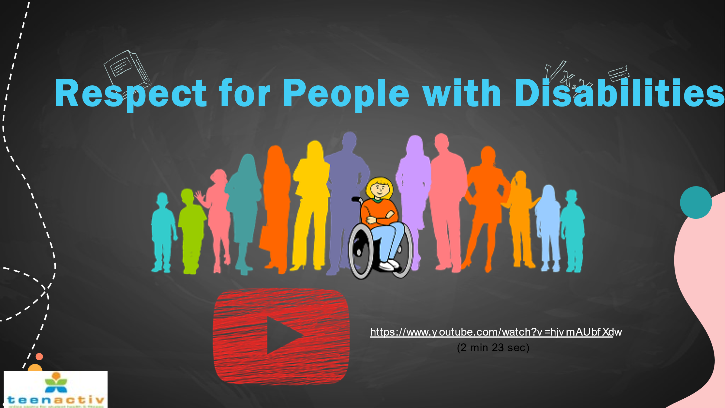  Watch:  Disabilities: How to cope with them & support others:  https://www.youtube.com/watch?v=hjvmAUbfXdw (2 min 23 sec) | 7
2  2  2  2  2 | This is an interesting quote by Ian MacLaren– and it’s important that we realise that as much as we may be going through something, so are others. We may need a little extra care and attention sometimes and so do others.  Next, we will now look at respecting people living with HIV / AIDS | 8
2  2  2  2  2 | Learners have covered HIV and AIDS many times – but it’s still necessary to go over the salient points – get everyone on the same page.  What Is HIV?  HIV (human immunodeficiency virus) is a virus that attacks the immune system. The immune system becomes weaker, making it harder for the body to fight off infections.  Most people who are diagnosed early and take medicines for HIV can live long, healthy lives.  What Is AIDS?  AIDS (acquired immune deficiency syndrome) happens after someone has had HIV for many years. In AIDS, the immune system is severely weakened. Serious infections and health problems happen. Medicines can help prevent HIV from developing into AIDS.  Worth pointing out to learners that:  ‘AIDS was a defining feature of the earlier years of the HIV epidemic, before antiretroviral therapy (ART) became available. Now, as more people access ART, the majority of people living with HIV will not progress to AIDS.’  [Taken from https://www.who.int/news-room/questions-and-answers/item/hiv-aids; Accessed on 10th March 2023] | 9
2  2  2  2  2 | HIV does not discriminate between gender, race, age or wealth – it can happen to anyone.  HIV can affect anyone regardless of sexual orientation, race, ethnicity, gender, age, or where they live. However, certain groups of people may be more likely to get HIV than others because of particular factors, such as risk behaviours for example.  What we can do is support those around us and in our communities.  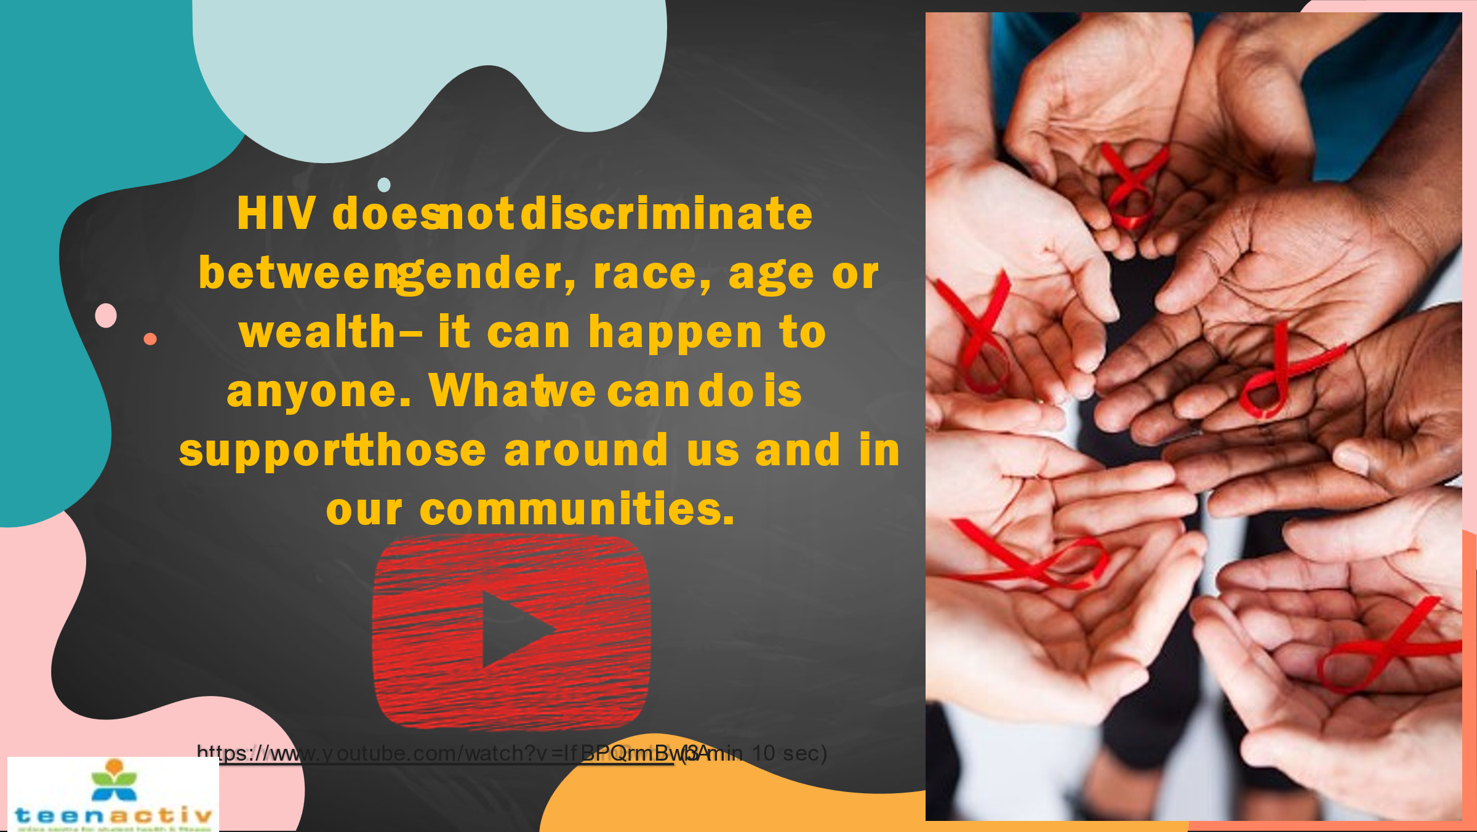  Watch:  Living with HIV:  https://www.youtube.com/watch?v=IfBPQrmBwbA (3 min 10 sec) | 10
2  2  2  2  2 | HIV and Aids has an impact on the person living with the diagnosis but also their families and loved ones.  However, people with HIV can live at home and maintain a normal social life. Since the virus is not spread by casual (day to day, nonsexual) household contact, family members, roommates, and visitors are not at risk of becoming infected.  Friends and family members may experience feelings of fear, confusion and sadness. It is important for these persons to seek expert counseling. There are counselors and many professionals available to listen and give advice for friends and family members of HIV infected persons. Your family doctor, local day clinic, local pharmacy or church leader may be other good sources of information.  There is no reason to cut someone off just because they have the virus or are living with HIV. | 11
2  2  2  2  2 | HIV stigma is negative attitudes and beliefs about people with HIV. It is the incorrect beliefs or ideas that lead to labeling an individual as part of a group that is believed to be socially unacceptable.  Here are a few examples:  - Believing that only certain groups of people can get HIV.  - Making moral judgments about people who take steps to prevent HIV transmission.  - Feeling that people deserve to get HIV because of their choices.  We can all help end HIV stigma through our words and actions in our everyday lives. Lead others with your supportive behavior. | 12
2  2  2  2  2 | How can you provide support to a person who is HIV positive and in so doing respect their rights?  Make sure they have access to information at school or support at school (e.g. counsellors). BUT be mindful to respect the person’s privacy at all times – especially if it is not public knowledge yet.  What other ways can you support such a person? Any ideas?  Suggestions could include:  - Ask your friend / loved one what you can do to support them in establishing a medication routine and sticking to it.  - You can ask what other needs they might have and how you can help them stay healthy. Learn more about treatment and how to stick to a treatment plan.  - Remind them that it is possible for people who are infected with HIV to live long healthy lives.  You can help those who are infected by:  - showing love, respect and support  - knowing the facts about HIV/AIDS and talking openly about the disease  - helping to reduce stress and stressful situations.  - helping to provide balanced and nutritious meals.  - encouraging them to get treatment if they are sick. Most infections are easily treated and cured, even if a person is HIV positive. | 13
2  2  2  2  2 | QUESTIONS  Learners can ask any questions they may have and use this time to complete Activity 1 and Activity 2 in their  Lesson 2 - Worksheet.  They can also work in pairs; this can help facilitate discussion amongst them and encourage dialogue on today’s lesson.  Lesson 2 – Worksheet MEMO provides answers to Activity 1 and 2. | 14

Lesson 3
Preparation (Prior to Lesson):
- Remind learners to have their notebooks available to make notes where relevant.
- Print copies Lesson 3 - Worksheet for learners and Lesson 3 – Worksheet MEMO for yourself, Lesson 3 - Reflection and Content Summary.
- Teacher can share with learners to work through on their own if learners are online.
- Familiarise yourself with the activity portions of the lesson beforehand.
- Watch suggested video clips to familiarise yourself with the content:
Know your history: Freedom Day:
https://www.youtube.com/watch?v=gCor9Gg-Vhw (1 min 19 sec)
Why do we celebrate Youth Day?
https://www.youtube.com/watch?v=XxgqSWapzLo (2 min 09 sec)
Mandela Day:
https://www.youtube.com/watch?v=iiqFMx1_abc (2 min 39 sec)
South African Public Holidays in 2023:
https://www.youtube.com/watch?v=Ic4tdiETK78 (1 min 27 sec)

PowerPoint 3

Lesson | Breakdown | Slide
3  3  3  3  3  3  3 | Introduce the new lesson: Celebrations of National and International Days | 1
3  3  3  3  3  3  3 | This lesson will focus on PUBLIC HOLIDAYS in South Africa.  How many can you name off the top of your head? | 2
3  3  3  3  3  3  3 | Why do we have public holidays and celebrate certain national days?  South Africans enjoy public holidays; we celebrate our constitution, landmarks in our political and cultural history. Public holidays serve as reminders of the struggles that South Africa has overcome and the sacrifices that were made by many.  We have national holidays to honour, memorialise and remember some of our Country's most important sacrifices, and events.  Let’s go through these now.  Teacher Note: Below, more information is provided than necessarily required regarding each National Day. Potentially hand out the Content Summary for learners to go through during the lesson. | 3
3  3  3  3  3  3  3 | Human Rights Day: 21st March  Human Rights Day is a national day that is commemorated annually on 21 March to remind South Africans about the sacrifices that accompanied the struggle for the attainment of democracy in South Africa.  The 1960s were characterised by systematic defiance and protest against apartheid and racism across the country. On March 21 1960, the community of Sharpeville and Langa townships, like their fellow compatriots across the country, embarked on a protest march to march protest against pass laws. The apartheid police shot and killed 69 of the protesters at Sharpeville, many of them shot while fleeing. Many other people were killed in other parts of the country. The tragedy came to be known as the Sharpeville Massacre and it exposed the apartheid government’s deliberate violation of human rights to the world.  The democratic government declared March 21 Human Rights Day to commemorate and honour those who fought for our liberation and the rights we enjoy today. Our Constitution is hailed as one of the most progressive in the world. The Constitution is the ultimate protector of our Human Rights, which were previously denied to the majority of our people under Apartheid. We commemorate Human Rights Day to reinforce our commitment to the Bill of Rights as enshrined in our Constitution. | 4
3  3  3  3  3  3  3 | Freedom Day: 27th April  Freedom Day is the commemoration of the first democratic elections held in South Africa on 27 April 1994. These were the first post-apartheid national elections to be held in South African where anyone could vote regardless of race.  The commemoration comes at a time when South Africa is about to embark on a massive vaccination programme. Vaccines save lives and represent our best chance to return to our normal way of life.  Although we have made remarkable progress since 1994, the spectre of inequality, poverty and unemployment remains one of the most glaring impediments to South Africa’s goal of national unity and social cohesion.  We also dare not forget the terrible past from which we have come, nor should we forget the many sacrifices made by patriots to ensure our democracy and freedom. Our history abounds with selfless patriots who paved the way for a democratic and free South Africa.  Watch:  Know your history: Freedom Day:  https://www.youtube.com/watch?v=gCor9Gg-Vhw (1 min 19 sec) | 5
3  3  3  3  3  3  3 | Heritage Day: 24th September  Heritage Day recognises and celebrates the cultural wealth of our nation. South Africans celebrate the day by remembering the cultural heritage of the many cultures that make up the population of South Africa. Various events are staged throughout the country to commemorate this day.  Nelson Mandela used the phrase "rainbow nation" to describe South Africa's diverse cultures, customs, traditions, histories, and languages. This day is a celebration of that diversity. | 6
3  3  3  3  3  3  3 | Reconciliation Day: 16th December  The Day of Reconciliation has been created to mark the end of apartheid. The day, therefore, has been in existence since 1995. The purpose of this day was to foster unity and reconciliation across the country. The reason the date was selected is that it is significant to both African and Afrikaner cultures. The government purposefully selected a date that would be meaningful for both ethnic groups in an attempt to create racial harmony.  There is no denying that this is one of the most significant and important dates in history. It is a day whereby we remember the past history of the country. There are a number of festivities that take place on this date, as well as marching and we also recognize the contributions of veterans.  While the date is an important one in South African history, it is also a day that is honored all around the world. After all, we can all appreciate the importance of building bridges and working on healing. It is a sad fact that there are a lot of ethnic groups that feel underappreciate and discriminated against all around the world. | 7
3  3  3  3  3  3  3 | Youth Day: 16th June  Youth Day commemorates the Soweto youth uprising of 16 June 1976.  In 1975 protests started in African schools after a directive from the then Bantu Education Department that Afrikaans had to be used on an equal basis with English as a language of instruction in secondary schools.  The June 16, 1976, Uprising that began in Soweto and spread countrywide profoundly changed the socio-political landscape in South Africa. Events that triggered the uprising can be traced back to policies of the Apartheid government that resulted in the introduction of the Bantu Education Act in 1953.  The aftermath of the events of June 16, 1976, had dire consequences for the Apartheid government. Images of the police firing on peacefully demonstrating students led an international revulsion against South Africa as its brutality was exposed.  Watch:  Why do we celebrate Youth Day?  https://www.youtube.com/watch?v=XxgqSWapzLo (2 min 09 sec) | 8
3  3  3  3  3  3  3 | Worker’s Day: 1st May  Originally born from the protracted struggle for workers’ rights and social justice of the late 1800s, Workers’ Day has been an international holiday in many countries since 1891. In South Africa, a country with its own long and sordid history of labour and social conflicts.  Workers’ Day has been officially recognised and observed since the first democratic elections in 1994. The holiday serves both as a celebration of workers’ rights and as a reminder of the critical role that trade unions, the Communist Party and other labour organisations played in the fight against Apartheid.  Workers’ Day in South Africa holds its own cultural significance, as the public holiday has come to signify not only the sacrifices made on the long road toward fair employment standards but also the bitter battle against Apartheid in which trade and labour unions played a key role.  Because South Africa’s working classes were those most oppressed by Apartheid, the struggle for better working conditions and the struggle to overthrow systemic segregation became closely linked. Before the elections of 1994, labour and trade groups often used Workers’ Day as a symbol to rally the population against the segregation and oppression of the Apartheid system, organising demonstrations and encouraging widespread resistance. | 9
3  3  3  3  3  3  3 | Women’s Day: 9th August  In South Africa, August is Women’s Month - and each year August 9th is celebrated as National Women’s Day.  National Women's Day celebrates the strength and resilience of women and their contribution to society and country.  National Women's Day forms part of South Africa's Women's Month which provides an opportunity to pay tribute to the generations of women whose struggles laid the foundations for the progress made in empowering women and achieving gender equality to date.  Women's Day is a important day to call for equality  National Women's Day is a South African public holiday commemorating the 1956 march of approximately 20,000 women to the Union Buildings in Pretoria to petition containing more than 100,000 signatures against the country's pass laws that required South Africans defined as "black" under The Population Registration Act to carry an internal passport, known as a pass, that served to maintain population segregation, control urbanisation, and manage migrant labour during the apartheid era.  Not only did they march, they remained standing outside the Union Buildings in silence for 30 minutes in a non-violent and very powerful display of unity. | 10
3  3  3  3  3  3  3 | Africa Day: 25th May  On 25 May 1963, Africa made history with the foundation of the Organisation of African Unity (OAU) the precursor to the African Union (AU).  Africa Day is intended to celebrate and acknowledge the successes of the Organisation of African Unity (OAU now the AU) from its creation on May 25, 1963, in the fight against colonialism and apartheid, as well as the progress that Africa has made while reflecting upon the common challenges that the continent faces in a global environment.  The annual commemoration of Africa Day marks the founding of the Organisation of African Unity (OAU) in 1963.  Each year, the African Union (AU) commemorates International Africa Day on 25 May.  It is usually marked by festivals, concerts and speeches. | 11
3  3  3  3  3  3  3 | Nelson Mandela Day:  The celebration of this international day recognises and gives credence to the former President’s commitment to human rights, conflict resolution and reconciliation.  It is an annual celebration of Nelson Mandela’s life and a global call to action for people to recognise their individual power to make an imprint and change the world around them.  A global movement for positive change begins with small actions. As each person acts, they fuel momentum toward positive change, raising awareness and expanding the reach of Mr Mandela’s values – fighting injustice, helping people in need and practicing reconciliation.  Mandela Day was created to inspire people to embrace the values of democracy and contribute towards the ideals of ensuring a just and fair society.  President Jacob Zuma first introduced the concept of Nelson Mandela Day in 2009, to motivate a nationwide campaign to get the public involved in charitable activities.  Before his presidency, Mandela was heavily involved in anti-apartheid activities. He served 27 years in prison, many of which were spent with other sentenced freedom fighters.  While officially retired, he continued to voice his opinion on topical humanitarian issues and campaigns globally for peace, children and the fight against HIV and AIDS.  Government calls on all South Africans to contribute to the social and economic security of Africans, by living the values of our Constitution that provides for the rights of all people living in our country and the affirms democratic values of human dignity, equality and freedom for all.  Watch:  Mandela Day:  https://www.youtube.com/watch?v=iiqFMx1_abc (2 min 39 sec) | 12
3  3  3  3  3  3  3 | World Refugees’ Day: 20th June  World Refugee Day is an international day designated by the United Nations to honour refugees around the globe. It falls each year on June 20 and celebrates the strength and courage of people who have been forced to flee their home country to escape conflict or persecution. World Refugee Day is an occasion to build empathy and understanding for their plight and to recognize their resilience in rebuilding their lives.  Every minute 20 people leave everything behind to escape war, persecution or terror. There are several types of forcibly displaced persons:  Refugees  A refugee is someone who fled his or her home and country owing to “a well-founded fear of persecution because of his/her race, religion, nationality, membership in a particular social group, or political opinion”, according to the United Nations 1951 Refugee Convention. Many refugees are in exile to escape the effects of natural or human-made disasters.  Asylum Seekers  Asylum seekers say they are refugees and have fled their homes as refugees do, but their claim to refugee status is not yet definitively evaluated in the country to which they fled.  Internally Displaced Persons  Internally Displaced Persons (IDPs) are people who have not crossed an international border but have moved to a different region than the one they call home within their own country.  Stateless Persons  Stateless persons do not have a recognized nationality and do not belong to any country.  Statelessness situations are usually caused by discrimination against certain groups. Their lack of identification — a citizenship certificate — can exclude them from access to important government services, including health care, education or employment.  Returnees  Returnees are former refugees who return to their own countries or regions of origin after time in exile. Returnees need continuous support and reintegration assistance to ensure that they can rebuild their lives at home. | 13
3  3  3  3  3  3  3 | National Health Days:  What is the purpose of National Health Days?  The purpose of World Health Day is to create awareness about health care and working conditions, and through training and support, aims to better equip health practitioners to provide better health services.  Awareness is essential for prevention, early detection, targeted therapy and is key to ensuring effective treatment. Being aware of a disease and its symptoms means people are more likely to take preventative action, and go for screenings, tests and check-ups.  Examples include: World Cancer Day (4 February), International Epilepsy Day (13 February), World TB Day (24 March), World Malaria Day (25 April), World Hygiene Day (5 May), World Hypertension Day (17 May) etc | 14
3  3  3  3  3  3  3 | Watch:  South African Public Holidays in 2023:  https://www.youtube.com/watch?v=Ic4tdiETK78 (1 min 27 sec)  How do YOU celebrate different Public Holidays?  What do you and your family do? | 15
3  3  3  3  3  3  3 | Spend the rest of the lesson working through Activities 1 to 4 questions on the Lesson 3 – Worksheet to assess your understanding of what was covered today.  Complete the Activities on your own (i.e. it is an individual activity).  Answers to the questions will be discussed as a class before the end of the lesson.  Lesson 3 – Worksheet MEMO is available for the answers.  Complete Lesson 3 – Reflection as a self-reflection activity at the end of the lesson. | 16

