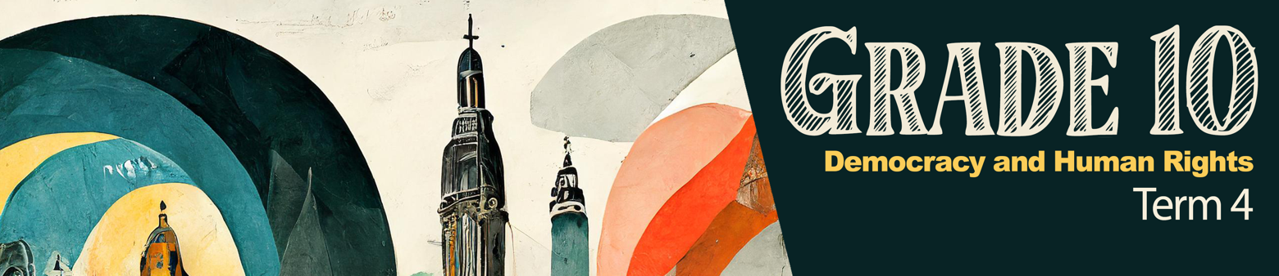
Lesson 2 – Worksheet

Activity 1: Group Discussion
Based on the clip (#CoverTheAthlete, https://www.youtube.com/watch?v=Ol9VhBDKZs0) you watched in class, discuss the following in your group.

1.1 Read through the stereotypes that each person identified while watching the clip.
1.2 Identify TWO examples from the clip that you have observed in your own school sports.
____________________________________________________________________________________________________________________________________________________________________________________________________________________________________________________________________________________________________________________________________________________________

1.3 How can the school "redress" these incidences of gender stereotyping?
____________________________________________________________________________________________________________________________________________________________________________________________________________________________________________________________________________________________________________________________________________________________

1.4 Does your school promote upcoming games on social media/at assemblies? Provide THREE ways your school could motivate more gender-equal representation of the coverage of school sports.
_________________________________________________________________________________________________________________________________________________________________________________________________________________________________________________________________________________________________________________________________________________________________________________________________________________________________________________________________________________________________________________________________________________________________________________________________________________________________

Activity 2: Individual Activity
Read the extract below and answer the questions that follow.
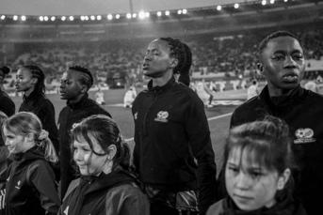
Re-thinking women’s sports in South Africa

The 2023 Soccer and Netball World Cup have revealed the country’s gender stereotyping mindset on women’s sports.

The challenges that Banyana Banyana faced prior to the World Cup include the pay gap between them and the male team (Bafana Bafana). It was also revealed that the South African Football Association (SAFTA) was paying the female team 10% less than the male team.

This goes against the Employment Equity Act in terms of gender, sex discrimination and equal pay. Moreover, this is a clear indication that the football association has been undermining the women’s team.

The FIFA Women’s World Cup has revealed how South Africa and the rest of the world continue to resort to displaying poor support and recognition for professional women’s sports. This is evident in the mixed responses on social media platforms. Although soccer is the most-watched sport in South Africa, followed by cricket and rugby, these are also the most male-dominated sports, globally.

Media coverage of female athletes focuses on ‘traditional’ feminine sports. According to a study on the “Exposure to Women’s Sports”, women’s sport is perceived as less exciting and slower than men’s sports. Less than 10% of sports media covers women’s sports.

It is time that women’s sports, in general, get treated as professional sports, instead of being seen as a charity case. The first step towards re-thinking women’s sports is for society to change its attitude towards female athletes in order to slowly eradicate the patriarchal and prejudiced agenda towards sports investments.
[Adapted from https://mg.co.za/thought-leader/2023-08-21-re-thinking-womens-sport-in-south-africa/
Accessed on: 10 September 2024]

Write paragraphs on gender bias in women’s soccer in South Africa.

Use the following as a guideline:

- Define the term ‘gender stereotype’ and name TWO examples of how Banyana Banyana has been prejudiced. (1 + 2) (3)
(Lower Order)
___________________________________________________________________________________________________________________________________________________________________________________________________________________________________________________________________________________________________________________________________________________________________________________________________________________________________________________

- Describe FOUR ways in which bias in sport could negatively impact sportswomen. (4 x 2) (8)
(Middle Order)
________________________________________________________________________________________________________________________________________________________________________________________________________________________________________________________________________________________________________________________________________________________________________________________________________________________________________________________________________________________________________________________________________________________________________________________________________________________________________________________________________________________________________________________

- Recommend THREE ways in which South Africans could redress gender bias in sports coverage. In your answers, also indicate how EACH recommendation could impact the promotion of female sporting codes. (3 x 3) (9)
(Higher Order)
________________________________________________________________________________________________________________________________________________________________________________________________________________________________________________________________________________________________________________________________________________________________________________________________________________________________________________________________________________________________________________________________________________________________________________________________________________________________________________________________________________________________________________________
____________________________________________________________________________________________________________________________________________________________________________________________________________________________________________________________________________________________________________________________________________________________
[20]


Activity 3: Reflection: Graffiti Wall
Seeing how sports coverage can warp our perceptions of different genders or races, can be a valuable learning experience. In today's lesson, you might have become aware of issues around stereotyping that you hadn't noticed before. Remember the short advert we watched at the beginning of this lesson with the hashtag #covertheathlete?

You will now have the opportunity to inspire learners in your class and school by completing the following THREE responses on the card/paper you have been given:
3.1 Write down a rule you believe should be implemented in school sports to promote gender equality.
3.2 Write down a rule you believe should be implemented to address racial bias and prejudice in school
sports.
3.3 Suggest a punishment that should be applied to spectators at school sports events who promote any form of prejudice.

These cards are anonymous. Once completed, place them on the graffiti wall in your class.

