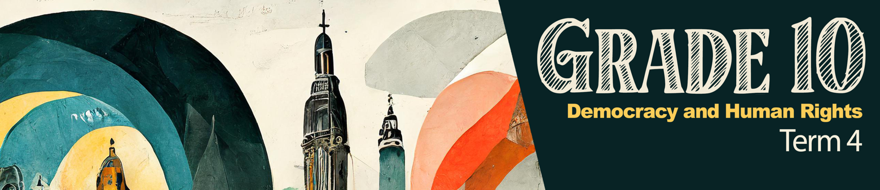
Lesson 1 – Worksheet

Activity 1: Individual Activity
Complete the following activity by recording the name of the religion next to the symbol. Write ONE fact you know about each of these religions. Choose from the list below:
Judaism Christianity Islam Buddhism Hinduism Baha'i African Traditional Religions
 | Symbol | Name | Fact
1.1 | 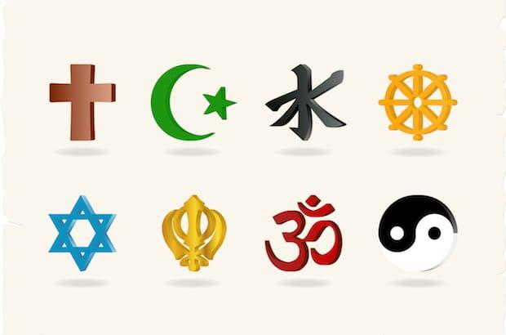
1.2 | 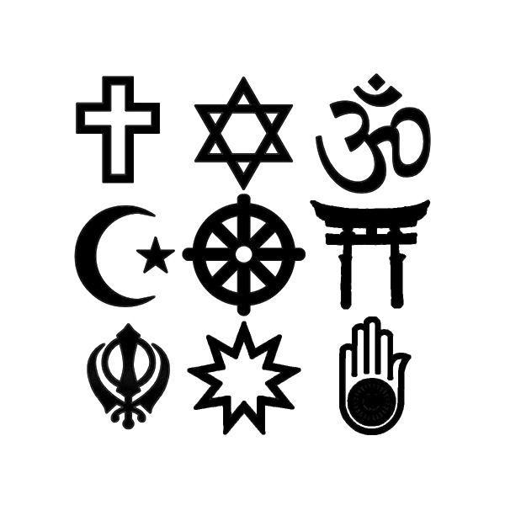
1.3
1.4
1.5 | 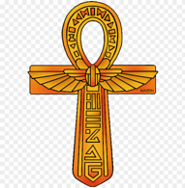
1.6 | 
1.7
Activity 2: Group Discussion: Poster
As a group, work through the Lesson 1 – Religions Info Sheet. Discuss the questions below and then summarise your findings on the Lesson 1 – Poster titled “What I learnt about Religions in South Africa today”. Choose a spokesperson to give feedback to the class.

2.1 Start by choosing THREE religions that your group knows the LEAST about.
2.1.1 Identify THREE things you have learnt or found particularly interesting about these religions.
2.1.2 Discuss THREE ways in which this knowledge could prevent prejudice amongst your classmates.
2.1.3 State the positive impact of these religions and explain how they help prevent or decrease prejudice in a community.
2.1.4 Create a slogan for religious inclusivity to feature on your poster.

Activity 3: Reflection: Graffiti Wall

In this final activity, you will reflect on an ethical/moral way of living that has inspired you from today's lesson. On the card/post-it provided by your teacher, complete the following:
3.1 Write ONE sentence explaining how a particular religion has morally/ethically inspired you.
3.2 Write ONE question you still have about a particular religion OR something you are still uncertain about.
These cards are anonymous. Once completed, place them on the graffiti wall in your class.

