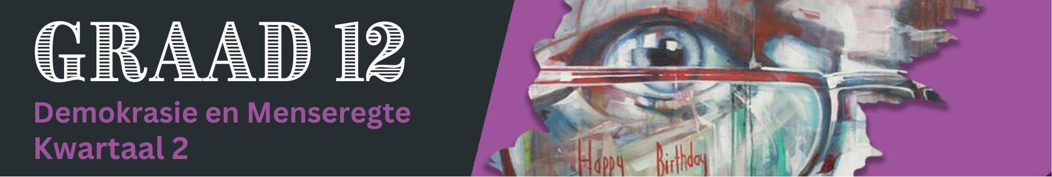
Les 2 – Werkkaart

Aktiwiteit 1:
Kyk die videogreep Beauty ad by Clicks deemed ‘racist in South Africa (https://www.youtube.com/watch?v=7vZzNaSPc_o) en reageer dan deur die volgende vrae te beantwoord.
Een van die beperkings op die media is: "Die media moet kwessies verduidelik sonder om sensasioneel te wees of te probeer skok.”

1.1 Definieer die term 'rassisme' en gee TWEE redes waarom die Tresemmé-advertensie as rassisties
beskou kan word. (1+2) (3)
_____________________________________________________________________________________________________________________________________________________________________________________________________________________________________________________________________
1.2 Verskaf DRIE redes waarom Suid-Afrikaanse burgers kwaad vir Clicks-winkels kon voel. (3x1) (3)
___________________________________________________________________________________________________________________________________________________________________________________________________________________________________________________________________________________________________________________________________________________________________________________________________________________________________________________
1.3 Beskryf TWEE maniere waarop die Suid-Afrikaanse media dalk nie hul rol in 'n demokrasie vervul
nie. (2x2) (4)
___________________________________________________________________________________________________________________________________________________________________________________________________________________________________________________________________________________________________________________________________________________________________________________________________________________________________________________

1.4 Bespreek TWEE maniere waarop fopnuus 'n demokratiese samelewing kan skade aandoen.
(2x2) (4)
___________________________________________________________________________________________________________________________________________________________________________________________________________________________________________________________________________________________________________________________________________________________________________________________________________________________________________________

1.5 Bespreek die negatiewe effek van enige DRIE beperkende rolle van die media in 'n demokratiese samelewing. (3x2) (6)
__________________________________________________________________________________________________________________________________________________________________________________________________________________________________________________________________________________________________________________________________________________________________________________________________________________________________________________________________________________________________________________________________________ _______________________________________________________________________________________ [20]

Aktiwiteit 2: Refleksie
Bespreek in jou groep EEN rol van die media waarvan jy nog nooit geweet het nie en EEN konsep uit hierdie les wat jy verder moet navors vir huiswerk. Beskryf die konsep in die spasie hieronder om jou te herinner om navorsing te doen.


