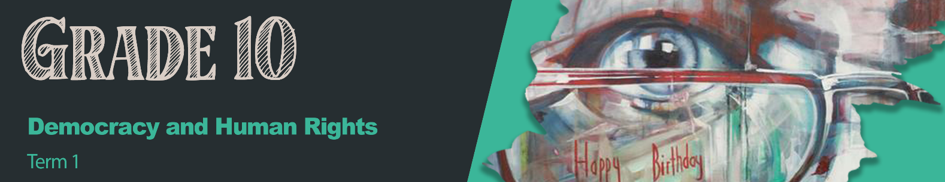

Lesson 2 – Worksheet MEMO
Activity 1:
Write down your understanding of the following concepts.
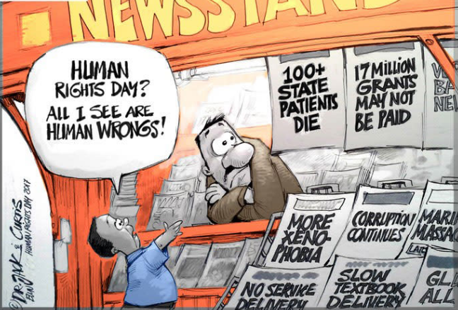
In the block below write down the types of discrimination you can see in the
cartoon.
[Adapted from https://ewn.co.za/2017/03/21/cartoon-humanrightsday; Accessed 10 October 2023]

Lack of health care
Discrimination based on race/culture (Xenophobia)
Lack of basic services
Lack of education
Corruption
Activity 2:
Write down THREE examples of fair discrimination and THREE examples of unfair discrimination.
 | VS | 
Redressing imbalances by giving people opportunities that they did not have in the past. | VS | Xenophobia - Treating foreigners as though they have no right to live in South Africa and work here.
Sports teams are required to be representative of the community they come out of. | VS | Sexism - Reserve employment based on gender rather than skill.
BBEEE - Companies are required to employ and partner with previously disadvantaged people to create more opportunities. | VS | Prejudice - Treating people with a disability as though they cannot do a job that they are qualified for.


Activity 3:
What would you say to someone who has been subjected to one of these discriminatory actions? On your piece of paper, write down what you would say.
Put your paper up on a wall/board in the classroom to create awareness of these issues.

Learners will give personal responses for this activity.

Activity 4:
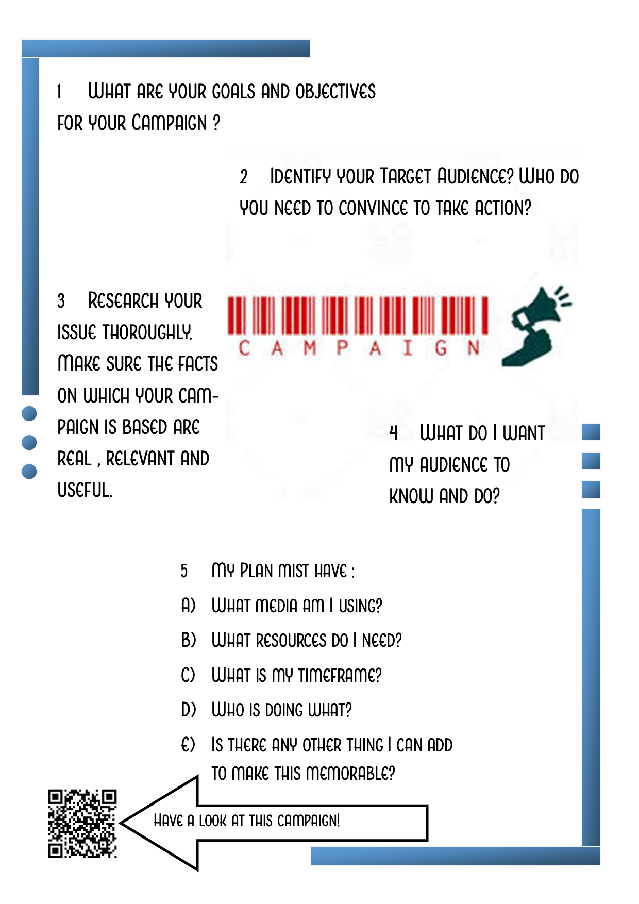
Let’s Campaign – What does an Advocacy Campaign entail:
Developed by Teenactiv
If you can’t access the video via the above QR code, here is the link:
https://youtu.be/x-Tz2lyxkbY?si=VWLadJCXRsGarsNs
Learners will give personal responses for this activity.

Activity 5:
See Lesson 2 – Group Activity Articles
Write answers to your group’s questions in the space below.
1

2

3

4

Refer to answers in Lesson 2 – Group Activity MEMO
Activity 6: Reflection
Referring to the images on Lesson 2 – PowerPoint, Slide 10:
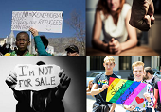
In the block below, write a paragraph on what the impact of these human rights violations would be on the individuals and then also on their families or those closest to them.
Individuals would feel unsafe and the effects of this abuse would impact their relationships and their schooling. They would feel that no-one understood or accepted them. In severe cases, some might suffer from depression or even suicidal thoughts. Their families might not know the full extent of the abuse and worry about their children, not knowing how to help.

