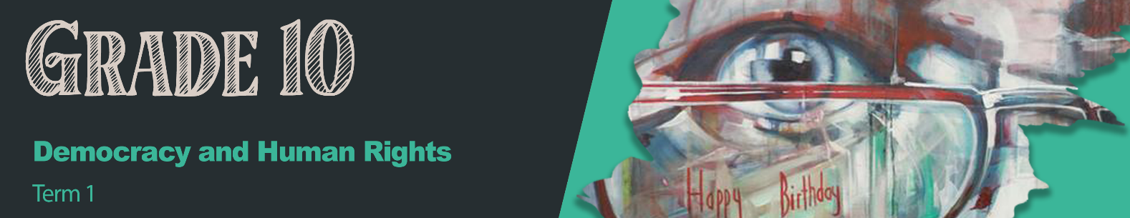

Lesson 2 – Worksheet
Activity 1:
Write down your understanding of the following concepts.
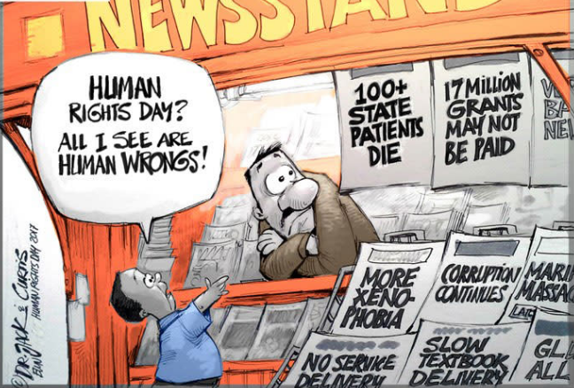
In the block below write down the types of discrimination you can see in the
cartoon.
[Adapted from https://ewn.co.za/2017/03/21/cartoon-humanrightsday; Accessed 10 October 2023]

Activity 2:
Write down THREE examples of fair discrimination and THREE examples of unfair discrimination.
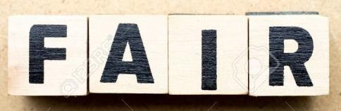 | VS | 


Activity 3:
What would you say to someone who has been subjected to one of these discriminatory actions? On your piece of paper, write down what you would say.
Put your paper up on a wall/board in the classroom to create awareness of these issues.

Activity 4:
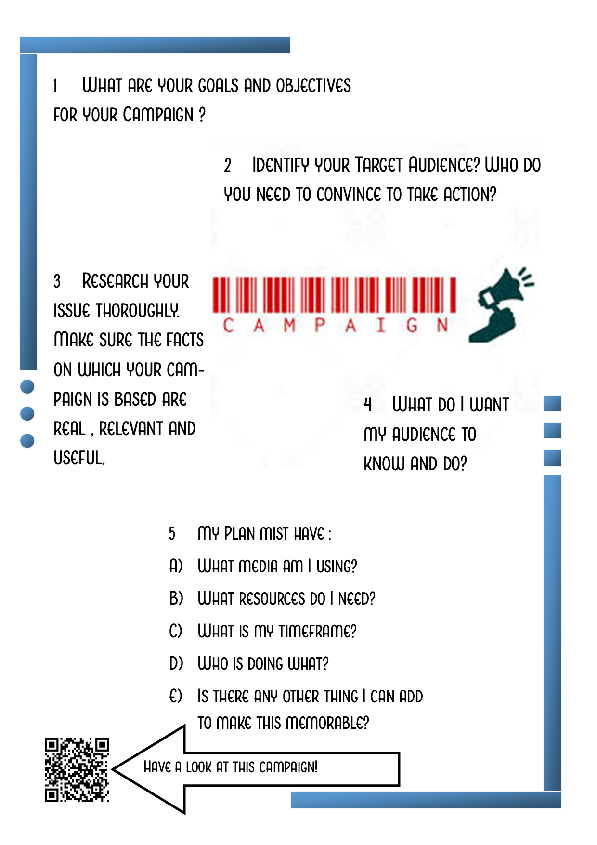
Let’s Campaign – What does an Advocacy Campaign entail:
Developed by Teenactiv
If you can’t access the video via the above QR code, here is the link:
https://youtu.be/x-Tz2lyxkbY?si=VWLadJCXRsGarsNs

Activity 5:
See Lesson 2 – Group Activity Articles
Write answers to your group’s questions in the space below.
1

2

3

4

Activity 6: Reflection
Referring to the images on Lesson 2 – PowerPoint, Slide 10:

In the block below, write a paragraph on what the impact of these human rights violations would be on the individuals and then also on their families or those closest to them.

