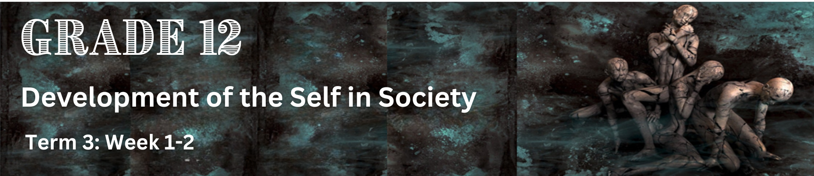
Lesson 2 – Worksheet
 | Activity 1: Informal Assessment  Complete the following activity individually.

Question 1.1
Various options are provided as possible answers to the following questions. Choose the correct answer and write only the letter (A–D) next to the question numbers (1.1.1 – 1.1.5) for example 1.1.6. D.

1.1.1 Identify the emotional benefits of long-term physical exercise:
A. Sustaining a sense of fulfilment.
B. Increased muscle tone and fitness.
C. Having a wider group of friends.
D. Improving one’s coordination.

1.1.2 Hypertension is a disorder that impacts an individual's:
A. Blood sugar
B. Blood pressure
C. Immune system
D. Lung capacity

1.1.3 Identify the disease that babies get when their mothers drink alcohol:
A. Foetal Alcohol Disorder
B. Alcohol Disorder
C. Foetal Alcohol Syndrome
D. Alcoholism Syndrome
1.1.4 A psychosomatic illness is an illness that ...
A. is caused by poor dietary habits.
B. is more often than not incurable.
C. has a vaccine one can take.
D. involves the body and the mind.
1.1.5 A devastating or adverse event, normally caused by nature or people, is known as a(n):
A. Disaster
B. Accident
C. Illness
D. Crisis (5 x 1) (5)

Question 1.2
Answer the following questions by writing the answer next to the question numbers (1.2.1 to 1.2.3). Write your answers in full sentences.

1.2.1 Define the term 'lifestyle disease' and give TWO reasons why TB is considered to be such a disease.
(1 + 2) (3)

1.2.2 Discuss THREE ways in which poverty may be a contributory factor to an increase in TB infections.
(3 x 2) (6)

1.2.3 Suggest THREE ways in which the local government can engage the community in sustainable programmes that will address TB and poverty alleviation. (3 x 2) (6)

[15]

Question 1.3
Read the extract below and answer the questions that follow.
OBESITY IN SOUTH AFRICA
South Africa has undergone a nutritional transition over the past 30 years which is characterised by the triple burden of malnutrition: households are simultaneously experiencing undernutrition, hidden hunger, and overweight or obesity due to nutrient-poor diets. Obesity statistics in South Africa are concerning as roughly 31% of men and 68% of women in the country are obese. Being overweight or obese can lead to a range of lifestyle diseases.

[Adapted from: https://theconversation.com/ Accessed 7 May 2024]

1.3.1 Identify TWO lifestyle diseases that can be caused by obesity. (2 x 1) (2)

1.3.2 Explain TWO examples where a poor diet contributes to lifestyle diseases. (2 x 2) (4)
1.3.3 Recommend TWO ways in which schools could assist learners in committing to long-term exercise. (2 x 2) (4)

[10]

[Grand Total: 30 Marks]

