GROUP 1 – PHYSICAL (MEMO)

As Group 1, read through the below article before answering the questions that follow.
(Possible answers per group)

This is the school dropout rate in South Africa
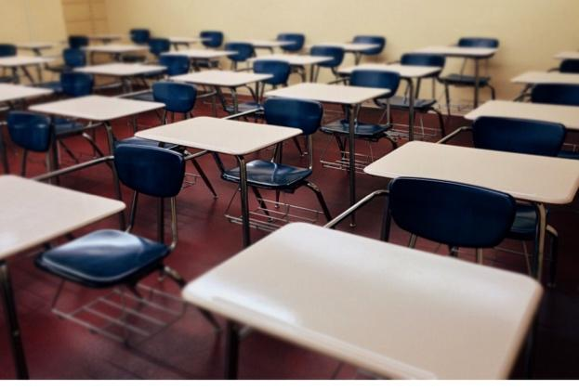
[Taken from: https://businesstech.co.za/news/government/438509/this-is-the-school-drop-out-rate-in-south-africa/ Accessed on 20 September 2023]
The Department of Basic Education has published new data on the drop-out rate at South African schools and the impact of the coronavirus pandemic.
Citing data from Statistics South Africa, the department said that an analysis of household survey data indicates that in recent years at least 50% of youths complete Grade 12.
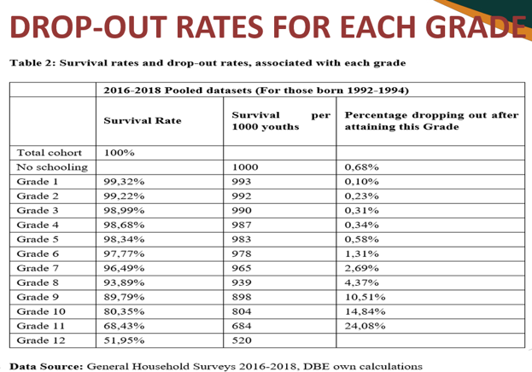
The data shows that the higher grades typically had the highest number of drop-outs. Grade 11 had the largest percentage of dropouts (24.08%) followed by Grade 10 (14.84%).
“Successful completion of Grade 12 must continue to increase, but South Africa’s secondary school completion is not unusual among developing countries.
Reasons for dropping out
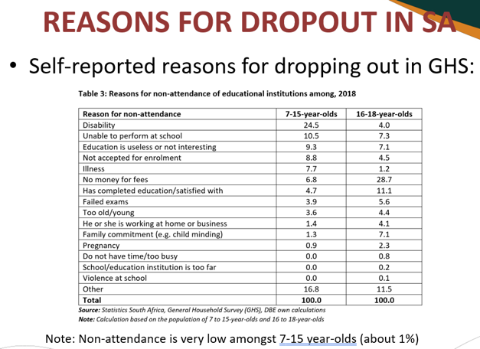
The department said that grade repetition may actually be a cause of dropping out of school.
Other possible reasons for drop-outs, as outlined in international literature include:
- Household poverty and income shocks
- Household labour and family responsibilities
- Migration
- Health problems

For the below questions, draw from your own experience and stories to give insight.

- Explain how physical factors have contributed to the drop-out rate amongst learners. (2x2)(4)
- Learners could have struggled with sickness  and missed large sections of work resulting in them being far behind.  The disillusionment of being far behind could result in learners dropping out. 
- A learner could fall pregnant while at school.  The pressure of looking after the child after the pregnancy as there is no support could result in a drop out. 

- Discuss TWO possible physical stressors that could influence the highest drop-out rate being in Grade 11. (2x2)(4)
- Some learners have chosen to smoke weed. They say it helps them cope with stress of academic pressure.  At times the addiction results in a lack of concentration over an extended period of time as well as an apathy. Should this learner fail Grade 11, it’s unlikely they will return to repeat Grade 11. 
- Some learners struggle daily from hunger on the verge of starvation.  Being of age to work and earn an income, some learners would drop out to earn an income to support their families’ basic needs. 

- Suggest advice to the present Grade 11s of your school by suggesting FIVE practical tips on how to manage physical stressors and finish Grade 12. Write these suggestions on your group poster. (5x3)(15)
- Get involved in regular exercise  which increases blood flow and a release of endorphins  that helps you alleviate physical tension. 
- Get enough sleep  so that your brain can fully recover and function at its full capacity  by being able to concentrate and remember what is taught. 
- Don’t eat excessive sugar  as it causes insulin spikes in your body  resulting in erratic bursts of energy, followed by physical exhaustion. 
- Eat balanced meals throughout the day  to ensure that you have the necessary nutrients  so you can concentrate and physically handle the day. 
- Manage your time on social media  as erratic scrolling increases dopamine levels  and influences your ability to concentrate. 
GROUP 2 - SOCIAL
As Group 2, read through the below article before answering the questions that follow.

This is the school dropout rate in South Africa
[Taken from: https://businesstech.co.za/news/government/438509/this-is-the-school-drop-out-rate-in-south-africa/ Accessed on 20 September 2023]
The Department of Basic Education has published new data on the drop-out rate at South African schools and the impact of the coronavirus pandemic.
Citing data from Statistics South Africa, the department said that an analysis of household survey data indicates that in recent years at least 50% of youths complete Grade 12.
The data shows that the higher grades typically had the highest number of drop-outs. Grade 11 had the largest percentage of dropouts (24.08%) followed by Grade 10 (14.84%).
“Successful completion of Grade 12 must continue to increase, but South Africa’s secondary school completion is not unusual among developing countries.
Reasons for dropping out
The department said that grade repetition may actually be a cause of dropping out of school.
Other possible reasons for drop-outs, as outlined in international literature include:
- Household poverty and income shocks
- Household labour and family responsibilities
- Migration
- Health problems

For the below questions, draw from your own experience and stories to give insight.

  - Explain how social stressors like family members dying or divorce could contribute to the drop-out rate amongst learners. (2x2)(4)
- When a family member dies, a learner could find that they don’t have support from family members while they struggle with academics and grief.  In the long run, this could impact results and attendance at schools and result in drop-out. 
- Divorce causes social stress as learners are forced to split their time between their parents.  Resulting in sometimes not finishing their work or loosing work between visiting parents houses.  / The effect on their academics could result in failure and if the learners is older than 16, some might not return to school. 

  - Discuss TWO ways that bullying impacts the drop-out rate in Grade 8 and 9. (2x2)(4)
- When a learner is bullied by other learners at school, they might bunk school or try and get their parents to believe they are sick and stay away from school.  This increases emotional stress which could result in suicide threats from these learners and parents might remove learners from school to remove them from the social stressor. 
- A learner with disabilities that others make fun off  could react with anger and feel unsafe in the school. He might put pressure on his parents to remove him from school. 

  - Suggest advice to the present Grade 11s of your school by suggesting FIVE practical tips on how to manage social stressors and finish Grade 12. Write these suggestions on your group poster. (5x3)(15)
- Manage the time you spend with your friends  as the influence of peer pressure  could result in anxiety and broken relationships. 
- Surround yourself with a positive support system.  Connect with classmates, teachers, and friends  who share your academic goals and would encourage you along the year when you are struggling. 
- Manage your romantic relationships with open communication  so that the relationship will be a positive influence on you  and your partner will support your academic dreams. 
- Choose positive role models  that would be a positive influence and motivate you  to keep on improving when you might feel like giving up. 
- Resolve conflict situations with peers as soon as possible  so that the emotional impact of the unresolved conflict  doesn’t upset you and impact your motivation to do well academically. 

GROUP 3 – ENVIRONMENTAL

As Group 3, read through the below article before answering the questions that follow.

This is the school dropout rate in South Africa
[Taken from: https://businesstech.co.za/news/government/438509/this-is-the-school-drop-out-rate-in-south-africa/ Accessed on 20 September 2023]
The Department of Basic Education has published new data on the drop-out rate at South African schools and the impact of the coronavirus pandemic.
Citing data from Statistics South Africa, the department said that an analysis of household survey data indicates that in recent years at least 50% of youths complete Grade 12.
The data shows that the higher grades typically had the highest number of drop-outs. Grade 11 had the largest percentage of dropouts (24.08%) followed by Grade 10 (14.84%).
“Successful completion of Grade 12 must continue to increase, but South Africa’s secondary school completion is not unusual among developing countries.
Reasons for dropping out
The department said that grade repetition may actually be a cause of dropping out of school.
Other possible reasons for drop-outs, as outlined in international literature include:
- Household poverty and income shocks
- Household labour and family responsibilities
- Migration
- Health problems

For the below questions, draw from your own experience and stories to give insight.

- Explain TWO reasons why the location of a school could contribute to the drop-out rate amongst learners. (2x2)(4)
- If a school is located in a high crime rate area,  learners might feel unsafe traveling to and from school and directly impact their decisions to drop-out. 
- Learners might experience xenophobic threats from the community that school is found in.  As a result the learner feels scared and threatened and chooses to drop out instead. 
- Discuss TWO examples of environmental stressors that could influence a high school learner when thinking about dropping out of school. (2x2)(4)
- Some schools are influenced by pollution  because of the pollution, learners have struggled with long-term sickness. 
- Should a learner experience a setback like a fire in their home where all their belongings have been burnt,  a learner might feel it’s hopeless as there is no money to replace anything. Due to circumstantial stress, the learner drops out of school. 

- Suggest advice to the present Grade 11s of your school by suggesting FIVE practical tips on how to manage environmental stressors and finish Grade 12. Write these suggestions on your group poster. (5x3)(15)
- When you have experienced an emotional trauma like a burglary in your home,  communicate with your teachers so that they can provide support for you during that time  and make sure your other teachers are aware of what’s been going on in your life. 
- Due to the location of where some learners live when there has been a provincial taxi strike, learners cannot get to school.  Listen to local news for advice on what to do in a provincial strike  so that you’re able to communicate with the school and make arrangements for when you return. 
- When a disaster like a flood strikes and you cannot go to school because of the stress on your family,  communicate with your school so they are aware of the trauma you and your family have suffered.  In that way, on returning to school they could arrange counselling or support to help you finish Grade 12. 
- As the problem of loadshedding increases in the country,  some learners might have limited access to online services or textbooks and struggle to finish homework every day.  Communicate with your parents and teachers and try to find ways to alleviate the pressure by working when there is electricity rather than your own schedule 
- Some learners live in a home where they share a room with four other siblings and have no privacy.  Communicate your needs to have an area to study with your parents and peers  and see if you can make an arrangement to create a small study area in the home. 

GROUP 4 – EMOTIONAL
As a Group 4, read through the below article before answering the questions that follow.
This is the school dropout rate in South Africa
[Taken from: https://businesstech.co.za/news/government/438509/this-is-the-school-drop-out-rate-in-south-africa/ Accessed on 20 September 2023]
The Department of Basic Education has published new data on the drop-out rate at South African schools and the impact of the coronavirus pandemic.
Citing data from Statistics South Africa, the department said that an analysis of household survey data indicates that in recent years at least 50% of youths complete Grade 12.
The data shows that the higher grades typically had the highest number of drop-outs. Grade 11 had the largest percentage of dropouts (24.08%) followed by Grade 10 (14.84%).
“Successful completion of Grade 12 must continue to increase, but South Africa’s secondary school completion is not unusual among developing countries.
Reasons for dropping out
The department said that grade repetition may actually be a cause of dropping out of school.
Other possible reasons for drop-outs, as outlined in international literature include:
- Household poverty and income shocks
- Household labour and family responsibilities
- Migration
- Health problems

For the below questions, draw from your own experience and stories to give insight.

- Explain the emotional impact of teen pregnancy and how it contributed to the drop-out rate amongst learners. (1x2)(2)
A learner who is pregnant might struggle with feelings of shame over her condition and prefer to avoid her peers.  This increased pressure during the pregnancy could result in more school missed and impact decisions to drop out in the long run. 

- Discuss TWO possible reasons why repeating a grade would increase the learner drop-out rate. (2x2)(4)
- A learner might feel insecure  and think that failing is a reflection on their intelligence. 
- The embarrassment of facing their peers  might influence feelings of rather dropping out than dealing with what others might think. 

- Suggest advice to the present Grade 11s of your school by suggesting FIVE practical tips on how to manage emotional stressors and finish Grade 12. Write these suggestions on your group poster. (5x3)(15)
- To prevent feeling overwhelmed by the magnitude of work from all your subjects,  make a list of all the tasks you have to achieve in a day  so that you can feel a sense of accomplishment when completing some of the tasks. 
- Use a study time table in preparation of the stress of exams  to prevent anxiety the night before and during the exam  that you might not have finished all the work and fear failing the actual subject. 
- When experiencing moving house during your term ,  to prevent anxiety over the move,  prepare early by communicating with teachers  so that you can get tasks finished before the time and alleviate stress. 
- Being forced to move schools in Grade 12 would be a great emotional stressor.  Communicate with your parents how anxious you feel  and see if you can put arrangements in place that will give you the necessary support you would need to still pass Grade 12 well. 
- As pressures increase in the home as a result of a parent losing their job,  a learner might feel the pressure to support the family while studying. Communicate openly with your family  to see where you can help realistically and still be able to focus on your studies. 

