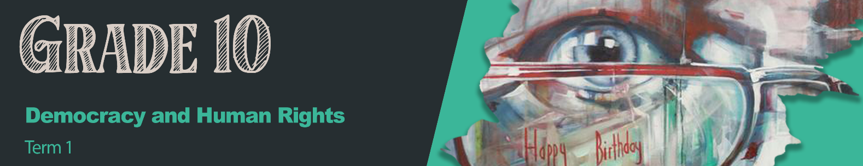


Lesson 1 – Worksheet MEMO

Activity 1:
Write down your understanding of the following concepts. (6x1)(6)
Fairness: Treating all people the same way where possible; being treated by all people the same way.
Rights: Guidelines; ideas that enable us to live safely and healthily and in freedom.
Future: Events that are still to come which affect the way that we will live.
Safety: To be able to live free from harm or threat.
Equality: All people should be treated fairly and equally. The same rules should apply to all people.
Property: Everything that you own and find valuable.

Activity 2:
Answer the following questions based on the videos watched.
Odwa’s Story (https://www.youtube.com/watch?v=Z5VeOr-JqxU )
State TWO challenges that Odwa experienced in his community. (2x1)(2)
Pollution, living in shacks (inadequate shelter); poverty; no access to electricity; others live in luxury while the poor suffer; violence and the presence of gangs. 
Discuss how TWO of these challenges can be seen as a violation of his human rights. (2x2)(4)
- Pollution in his community leads to a lack of unhygienic living conditions which could lead to sickness  (Right to health). Local government should provide basic health services and take care of infrastructure for people at risk in his community. 
- No electricity in this area means poor lighting and this becomes a safety risk at night.  (Right to safety and security). Government should be responsible for providing support like an increased police presence and adequate lighting. This would ensure that communities feel safer as they can move around safely at night. 


Write on your post-it … What would you say to someone like Odwa who experienced the difficulties in this video?

GLSEN (https://www.youtube.com/watch?v=iAwJQYs7pKM )
State TWO challenges the LGBTQI+ community face on a daily basis. (2x1)(2)
- They are bullied, called names and broken down emotionally. 
- They are made to feel unsafe and anxious. 
- They are overlooked for certain positions because of their lifestyle. 

Discuss TWO strategies that teachers and fellow learners could do to help the LGBTQI+ community feel safe. (2x2)(4)
- Teachers and other learners can be tolerant and treat people from the LGBTQI+ community as regular people.  This will show them that they are valuable members of the community. 
- They can listen to them and their fears.  In this way, show that people care for them and they are not alone. 
- They can create safe spaces for them  which will allow them to express themselves and their identity without prejudice. 

Write on your post-It … What would you say to someone like GLSEN who experienced the difficulties in this video?

Teenagers and Sexual Abuse (https://www.youtube.com/watch?v=aOwmLMnZwi4 )
State TWO challenges that teens have to deal with on a daily basis. (2x1)(2)
- Sexual abuse/Assault 
- Sexual and emotional manipulation 
- Harassment 
- Physical abuse 
- Social isolation 
Discuss TWO ways in which parents and friends could help teens to cope with these challenges. (2x2)(4)
- Listen to them and accept them for who they are.  They will then feel that someone supports them. 
- Create awareness of violations or abuses that have taken place  by educating learners in school on sexual abuse. 
- If they witness the abuse or signs thereof, put a stop to it  by reporting the incident to the police or a teacher at school. 
- Give space for teens to process what has happened to them.  Provide opportunities for counselling at school or through a crisis counselling centre. 

Write on your post-it … What would you say to the teenagers in this video?

Activity 3:
Write down the FOUR basic principles on which our Bill of Rights is based in the box below.

1.  Dignity |  | 2.  Equality
 | 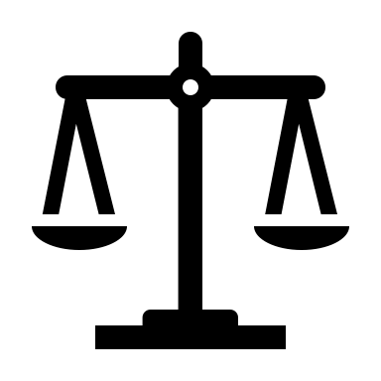
3.  Democracy |  | 4.  Freedom

Fill in the missing words of the description.
The purpose of the Bill of Rights is to protect the basic human rights of all the citizens (and residents of South Africa). It stops discrimination and unequal treatment. It makes sure that there are fair laws which makes sure that all South Africans can live together in freedom, equality and dignity. It makes sure that the government is held accountable and that they uphold democracy, equality and justice in South Africa.

Activity 4: Reflection
Possible answers
1. Explain why you think the protection of rights is important.

The human rights are meant to make all people feel valued and safe. It bridges the divide between those who have access to resources and services and those who don’t. Without these rights, people do not feel safe and part of a democracy.

2. Why is it so important that when we talk about human rights, that we also talk about the responsibility to uphold these rights?

We have to talk about human rights so that as many people as possible are made aware of these rights and what they mean. We must also realise that we all have a role to uphold these rights and not just rely on government and other structures to uphold it.

Homework Activity

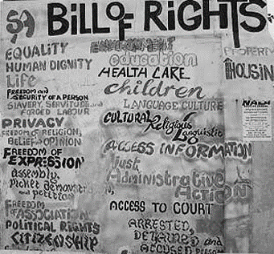
- Look at the picture printed below. Choose FIVE of the rights listed – ask your parent; guardian; care giver what they mean to him/her/them.
The five rights I’ve chosen are:
      - _______________________
      - _______________________
      - _______________________
      - _______________________
      - _______________________
- Now, write down what your responsibility is in protecting these rights.
(E.g. To protect my right to education – I can work as diligently as I can to make the most of my schooling so that I can have the career that I dream of.)

For more information, have a look at this video on YouTube -
(use the QR Code or https://youtu.be/y-F0z13elCY?si=nJNZLq7MrKOxhjPF)

Learners will give personal responses for this activity.

