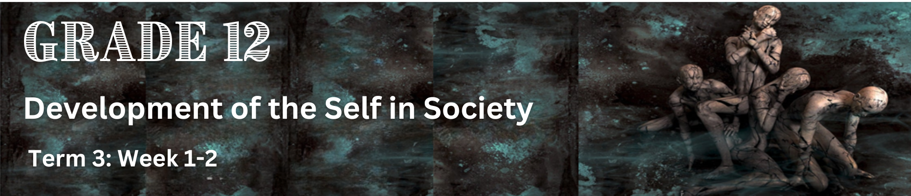
Lesson 1 – Worksheet MEMO
 | Activity 1: Informal Assessment  Complete the following activity with a partner.

Read the extract below and answer the questions that follow.
STATISTICS SHOW THOUSANDS OF YOUNG PEOPLE DYING IN ROAD ACCIDENTS
South Africa is experiencing an alarming epidemic of deaths amongst its youth due to road accidents that have killed a total of 8 547 young people between the ages of 21 and 34 years on the roads between 2019 and 2021.
This statistics collated by the Road Traffic Management Corporation (RTMC) raised concerns among the public, encouraging people to maximise efforts to be alert, drive safely and operate within the confines of the law.
Factors that contribute to the high number of road fatalities among the youth include persistent risk-taking behaviour such as reluctance to use safety belts, driving at speeds that are too fast and driving under the influence of alcohol.
[Adapted from: https://www.iol.co.za/pretoria-news Accessed: 10 May 2023]

Question 1.1
Various options are provided as possible answers to the following questions. Choose the correct answer and write only the letter (A-D) next to the question numbers (1.1.1 to 1.1.3), for example, 1.1.4 D.

1.1.1 Psychological factors are factors which involve ...
- emotional aspects of being human. (ü)
- people, the community and the public.
- a variety of religions or belief-systems.
- different cultural influences or practices.

1.1.2 Which of the following is NOT an example of a disaster?
- Severe storms and floods.
- Industrial accidents.
- Acts of terrorism.
- Car accidents and house fires. (ü)

1.1.3 Which of the following could help in preventing accidents?
- Improving the design of systems and implementing safety measures. (ü)
- Having access to proper sanitation, infrastructure, and healthcare.
- Turning to alcohol or other substances to feel better.
- Engaging in cultural practices like wife inheritance. (3 x 1) (3)

Question 1.2

Answer the following questions by writing the answer next to the question numbers (1.2.1 to 1.2.3). Write your answers in full sentences.

1.2.1 Discuss how human factors such as fatigue and exhaustion could result in ill health or accidents. (2 x 2) (4)
Possible answers may include the following:
- Fatigue can impair cognitive functions such as attention/concentration/memory/decision-making (ü) which can lead to increased errors and reduced situational awareness. (ü)
- Exhaustion can also affect motor skills and reaction times (ü) making it more difficult to respond quickly and effectively to changing situations. (ü)
- When people are tired or fatigued, they may be more prone to taking risks (ü) as individuals may ignore safety protocols/underestimate the potential consequences of their actions. (ü)
- Increased chance of falling asleep while driving/operating heavy vehicles (✓) due to a lack of sleep/fatigue. (ü)

Any TWO of the above or any relevant answers for TWO marks each.
(i.e. ONE mark for the statement and ONE mark for the qualifier/outcome)

1.2.2 Explain how psychological, social and religious/cultural factors can affect people’s wellbeing.
(3 x 2) (6)

Possible answers may include the following:
Psychological Factors:
- High levels of stress and anxiety can negatively affect mental and physical health (ü) as stress from work/relationships/financial pressures can lead to insomnia/mood disorders/other health issues. (ü)
- Individuals who have experienced trauma, whether from abuse, violence, or war, often struggle with symptoms of post-traumatic stress disorder (PTSD), (ü) affecting their daily functioning and relationships. (ü)
Social Factors:
- Social isolation/loneliness (ü) can increase the risk of depression/anxiety/other mental health issues. (ü)
- Discrimination based on factors such as race/ethnicity/gender identity/sexual orientation (ü) can lead to chronic stress/low self-esteem/poor mental health. (ü)
- Socioeconomic factors like poverty/unemployment/lack of access to resources (ü) can impact people's well-being by limiting their opportunities for education, healthcare, and social participation. (ü)

Religious and Cultural Factors:
- Cultural attitudes toward mental health/help-seeking behaviour/expressions of emotions (ü) can influence how individuals perceive/cope with psychological distress. (ü)
- Cultural expectations regarding family roles/hierarchy/obligations (ü) can impact interpersonal relationships and contribute to stress/support within families. (ü)

Any THREE of the above or any relevant answers for TWO marks each.
(i.e. ONE mark for the statement and ONE mark for the qualifier/outcome)

1.2.3 Discuss the impact of causing a car accident on a young adult. (1 x 2) (2)

They could…
- experience shock/guilt/remorse for their actions, (ü) knowing that the accident could have been prevented had they been more attentive. (ü)
- sustain injuries (ü) ranging from minor cuts and bruises to more serious injuries such as broken bones, spinal cord injuries, traumatic brain injuries, or even fatalities. (ü)
- suffer Injuries that can result in long-term physical disabilities/chronic pain/require extensive medical treatment/rehabilitation, (ü) impacting their quality of life and ability to participate in daily activities/pursue future goals. (ü)
- experience feelings of guilt/remorse/fear/anxiety/depression/post-traumatic stress disorder (PTSD) (ü) which can deeply affect their mental well-being/require professional counselling or therapy to cope. (ü)
- experience social stigma/judgment from peers/family members/community, (ü) which can impact their social relationships/independence/sense of belonging. (ü)

Any ONE of the following or any relevant answer for TWO marks.
(i.e. ONE mark for the statement and ONE mark for the qualifier/outcome)

[12]

[Grand Total: 15 Marks]

Activity 2: Reflection
Complete the following activity individually.

2.1 How have economic factors such as access to healthcare, nutritious food, and living conditions influenced your health and well-being?

__________________________________________________________________________________________
__________________________________________________________________________________________
__________________________________________________________________________________________
__________________________________________________________________________________________
Learners will have personal responses to this question.

