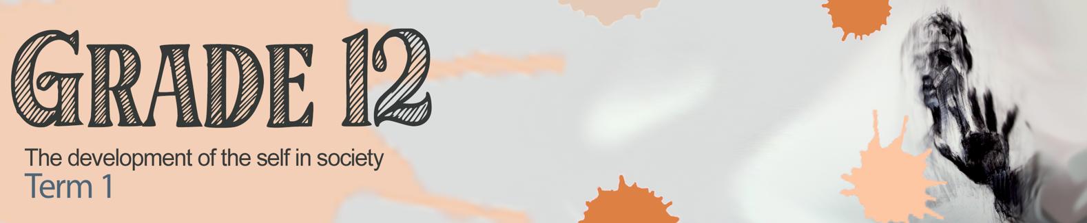


Lesson 5 – Worksheet MEMO

Activity 1:
Let’s start by simply mind mapping a few options of what our future could look like. Don’t be scared to dream big even though you cannot see how those dreams can come true now. Use this mind map to trigger some ideas.

FUTURE

Learners will give personal responses for this activity.

Activity 2:
Your five years at high school have been quite unique in that you have experienced a pandemic and are now living through the impact of the aftershocks on your family and our economy.
Turn to your group and discuss the following:
- Share TWO ways that the economic recession has impacted your dreams and goals for the future?
- How do you think life would be different from your experience of school if you are studying or working next year? Discuss FIVE differences in your group and give feedback to the class.
Learners will give personal responses for this activity.

Activity 3:
Write a letter to yourself that you intend to open in TWO years’ time. In this letter, include what you hope to achieve in the next two years and certain goals you have for your physical, social, emotional and spiritual well-being. Include in your letter how you are going to prepare for the changes to come. Keep your letter positive.


Learners will give personal responses for this activity.

Activity 4:

As we come to the end of this series, reflect on your understanding of the content covered.

1) Rate your level of understanding in the content covered over the last five lessons:
(1 - Absolutely not!, 2 - Still feeling unsure, 3 - Totally aced it!)

Rate
1 or 2 or 3
1.1 | I can apply a range of life skills required to adapt to change as part of ongoing healthy lifestyle choices: Stressors, change and quality of life. (Week 1)
1.2 | I can implement my own coping mechanisms that are healthy and positive. (Week 2)
1.3 | I am able to be assertive while being respectful and firm. (Week 3)
1.4 | I can distinguish between interpersonal conflict and intrapersonal conflict. (Week 3)
1.5 | I am able to discuss the importance of initiating, building and sustaining positive relationships. (Week 4)
1.6 | I am able to research and locate accommodation and travel arrangements, and determine possible challenges. (Week 5)
1.7 | I am able to discuss the positive and negative aspects of change. (Week 5)

2) Based on your ratings in the above table, which week did you rate the lowest in?
Which aspect of that lesson do you need to revise?

Learners will give personal responses for this activity.

HOMEWORK:
In our next lesson we will be covering study techniques and how to get the most out of your Grade 12 year. You will need to watch a TED talk clip BEFORE you return to class for the next lesson.
Watch:
https://www.youtube.com/watch?v=Na8m4GPqA30

