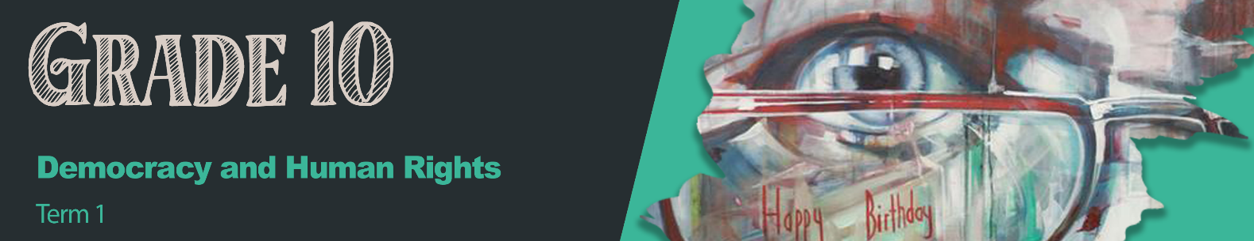


Lesson 5 – Worksheet MEMO

Activity 1:
Use these questions as a guide when you walk around and evaluate the different campaigns. Remember to add your TWO questions to this questionnaire.

- What was the purpose of your campaign?

- How can I participate in your campaign?

- How will you communicate to others about your campaign?

Learners will give personal responses for this activity.

Activity 2: Informal Assessment
Complete the following questions as practice for the mid-year Controlled Test:
Question 1
Various options are provided as possible answers to the following questions. Choose the correct answer and write only the letter (A–D) next to the question number (1.1.1 – 1.1.3), for example 1.1.4. D.

1.1.1 The Bill of Rights is important because:
- This bill models upsetting and disruptive behaviour.
- It encourages opinions over facts when on social media.
- People are protected from justice when they commit a crime.
- Citizens are aware of both their rights and their obligations.

1.1.2 Abuse and damaging attitudes based on opinions and inexperience can be referred to as:
- Xenophobia
- Discrimination
- Stigmatisation
- Situational Bias

1.1.3 Which of the following is not an example of social justice?
- Disallowing someone from voting because of their sex, race or religion.
- Promoting free healthcare for all South Africans, despite their income.
- Aiding refugees by providing them with safe lodging, food and clothing.
- Stopping someone in a wheelchair from playing a sport for safety reasons.

(3x1) (3)

1.2. Give ONE word/term for EACH of the following descriptions.
Write only the word/term next to the question number (1.2.1 to 1.2.3).

1.2.1 Justice in terms of the distribution of wealth, opportunities, and privileges within a society. (1)
Social Justice ✔

1.2.2 The ethical framework which suggests that an individual has an obligation to work with other individuals or organisations for the good of their community or society. (1)
Social responsibility✔
1.2.3 The unlawful act of transporting people in order to benefit from their work or service, usually
in the form of forced labour. (1)
Human Trafficking✔
(3x1) (3)
[6]

Question 2

Study the cartoon below and answer the questions that follow.

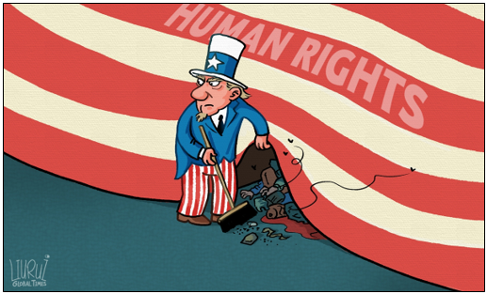
[Accessed from: https://www.globaltimes.cn; Accessed on 1 March 2021]

Write paragraphs on the role of human rights.
Use the following as a guideline:

- Define the term ‘human rights’ and provide TWO examples of recent human rights
violations on a global scale. (1+2) (3)

Human rights: a right which is believed to belong to every person. ✔

Any TWO of the below or any relevant answers for ONE mark each.

- People losing their shelter because of poverty or Covid-regulations✔
- Food insecurity due to poverty, job loss, food shortages✔
- Children/ people are denied education because of sex, gender, race, etc.✔
- There is an increase in violence or harm/ people are experiencing violence and are being hurt.✔

- Discuss FOUR roles of international conventions and instruments to help ensure that
human rights are upheld. (4x2) (8)
Any FOUR of the below or any relevant answers for TWO marks each.
(i.e. ONE mark for statement and ONE mark for qualifier / explanation)

- Expose human rights violations✔ so that the public is aware of which rights are being violated. ✔
- Reveal unlawful activities, corruption and mismanagement✔ so that those who are violating human rights can be held responsible. ✔
- To communicate and inform citizens of their rights and responsibilities✔ so that they are able to take action and make well-informed decisions with regards to their rights. ✔
- Discuss the complexities of human rights and their relevance to citizens, in detail✔ so that citizens can make informed choices in their daily lives and act according to the constitution. ✔
- Identify human rights issues in the country and community✔ so that authorities can take action to help uphold human rights at a large scale✔.
- Promote discussions and debates about human rights✔ so that people can be exposed to and hopefully understand diverse understanding of human rights. ✔
Give publicity to successes of human rights campaigns and inspirational people who champion them✔ as this will promote nation building/ national pride while tackling human rights issues /or/ this will model the correct way to act so that all people can experience their basic human rights. ✔

- Develop THREE strategies that International Conventions such as the United Nations could
put in place to ensure that global citizens have access to reliable information on Human Rights. In your answer, also indicate how EACH suggestion could lead to a more accurate
idea of the issues surrounding Human Rights in the world. (3x3) (9)

Any THREE of the below or any relevant answers for THREE marks each.
(i.e. ONE mark for statement, ONE mark for qualifier / explanation, ONE mark for outcome)

- They could work together with countries and communities to have very strict policies in place ✔so that everyone is aware of exactly what sources/ journalism is acceptable. ✔This will ensure that they will be less likely to overlook violations in their journalism and media. ✔
- There could be multiple checks and balances that journalists and the media must pass to publish a story✔ so that anything that has been published has been checked multiple times✔ and in this way, information is less likely to be false. ✔
- They could ensure that they, as a partnership, can offer continuous training and professional development courses to all interested parties✔ to keep their journalists up to date✔. This would ensure that all journalists and media outlets are fully aware of new protocols to get the best, most reliable news. ✔
- They could perform random checks on media platforms✔ so that they can spot any oversight or violations quickly. ✔ This means that they can put measures in place to rectify any violations timeously and ensure that they don’t happen again.✔
- They could provide a platform for the public to report potentially inaccurate or harmful media coverage of human rights issues/campaigns ✔so that they can be made aware of problems that they didn’t anticipate. ✔This will allow the public to have a more diverse understanding of what is acceptable.✔

[20]
Activity 3: Reflection

In the space below, reflect on your own campaign. What have you learnt about the issue that your group addressed that you never knew before?
How can you use your time to get involved in making a difference in your community?

Learners will give personal responses for this activity.

