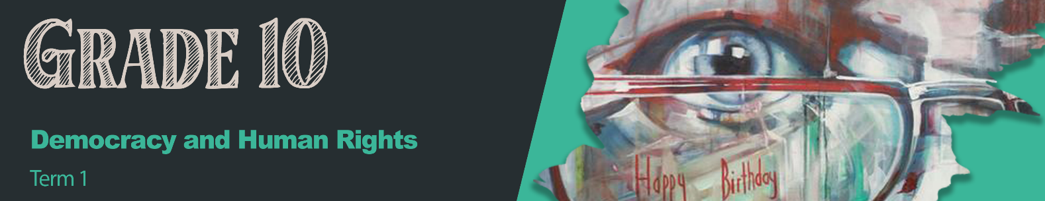


Lesson 5 – Worksheet

Activity 1:
Use these questions as a guide when you walk around and evaluate the different campaigns. Remember to add your TWO questions to this questionnaire.

- What was the purpose of your campaign?

- How can I participate in your campaign?

- How will you communicate to others about your campaign?

Activity 2: Informal Assessment
Complete the following questions as practice for the mid-year Controlled Test:
Question 1
Various options are provided as possible answers to the following questions. Choose the correct answer and write only the letter (A–D) next to the question number (1.1.1 – 1.1.3), for example 1.1.4. D.

1.1.1 The Bill of Rights is important because:
- This bill models upsetting and disruptive behaviour.
- It encourages opinions over facts when on social media.
- People are protected from justice when they commit a crime.
- Citizens are aware of both their rights and their obligations.

1.1.2 Abuse and damaging attitudes based on opinions and inexperience can be referred to as:
- Xenophobia
- Discrimination
- Stigmatisation
- Situational Bias

1.1.3 Which of the following is not an example of social justice?
- Disallowing someone from voting because of their sex, race or religion.
- Promoting free healthcare for all South Africans, despite their income.
- Aiding refugees by providing them with safe lodging, food and clothing.
- Stopping someone in a wheelchair from playing a sport for safety reasons.

(3x1) (3)

1.2. Give ONE word/term for EACH of the following descriptions.
Write only the word/term next to the question number (1.2.1 to 1.2.3).

1.2.1 Justice in terms of the distribution of wealth, opportunities, and privileges within a society. (1)

1.2.2 The ethical framework which suggests that an individual has an obligation to work with other individuals or organisations for the good of their community or society. (1)

1.2.3 The unlawful act of transporting people in order to benefit from their work or service, usually
in the form of forced labour. (1)

(3x1) (3)
[6]
Question 2

Study the cartoon below and answer the questions that follow.

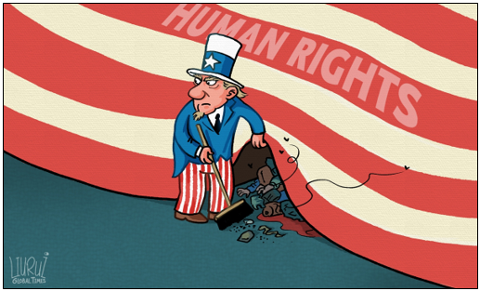
[Accessed from: https://www.globaltimes.cn; Accessed on 1 March 2021]

Write paragraphs on the role of human rights.
Use the following as a guideline:

- Define the term ‘human rights’ and provide TWO examples of recent human rights
violations on a global scale. (1+2) (3)

- Discuss FOUR roles of international conventions and instruments to help ensure that
human rights are upheld. (4x2) (8)

- Develop THREE strategies that International Conventions such as the United Nations could
put in place to ensure that global citizens have access to reliable information on Human Rights. In your answer, also indicate how EACH suggestion could lead to a more accurate
idea of the issues surrounding Human Rights in the world. (3x3) (9)

[20]
Activity 3: Reflection

In the space below, reflect on your own campaign. What have you learnt about the issue that your group addressed that you never knew before?
How can you use your time to get involved in making a difference in your community?

