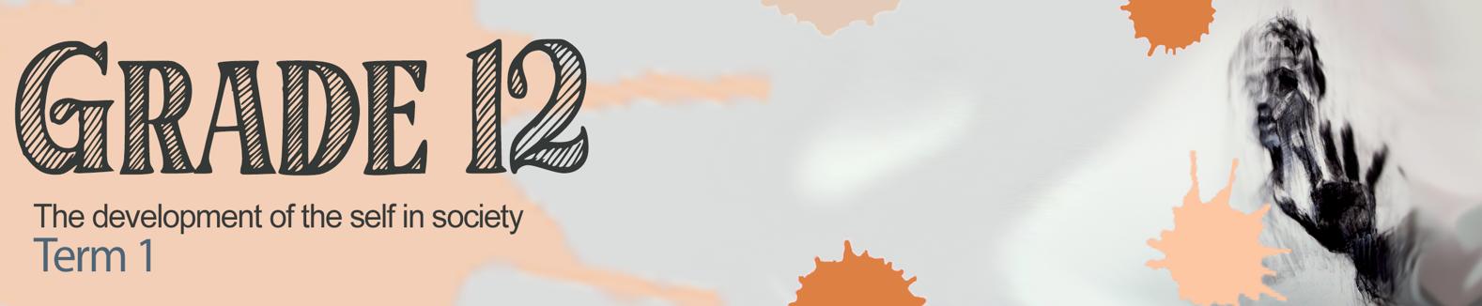


Lesson 4 – Worksheet MEMO

Activity 1:

Complete the following once you have watched the clip on ‘Guide to maintaining friendships’.
(https://www.youtube.com/watch?v=5xrzH2elhIE)

1) List the THREE conditions, according to sociologists, that you need to maintain friends:
- How close you are geographically.
- How often you hang out.
- How comfortable you are with each other.

STEP 1: Communicate

2) Complete the acronym

S
See
P
Phone
E
Email

STEP 2: Send YOU greetings.
EG: How are you doing?

STEP 3: Don’t be too hard on your friends.
Focus on shared experiences NOT differences!

STEP 4: Take advantage of big events.
INVITE!!!!!!
Activity 2:
Identify the symbol that best relates to the communication skill. Merely write the letter
(Communication Skill) next to the appropriate number (Symbol) e.g. 8 H
Symbol |  |  | Communication Skill
1 |  | E | A | Make an effort to learn a person’s name.
2 |  | A | B | Become a GREAT listener! This means rephrasing what they have said to show you have listened e.g.:  It sounds like you feel….because….  What I hear you are saying is…..
3 |  | C | C | Be willing to share a little about yourself. Avoid boasting or showing off.
4 |  | G | D | Follow the golden rule of friendship. Listen to others as you would like them to listen to you.
5 |  | F | E | Learn to INITIATE a conversation. Don’t be scared to start small talk to get people around you talking. Ask them about themselves, that will get them talking.
6 | 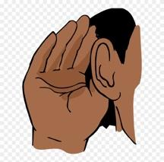 | B | F | Join clubs or groups with people of like-minded interests e.g. Sports, etc.
7 |  | D | G | Keep up to date with the latest news and topics so you can take part in discussions.

Activity 3: Test time!

Answer the following questions as though you were in a test.
Try to write as much from memory as possible.
Question 1
Various options are provided as possible answers to the following questions.
Choose the correct answer and write only the letter (A-D) next to the question number
1.1.1 Which of the following are positive stress management techniques?
- Time management, journaling, laughter and exercise. ✔
- Journaling, comfort eating, exercise and laughter.
- Comfort eating, laughter, meditation and exercise.
- Exercise, meditation, time management and alcohol use.

1.1.2 Which of the following can be considered as a physical stressor?
- Worrying about getting to a test venue on time.
- Adapting writing style because of a broken wrist. ✔
- Being unable to study due to loud construction.
- Pressure from friends to party during exam time.

1.1.3 Having to be right and win an argument is a characteristic of a(n)______ personality.
- Avoidant
- Competitive ✔
- Collaborative
- Assertive
(3x1) (3)

- Give ONE word/term for EACH of the following descriptions. Write only the word/term next to the question number (1.2.2 – 1.2.2).
  - A type of stressor that links to the physical spaces surrounding individuals or groups. (1)
Environment (✔)

  - An active attempt to adapt to and deal with the stress in the life of an individual or group. Coping mechanism (✔) (1)

- Answer the following questions by writing the answer next to the question number (1.3.1-1.3.2). Write your answers in full sentences.

- Provide TWO reasons why it is unhealthy to be accommodative during a conflict situation. (2x1) (2)

To be accommodative could lead to …
- never having one’s own needs met. (✔)
- feeling unfulfilled within relationships. (✔)
- resenting/ feeling anger towards loved ones. (✔)
- other parties never respecting boundaries/ not knowing that there is a problem. (✔)
- a build-up of negative emotions over time until one explodes. (✔)
- health problems related to stress of always meeting other’s needs. (✔)
- feelings of isolation/ loneliness/ depression/ anxiety for compromising on your personal needs. (✔)

Any TWO of the above for ONE mark each.

- Explain THREE reasons why it is important for matric learners to sustain positive relationships with their teachers. (3x2) (6)

Positive learner-teacher relationships could …
- ensure that there is a deeper level of understanding for the learner’s needs (✔) so that the teacher can design their lessons with this in mind. (✔)
- maintain the proper boundaries and level of respect (✔) which could help in maintaining positive classroom discipline needed for effective learning. (✔)
- establish a deep level of trust for the teacher’s ability (✔) so that the learner could rely on the teacher for attaining best education possible. (✔)
- create a good rapport/reciprocal relationship between the learner and teacher (✔) meaning that the learner will be more likely to maintain motivation and focus. (✔)
- make it easier for learners to talk to their teachers if they are struggling (✔) so that they can get the help that they need to excel in their studies. (✔)
- create a positive attitude within the classroom (✔) which could make learning a far more pleasant experience. (✔)

Any THREE of the above for TWO marks each
(i.e. ONE mark for statement and ONE mark for qualifier / explanation)

Activity 4:

Take a moment to respond to this conversation. (Complete for homework)
- You have a friend who is obsessed with their social media profile. Every conversation revolves around new posts and likes and comments. It seems like every conversation you have with her, she interrupts and shares what someone said on Instagram or she read online. You’ve been friends since you started high school. In about 10 lines, write down the dialogue of the conversation you would have with her. Make sure to mention what habits she needs to change to be a better friend.

_________________________________

Learners will give personal responses for this activity.

