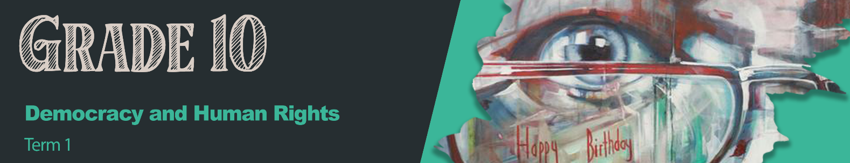


Lesson 4 – Worksheet MEMO

Activity 1:
As a group, discuss the following questions on the Mandela Day Campaign and This is Us Campaign. Write your agreed upon answers in the spaces below.
Mandela Day Campaign
Visit https://www.mandeladay.com

1. What is the purpose of this campaign? (1x1)(1)
It’s a call to make a positive impact in your community like Mandela did. 
It’s a call to get involved in making a difference in your local community through
volunteering. 

2. State TWO ways in which you can participate in the Mandela Day Campaign. (2x1)(2)
Start a social campaign about how others can volunteer and impact their community.  Plant a tree. 
Offer 67min on Mandela Day serving your community. 
3. State TWO ways in which the campaign attracts your attention. (2x1)(2)
Social media advertising  like posters, adverts, partnering with stores like Shoprite that will advertise the campaign. 
Word of Mouth  from friends that have seen the campaign and spoken about it. 

4. Discuss ONE way in which this campaign has made a difference in specific communities. (1x2)(2)
Various programmes aimed at different communities. E.g. Outreach programmes for women. 

5. Assess the effectiveness of the campaign. (2x2)(4)
The campaign was visually interesting  and required responses from the viewer. 
Based on the feedback from the public  the campaign was well received. 

This is Us Campaign
Visit https://www.sagoodnews.co.za/wp-content/uploads/2021/09/HeritageDay_ThisIsUs.pdf
1. What is the purpose of this campaign? (1x1)(1)
To build pride in being a South African. ✔
Celebrating our democracy. ✔

2. State TWO ways that you can participate in the This is Us campaign. (2x1)(2)
This campaign is about promoting unity over social media by sharing your story. ✔
You would tag #ThisisUs and share about your heritage that you would like others to inherit. ✔

3. Explain how they attract your attention. (1x2)(2)
Clever use of the colourful hashtag ✔ that everyone knows, connects with social media. ✔
4. Discuss how the effectiveness of the campaign can be measured. (2x2)(4)
Campaign has a global impact ✔ because the website is available all over the world and shared on individual social media campaigns. ✔
Using the hashtag - have you seen this used? ✔ By sharing on social media, more people would see the campaign and have an opportunity to take part. ✔

Activity 2:
Reflect on the two posters used for the exact same campaign in the PowerPoint.
In your groups, discuss the differences between these two posters. Mention FIVE differences.
1. | Each poster communicates on women - one focuses on GBV and the other on men who abuse women. ✔
2. | The left poster used bright colourful images, the right seems more conservative and serious ✔
3. | On the left, you can see the women’s faces and you feel you can relate, the identity of the male is hidden making you wonder who they are referring to. ✔
4. | The hashtags to share the campaign are clear on the left. The right poster seems more like it's communicating a standpoint that invites the viewer to participate. ✔
5. | The poster on the left gives us a date, telling us when to participate. ✔

Activity 3:
As we come to the end of this series (only one more lesson to go), reflect on your understanding
of the content covered thus far.

1) Rate your level of understanding in the content covered over the last four lessons:
(1 - Absolutely not!, 2 - Still feeling unsure, 3 - Totally aced it!)
Rating:
1 / 2 / 3
1.1 | I would be able to identify discrimination and violation in human rights when listening to the news. (Lesson 1&2)
1.2 | I understand why the Bill of Rights is important in South Africa. (Lesson 1)
1.3 | I understand that xenophobia is a violation of human rights and would report any incident that I came across. (Lesson 2)
1.4 | I feel that individuals like Dr Imtiaz Sooliman have inspired me to leave a legacy of hope for others. (Lesson 3)
1.5 | I am able to evaluate the impact of South African campaigns that address discrimination and human rights. (Lesson 4)*
1.6 | I feel confident that I understand how campaigns can educate the public about human rights violations. (Lesson 4)*
1.7 | I am able to discuss the positive and negative aspects of change. (Lesson 5)*
*Content is also covered in our final lesson (Lesson 5) next week.

2) Based on your rating in Activity 3, which lesson did you rate the lowest in? _____________
Which aspect(s) of that lesson do you need to revise? ________________________________
___________________________________________________________________________
___________________________________________________________________________
___________________________________________________________________________

Learners will give personal responses for this activity.

