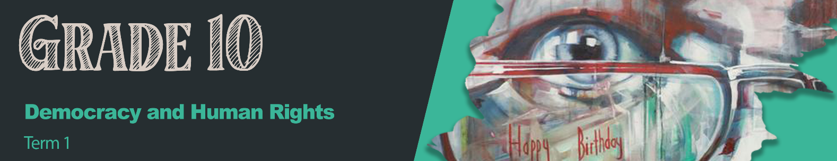

Lesson 3 – Worksheet MEMO


Activity 1:
Answer the online quiz by following the link
(https://quizizz.com/admin/quiz/65058c10bcb5e839e1ffb768?source=quiz_share) or this
QR code:
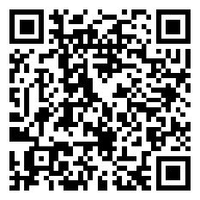

Alternatively, the questions are shown below:
Note: For the below Multiple-Choice Questions – more than one answer could be correct.

QUIZ

Question 1 (Multiple Choice): (1x1)(1)
When someone treats you in a way that is different and makes you feel ashamed, this is called . . .

A. framing B. affirmation C. discrimination  D. diversity
Question 2 (Fill in the Blank): (1x1)(1)
When human rights are not followed or not kept this is called a violation. 

Question 3 (Multiple Choice): (2x1)(2)
Which of the following are examples of human rights violations?
A. Human trafficking  B. Limited call time on your phone C. Xenophobia 
D. Religious freedom E. Aeroplane food

Question 4 (Multiple Choice): (1x1)(1)
The South African Bill of Rights is based on which four principles?
A. Ubuntu; Cultural Pride; Nationalism; Freedom
B. Democracy; Meritocracy; Time on task; Self-help
C. Equality; Xenophobia; Fair trade; Diversity
D. Dignity; Democracy; Equality; Freedom 

Question 5 (Fill in the Blank): (1x1)(1)
Xenophobia is the distrust and discrimination of foreigners. 

Question 6 (Fill in the Blank): (1x1)(1)
Human trafficking is the illegal  transportation of people across provincial or national
boundaries. 

Question 7 (Fill in the Blank): (1x1)(1)
Gender-Based Violence abuses the right to safety. 

Question 8 (Multiple Choice): (1x1)(1)
Corrective rape is most commonly practiced against ___________________ communities.

A. foreign B. rural C. LGBTQI+  D. small

Question 9 (Multiple Choice): (1x1)(1)
The causes of human rights violations can be seen as …
A. ignorance; hatred of diversity; greed; power or cultural prejudice.
B. poverty; education; westernisation or tolerance
C. economic conditions; overpopulation; diversity of languages; too much social media
D. power cuts; inadequate policing; violent politicians; basic services for all.

Question 10 (Fill in the Blank): (1x1)(1)
Everybody can be a human rights champion!

Activity 2:
Qualities of a superhero – in the block below, write down THREE qualities that you
think every superhero should have. (3x1)(3)

1. Kind

2. Courageous

3. Trustworthy

Activity 3:
Answer the following questions based on the three videos that you have watched.
DR IMTIAZ SOOLIMAN
(Watch: https://www.youtube.com/watch?v=U4JAqwqdfjw)
1. | If you had to think of three words to describe Dr Sooliman, what would they be? (3x1)(3)
 | Kind, generous, brave, fearless
2. | What does Dr Sooliman’s organisation do? (1x1)(1)
 | They provide aid to disaster zones all over the world.
3. | Name THREE human rights that you think Dr Sooliman champions. (3x1)(3)
Right to medical care
Right to safety / food
Right to life / dignity
4. | Explain ONE characteristic of Dr Sooliman that you admire. (1x2)(2)
 | He is very selfless and wants to help other people. He doesn’t care about any other accolades. 

MICHAELA ‘CHAELI’ MYCROFT
(Watch: https://www.youtube.com/watch?v=SuRlW4LPJdo )
1. | Explain what you think it means to be a ‘Disability Activist’. (1x2)(2)
A person who fights for the rights of people with disabilities  to live a normal life in society. 
2. | Identify THREE reasons why disabled people are treated differently within society. (3x1)(3)
They might look, speak or react differently to those without disabilities. 
People might view them as having less abilities. 
People might feel that they are fragile. 
People might view them as strange. 
3. | State TWO reasons why talking openly about an issue is so important for breaking down prejudice. (2x1)(2)
When people talk to one another, they see that they are more similar to the person. 
When they talk they get more information to make a more informed decision. 

RACHEL AND SIYA KOLISI
(Watch: https://www.youtube.com/watch?v=GbxQ-1aM828&t=9s )
1. | Identify THREE areas of need the Kolisi Foundation addresses. (3x1)(3)
Food security:  Feeding people who don’t have an income to buy food. 
Education and sport:  Providing opportunities for education and sports programmes for those who cannot.
Gender-based violence:  Protecting victims of GBV. 
2. | Give TWO reasons why the Kolisi Foundation has become so effective. (2x1)(2)
Siya Kolisi is very famous in South Africa so many donors will donate towards the foundation. 
They have dynamic people working with them. 
3. | Name THREE human rights that the Kolisi Foundation champions. (3x1)(3)
Right to food 
Right to education 
Right to safety and security 
Right to dignity 
Activity 4:
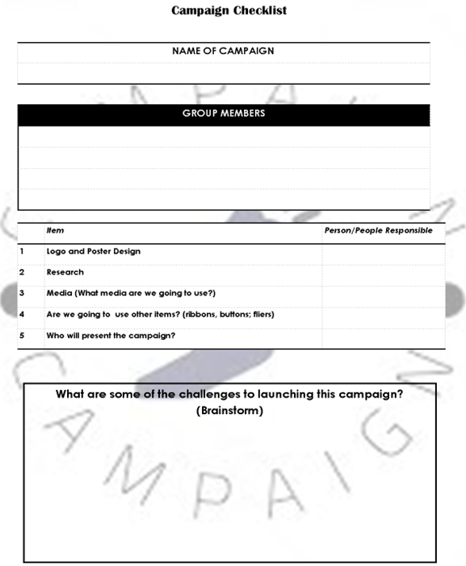
Fill in the Campaign Checklist – you can complete for Homework
Developed by Teenactiv
Developed by Teenactiv

Learners will give personal responses for this activity.

Activity 5: Self-Reflection

Who or what in the three videos inspired me the most?
Own response

What do I think is the greatest quality of a Human Rights Champion?
They believe in the best of other people and fight for things to change in society for those that don’t have anyone to fight for them.

What small action can I start DOING today?
I can become a person of integrity and less selfish considering the needs of people around me. I can draw attention to people who need support and put them in touch with who are able to help them.

Learners will give personal responses for this activity.

