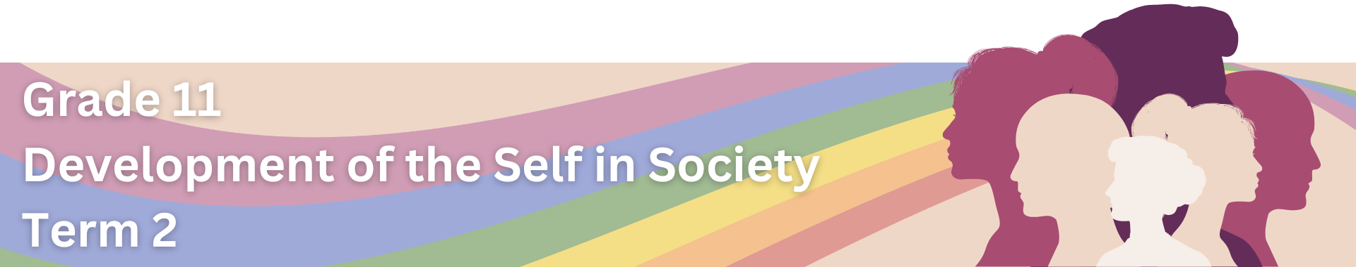

Lesson 2 – Worksheet MEMO
 | Activity 1: Factors that Contribute to GBV  Complete the following activities in your group.

Question 1: Patriarchy, Unequal Power Relations and Stereotypical Gender Norms
Read the below extract and answer the questions that follow.
How Gender Stereotypes and Norms Contribute to Violence Against Women
Gender stereotypes are present in all aspects of our society and children are subjected to them from very early on. We use language, colour coding, and actions that divide girls and boys, and women and men into different groups. This results in children learning from these signs and behaviours, and adopting gender stereotypes. Intimate partner violence has strong links to strict gender norms. If men tend to conform to strict gender roles, the likelihood of them using violence increases. Moreover, some environments might accept and reinforce the use of violence for men as a way of solving problems and of disciplining their partner or children.
[Adapted from https://medium.com/we-encourage/how-gender-stereotypes-and-norms-contribute-to-violence-against-women-1bab00c22e04. Accessed 30 January 2023]

1.1. Discuss TWO instances where unequal power relations could lead to GBV within a family. (2x2) (4)
- When one partner controls all the money in the family, () the other partner may feel financially trapped and unable to leave an abusive situation, leading to prolonged exposure to GBV. ()
- If one partner isolates the other from friends, family, or support networks, () the isolated partner may feel helpless and have no one to turn to for help or support when facing GBV. ()
- When one partner dominates decision-making in the family, such as where to live, how money is spent, or how children are raised, () it can create a power imbalance that leads to GBV if the dominated partner disagrees or tries to assert their own preferences. ()
- If one partner constantly belittles, humiliates, or emotionally abuses the other, () it can create an environment of fear and control where the victimised partner may feel powerless to leave or seek help, contributing to ongoing GBV within the family. ()

Any TWO of the above for TWO marks EACH
(i.e. ONE mark for statement and ONE mark for qualifier / explanation)
1.2. Explain why social norms about the roles and responsibilities of each gender often lead to frustration and resentment. (1x2) (2)
- Social norms that say men should be strong and women should be nurturing can make people feel trapped in certain roles. () If someone wants to do something different, like a man wanting to be a stay-at-home dad or a woman wanting a career, they might feel frustrated because society expects them to act a certain way. ()
- When society tells boys they shouldn't show emotions and girls they should prioritise family over career, it puts pressure on everyone to fit into these moulds. () If someone doesn't want to or can't conform to these expectations, they might feel resentful because they're judged for not being what society says they should be. ()

The ONE of the above for TWO marks
(i.e. ONE mark for statement and ONE mark for qualifier / explanation)

1.3. Discuss TWO ways in which unequal power relations between parents can influence children. (2x2) (4)
- When there's an unequal power dynamic between parents, children may mimic these behaviours in their own relationships, () leading to cycles of power imbalance and potentially unhealthy dynamics later in life. ()
- Children may experience feelings of insecurity, anxiety, or confusion when witnessing conflict or witnessing one parent being marginalised or mistreated by the other. () This can impact their emotional well-being and development, potentially leading to issues such as low self-esteem or difficulties forming healthy relationships in the future. ()

The TWO above for TWO marks EACH
(i.e. ONE mark for statement and ONE mark for qualifier / explanation)

Question 2: Abuse of Power and Power Imbalance
Read the below extract and answer the questions that follow.
Woman Speaks Out After Harassment
Selwane Mfana, a 20-year veteran at the Matjhabeng Department of Safety and Transport, experienced sexual harassment during a job interview for a senior supervisor position in 2022. The perpetrator, Sam Mokhuoa, who is a head of department at the Matjhabeng Municipality, allegedly made unsolicited advances towards Mfana during a tea break while she was attending a job interview process. These advances included inappropriate touching, an obscene telephone call, and a suggestive WhatsApp message. Despite reporting the incident to her superiors, including the mayor, no action was taken. In desperation, Mfana turned to the Council for Conciliation, Mediation and Arbitration (CCMA). The CCMA report confirmed that Mokhuoa abused his authority, attempting to coerce Mfana into sexual favours in exchange for the senior superintendent position. While Mokhuoa has been suspended, he has not been dismissed from the municipality. The incident has significantly impacted Mfana's life, leading to humiliation and a severe blow to her self-esteem.

[Adapted from https://www.news24.com/news24/community-newspaper/vista/woman-speaks-out-after-harrassment202309143. Accessed 30 January 2023]

2.1. Discuss TWO reasons why abuse of power often occurs in the workplace. (2x2) (4)
- When individuals in positions of authority know they won't face consequences for their actions, they may be more inclined to misuse their power, () whether it's through harassment, favouritism, or unfair treatment of employees. ()
- Many workplaces operate within hierarchical structures where certain individuals or departments have more power and influence than others. () This power imbalance can create opportunities for abuse, as those in higher positions may exploit their authority to control or manipulate others, knowing that subordinates may feel powerless to challenge or report their behaviour. ()

The TWO above for TWO marks EACH
(i.e. ONE mark for statement and ONE mark for qualifier / explanation)

2.2. List TWO specific ways in which abuse of power can lead to sexual violence in the workplace. (2x1) (2)
- An individual in a position of power may make unwelcome sexual advances towards subordinates, using their authority to pressure them into engaging in sexual activity. ()
- Perpetrators of abuse may threaten retaliation, such as termination or demotion, if the victim does not comply with their sexual demands or attempts to report the harassment. ()
- Abusers may use manipulation tactics to control and manipulate their victims into accepting or tolerating sexual advances or harassment. ()
- Perpetrators may promise career advancement, promotions, or other favourable treatment in exchange for sexual favours. ()
- Abusers may create hostile work environments through sexual jokes, comments, or imagery, which can contribute to a culture of sexual harassment and normalise inappropriate behaviour. ()
Any TWO of the above for ONE mark EACH
Question 3: Sexual Orientation, Bigotry and Prejudice
Watch the following video and read the extract, before answering the following questions.
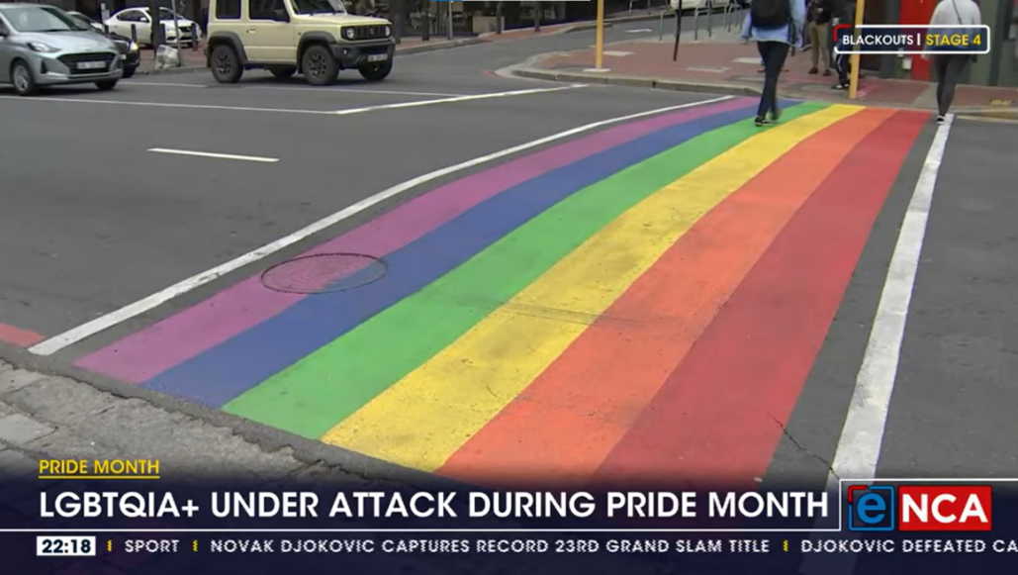

When individuals hold biased beliefs, they may feel justified in expressing their prejudice and bigotry through verbal, physical, or emotional violence. This hostile environment increases the vulnerability of LGBTQAI+ individuals to harassment, bullying, and even physical assaults, fostering a culture of discrimination that perpetuates GBV.
[Source: https://www.youtube.com/watch?v=mK53O-HyINM. Accessed 1 February 2024]

3.1. List FOUR reasons why people from the LGBTQIA+ community often face prejudice. (4x1) (4)
- People often hold misconceptions and stereotypes about LGBTQIA+ individuals. ()
- Some religious teachings and interpretations condemn non-heterosexual orientations and gender identities. ()
- Fear and discomfort with what is unfamiliar or different can lead to prejudice against LGBTQIA+ individuals. ()
- LGBTQIA+ identities have historically been stigmatised and marginalised in many societies. ()
- Limited education and awareness about LGBTQIA+ identities and experiences can contribute to prejudice and discrimination. ()

Any FOUR of the above for ONE mark EACH

3.2. Critically discuss how prejudice contributes to GBV in the workplace. (1x4) (4)
- When individuals hold prejudiced attitudes towards certain groups, they may treat them unfairly or with hostility in the workplace. () This can manifest in various forms, such as verbal abuse, exclusion from opportunities, or even physical violence. () Individuals in positions of authority may use their influence to target or marginalise those they hold prejudice against. () As a result, individuals who are subjected to prejudice in the workplace may feel unsafe, unsupported, and unable to speak out against mistreatment, leading to a toxic work environment where violence and discrimination thrive. ()

The above for FOUR marks
(i.e. To be awarded the full FOUR marks for a CRITICALLY DISCUSS question:
candidates must give a statement, () elaborate on the statement, ()
qualify the statement () and give an outcome ())

Activity 2: Reflection
Reflect on what you have learnt today by answering the following questions.

- In what ways do I contribute to or challenge the perpetuation of gender-based violence through my actions, language, or attitudes?
______________________________________________________________________________________________________________________________________________________________________________________________________________________________________________________________________________

- What personal changes can I make to actively contribute to a more equitable and violence-free environment?
______________________________________________________________________________________________________________________________________________________________________________________________________________________________________________________________________________
Learners will have personal responses to these questions.

