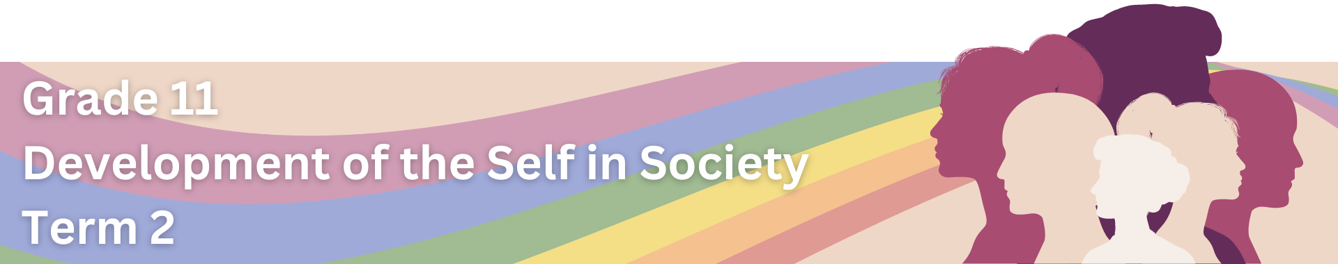
GBV Statistics: Fact Sheet
Read through the following South African GBV statistics. Select FIVE to SEVEN statistics to present visually in the form of an infographic poster.
- A World Health Organization study found that 60,000 women and children are victims of domestic violence in South Africa each year.
- A 2021 report by Statistics South Africa stated that one in five women (21%) had experienced physical violence by a partner.
- From October to December 2021, 902 women were murdered, with 232 of these murders directly linked to domestic violence. At the same time, around 11,315 rape cases were reported, which translates to 123 cases daily.
- In 2019/20, a total of 2,695 women were murdered in South Africa. This means a woman is murdered every three hours.
- 51% of women in South Africa say they’ve experienced GBV, with 76% of men saying they’ve perpetrated GBV at one stage in their lives.
- Femicide is five times higher in South Africa than the global average.
- In 2019/20, 53,293 sexual offences were reported, an average of 146 per day. Most of these were cases of rape.
- Between 25% and 40% of South African women have experienced sexual and/or physical IPV in their lifetime.
- Just under 50% of women report having ever experienced emotional or economic abuse at the hands of their intimate partners in their lifetime.
- Between 28 and 37% of adult men report having raped a women.
- South African health care facilities – an estimated 1.75 million people annually seek health care for injuries resulting from violence.
- HIV – an estimated 16% of all HIV infections in women could be prevented if women did not experience domestic violence from their partners.
- GBV costs South Africa between R28.4-billion and R42.4-billion per year, which amounts to 0.9% to 1.3% of our GDP annually.
NOTE: ACCURATE STATISTICS ARE DIFFICULT TO OBTAIN DUE TO THE FACT THAT MOST INCIDENTS OF GBV ARE NOT REPORTED.

