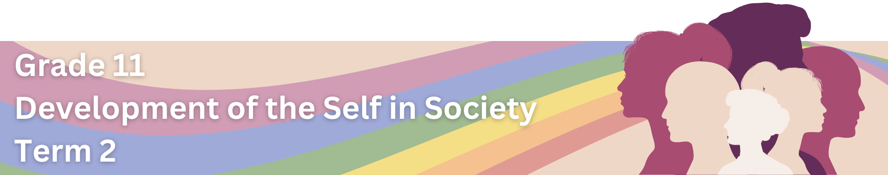

Lesson 1 – Worksheet
 | Activity 1: Forms of Gender-Based Violence  Complete the following activity to test your knowledge on the different forms of violence.

Examine the instances of violence provided in the first column and match them with the appropriate form of violence listed in the last column. Complete the empty centre column by inserting the correct letter (A-G).

Instance of Violence |  | Answer | Form of Violence
1.1. | A woman is intentionally killed by her partner because she wanted to pursue a career against his wishes. |  | A | Psychological Violence
1.2. | A university student is pressured into engaging in sexual activities against their will by someone they know from their friend circle. |  | B | Domestic Violence
1.3. | At work, a colleague consistently makes unwanted sexual comments, creating an uncomfortable and hostile environment for a coworker. |  | C | Sexual Violence
1.4. | A person forcibly engages in sexual intercourse with someone who clearly communicates that they do not want to participate. |  | D | Femicide
1.5. | During an argument, a husband becomes physically aggressive and hits his wife, causing visible injuries. |  | E | Rape
1.6. | In a family, a father frequently yells, threatens, and occasionally physically harms his wife and children. |  | F | Sexual Harassment
1.7. | A teenage girl consistently receives hurtful messages from her boyfriend, who tries to control what she does and who she talks to. |  | G | Physical Violence

Activity 2: Research Incidences of Gender-Based Violence
Use the space below to plan your infographic poster based on the Lesson 1 – Statistics Fact Sheet.

Activity 3: Reflection
Reflect on what you have learnt today by answering the following questions.

3.1. How do the statistics on gender-based violence in South Africa resonate with me emotionally?
____________________________________________________________________________________________________________________________________________________________________________________
__________________________________________________________________________________________

3.2. What actions can I take to raise awareness and contribute to the prevention of gender-based violence in my community?
____________________________________________________________________________________________________________________________________________________________________________________
__________________________________________________________________________________________

