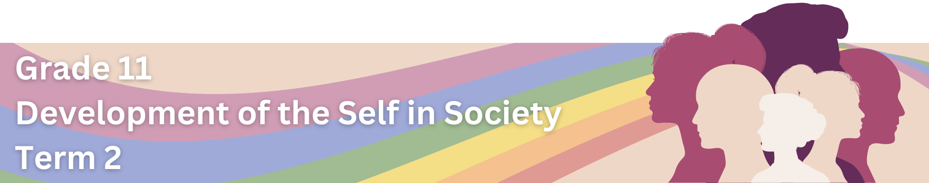
Content Summary
Lesson 1: Forms and Incidences of Gender-Based Violence
The UN defines violence against women as, "any act of gender-based violence that results in, or is likely to result in, physical, sexual or psychological harm or suffering to women, including threats of such acts, coercion or arbitrary deprivation of liberty, whether occurring in public or in private life". Gender-based violence (GBV) can also be broadly defined as violence (physical, sexual, mental, or economic) that occurs as a result of the social norms associated with each gender, along with the unequal power relations between genders.
social norms: shared expectations or "rules" within a society that prescribe how individuals should behave in various situations.
unequal power relations: situations where certain individuals or groups hold more power, privilege, or authority compared to others.
female genital mutilation: the ritual removal of some or all of the external female genitalia.

Gender-based violence (GBV) is a serious issue in South Africa that impacts individuals across the gender spectrum. While it is important to acknowledge that GBV can affect people of any gender, it is crucial to recognise that women and girls often face a greater impact. The focus on addressing GBV against women and girls stems from historical patterns of gender inequality, where they have been more vulnerable to various forms of violence, such as sexual harassment, sexual violence, female genital mutilation, child marriage, psychological abuse, and controlling behaviours.

Let's take a closer look at some of these types of gender-based violence:

 | DOMESTIC VIOLENCE  Domestic violence refers to any form of abusive behaviour that occurs within a domestic setting (the private space where individuals live together), typically involving partners or family members. It can manifest as physical, emotional, or psychological harm aimed at gaining control or power.

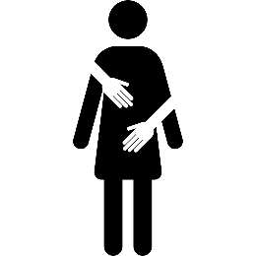 | SEXUAL VIOLENCE  Sexual violence involves any non-consensual sexual act or behaviour, including but not limited to rape, sexual assault, and harassment. It violates an individual's autonomy and personal boundaries.
 | RAPE  Rape is a criminal act involving non-consensual sexual intercourse or penetration. It is a severe form of sexual violence where one person forces another to engage in sexual activities against their will.
 | PHYSICAL VIOLENCE  Physical violence involves the use of force that causes harm or injury to another person's body. It can range from slapping and hitting to more severe forms of assault.
victim: someone who has experienced harm or suffering as a result of GBV.

 | PSYCHOLOGICAL VIOLENCE  Psychological violence, also known as emotional or mental abuse, refers to behaviours that inflict emotional harm, such as manipulation, intimidation, or constant criticism. It aims to control or demean the victim's mental well-being.

 | FEMICIDE  Femicide is the intentional killing of women or girls based on their gender. It often involves gender-based motives and reflects broader issues of gender inequality and discrimination.

 | SEXUAL HARASSMENT  Sexual harassment is unwanted and unwelcome behaviour of a sexual nature, including comments, advances, or requests, that create a hostile or uncomfortable environment for the recipient. It occurs in various settings, such as workplaces or educational institutions.

 | ECONOMIC VIOLENCE  Economic violence is the use of economic power and control as a form of abuse or coercion within relationships or societal structures. It involves actions that limit an individual's financial independence, autonomy, or access to economic resources based on their gender.
coercion – the practice of persuading someone to do something by using force, threats, or manipulation.

Lesson 2: Factors that Contribute to Gender-Based Violence
In this section we will look at the fundamental factors that contribute towards GBV. Once we understand its root causes, we can act on or try and prevent GBV from occurring.

UNEQUAL POWER RELATIONS
Unequal power relations play a significant role in contributing towards GBV by creating an environment where certain individuals or groups have more power and control, while others are marginalised and disempowered.

Examples:
- Unequal power relations contribute towards GBV by enabling the more powerful individuals to exert control and dominance. In intimate relationships, this may lead to various forms of violence.
- Unequal power relations allow individuals to use control and coercion within relationships. This extends to limiting freedom, isolating victims, and manipulating decisions, creating a coercive and abusive environment.
- Unequal economic power contributes to dependency, making it difficult for economically disadvantaged partners to leave abusive relationships.

STEREOTYPICAL GENDER NORMS
Stereotypical gender norms (stereotypes) are societal expectations and beliefs about how individuals of different genders should behave and what roles they should fulfil, based on traditional and often rigid views of masculinity and femininity. Many of these gender norms and stereotypes stem from patriarchy which is a social system where men, particularly in familial and societal structures, hold unequal power, influence, and authority. It often leads to the marginalisation and subordination of women, reinforcing traditional gender roles.

Examples:
Norm | Contribution towards GBV
Men are expected to be aggressive and assertive. | This belief that men should be aggressive can make violence seem acceptable, as it becomes a way for them to show control. This contributes to domestic violence and other forms of GBV.
Women are expected to be submissive and accommodating. | Women may feel pressured to accept abuse to fit in with society's expectations, making domestic violence more likely to continue.
Strict adherence to binary gender norms (male and female). | People who don't follow traditional gender norms, like transgender or gender-nonconforming individuals, may face discrimination and violence due to societal expectations. This contributes to hate crimes and harassment.
Victim-blaming when it comes to sexual assault. | This idea that survivors are at fault can stop them from seeking help, as they worry about being judged or not believed. This perpetuates a culture of silence around sexual violence.
Men are expected to be emotionally stoic and not show vulnerability. | Men may internalise emotions, because society expects them to, which can lead to frustration and sometimes violent behaviour as an outlet.
Women are expected to prioritise family and relationships over personal aspirations. | This belief that women should depend on others economically can create imbalances of power, making it hard for women to leave abusive relationships.
prejudice: Preconceived opinions or attitudes about a person or a group based on factors such as race, gender, religion, or other characteristics, without adequate knowledge or understanding.
sexual orientation: An enduring personal pattern of romantic attraction or sexual attraction to persons of the opposite sex or gender, the same sex or gender, or to both sexes or more than one gender.
LGBTQIA+: Lesbian, gay, bisexual, transgender, intersex, queer/questioning, asexual and many other terms (such as non-binary and pansexual).

SEXIST VIEWS
Sexist views involve discriminatory attitudes or beliefs based on a person's gender, often favouring one gender over another. These views contribute towards GBV by perpetuating above-mentioned harmful stereotypes and normalising unequal power relations. Having sexist views is a form of prejudice.
Examples:
- Believing that men are inherently superior to woman.
- Viewing women as inherently weak or incapable.
- Prescribing specific roles and responsibilities to each gender.
- Seeing women primarily as objects of sexual desire rather than individuals with autonomy.
- A cultural acceptance of sexist views may contribute to the tolerance of domestic violence.
- Dismissing or discriminating against individuals who don't conform to traditional gender norms or sexual orientation.

BIGOTRY
Bigotry refers to an intolerant or prejudiced outlook, often characterised by a strong, unreasonable attachment to one's own beliefs and a disdain for those who differ.
Examples:
- Homophobic or Transphobic Bigotry: A person holding bigoted views against the LGBTQIA+ community may contribute to violence against individuals who identify as lesbian, gay, bisexual, transgender, queer, or intersex.
- Religious Bigotry Impacting Gender Roles: Bigotry rooted in religious beliefs may contribute to the justification of strict gender roles, leading to discrimination and violence against individuals, particularly women, who deviate from these roles.
- Racial and Ethnic Bigotry Intersecting with Gender Bias: Bigotry based on race or ethnicity, combined with gender bias (prejudice), may lead to discriminatory practices that disproportionately affect women of certain racial or ethnic groups, contributing to GBV. Marginalised groups may face additional barriers in accessing support and resources.
- Age-Based Bigotry: Bigotry against younger or older individuals based on age and gender stereotypes may contribute to different forms of violence, such as child marriage or elder abuse, within families or communities.

POWER STRUGGLES
Power struggles refer to conflicts or contests for influence, authority, or control within relationships or societal structures.

Examples:
- In a relationship, if one partner constantly tries to control the other's actions, decisions, or social interactions, it can escalate into emotional or physical abuse as a means of asserting dominance.
- In a family where there is a power struggle over decision-making, particularly regarding finances or major life choices, it may lead to increased tension and, in extreme cases, domestic violence.
- Within social groups or communities, individuals may engage in power struggles to be the dominant voice or to control group dynamics, which can result in exclusion, bullying, or harassment, contributing to GBV.
- In a workplace, power struggles for positions of authority or influence may result in harassment or discrimination, particularly if individuals use their power to exploit or mistreat others.
- In societies where there are power struggles over access to resources, such as education, employment, or healthcare, it can lead to discrimination and violence, contributing to the overall prevalence of GBV.
exploitation: the action of treating someone unfairly in order to benefit from their work.

ABUSE OF POWER
Abuse of power refers to the misuse or exploitation of authority, influence, or control to harm or manipulate others.

Examples:
- A person in a position of power at work may exploit their authority to harass or discriminate against others based on their gender, creating a hostile environment, and contributing to GBV.
- In institutional settings like schools or care facilities, those in authority may abuse their power to mistreat individuals under their care, leading to physical or emotional violence.
- A community leader may misuse their influence to exploit vulnerable members, leading to instances of sexual or economic violence and contributing to GBV within the community.
- Law enforcement figures may abuse their power by engaging in violence or harassment, particularly towards marginalised groups, contributing to systemic issues of GBV.
- People on social media may use their platform to engage in cyberbullying, harassment, or spreading harmful content, contributing to online forms of GBV.

Lesson 3: Impact and Effects of Gender-Based Violence
GBV has severe and far-reaching negative effects on the health and well-being of individuals, families, and societies. The impact extends to physical, psychological, and emotional dimensions, often causing lasting harm. Let us take a closer look the negative effects of GBV on each level:

GBV's Contribution to Societal Disintegration
Societal disintegration refers to the breakdown or deterioration of the various structures and functions within a society. It involves the weakening or loss of cohesion in social relationships, institutions, and norms that contribute to the overall stability and well-being of a community. Below are ways in which GBV contributes to the breakdown of various structures and functions within society.

Survivors Finding it Difficult to Build Trusting Social Relationships
perpetrator: the individual or individuals who commit acts of GBV.

- They experience a profound betrayal of trust, especially if the perpetrator is someone they know and trust.
- They may develop heightened levels of fear and anxiety, anticipating harm or betrayal in new relationships.
- GBV can significantly impact a survivor's self-esteem and self-worth. The resulting low self-esteem may lead individuals to doubt their own judgment and question the intentions of others.
- They may find it challenging to be vulnerable and sharing personal experiences and feelings, fearing that opening up may lead to further harm or exploitation.
- They may establish rigid boundaries as a protective mechanism which can impede the development of deep, trusting connections.

Broken Family Structures
- GBV incidents may lead to divorce or separation as survivors seek safety and distance from the perpetrator. Through this separation, children become torn between parents.
- Children who witness or experience GBV within the family may experience strained relationships with both parents. The trauma of witnessing violence can affect their emotional well-being and perception of family dynamics.
- GBV can disrupt relationships between siblings as they navigate the emotional aftermath of witnessing violence. Sibling bonds may be strained due to the shared trauma or protective instincts towards each other.
- In families affected by GBV, children may take on caregiving roles or responsibilities typically handled by adults. This role reversal can impact the normal development of children.
- Children who witness violence may, in turn, replicate similar behaviours in their own relationships, leading to a multigenerational impact on family structures.

Increased Social Ills
- GBV often results in economic consequences, such as unemployment, loss of income, or financial dependence.
- Communities affected by GBV may experience increased crime rates, including domestic violence, assault, and substance abuse.
- GBV can hinder educational opportunities, especially for survivors. This contributes to social inequality and limit the potential for social mobility.
- GBV reinforces and perpetuates discrimination and gender inequalities.
- Survivors of GBV may face social stigma and isolation, making it difficult for them to access support systems.

social mobility: refers to change in a person's socio-economic situation.
survivor: someone who has endured GBV and has managed to overcome or cope with the experience.

Burden on the Health System

 |  |  | 
Physical Injuries | STIs | Reproductive Health | Mental Health
Survivors of GBV often suffer from physical injuries which requires medical attention, emergency care, and rehabilitation services. | GBV, especially sexual violence, increases the risk of contracting STIs, including HIV/AIDS which requires testing, treatment, and ongoing care | GBV can result in reproductive health issues, including unintended pregnancies, gynaecological problems, and complications during childbirth. | Mental health services, counselling, and therapy are required to address mental health challenges that survivors of GBV might face.
 | 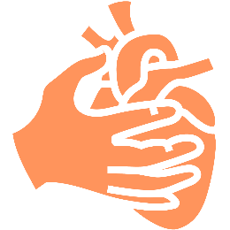 | 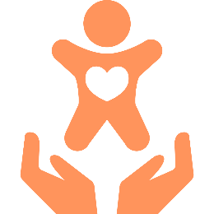 | 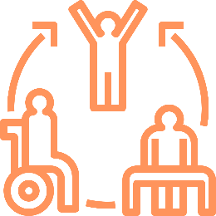
Substance Abuse | Chronic Health | Child Health Services | Rehabilitation
Some survivors may turn to substance abuse as a coping mechanism. Treating substance abuse issues, including rehabilitation and counselling services, becomes part of the healthcare response to GBV. | GBV can contribute to the development of chronic health conditions, such as cardiovascular problems, gastrointestinal issues, and chronic pain. Managing these long-term health consequences requires ongoing healthcare support. | Paediatric healthcare providers play a crucial role in managing the health needs of children who witness or experience GBV. | GBV survivors often require follow-up care and rehabilitation services, including physical therapy, counselling, and support groups.

Burden on the Judicial System:

 | 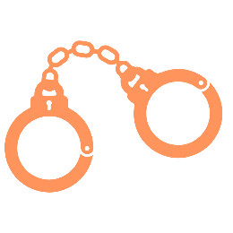 | 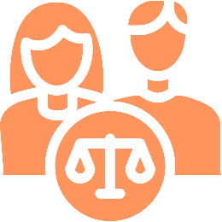 | 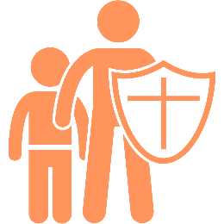
Protection Orders | Criminal Charges | Family Court Cases | Child Protection Cases
Survivors of GBV may seek protection orders to ensure their safety. Processing and enforcing these orders demand the attention of legal authorities. | Perpetrators of GBV may face criminal charges, leading to arrests, trials, and sentencing. | GBV often results in family-related legal issues, such as divorce, child custody battles, and spousal support hearings. These cases require court intervention and decision-making | GBV incidents within families may lead to child protection cases, involving the removal of children from unsafe environments. These cases require legal proceedings
 | 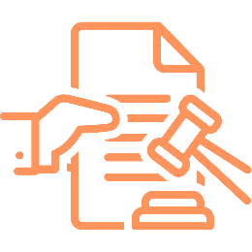 |  | 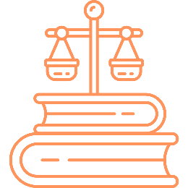
Law Enforcement | Appeals and Reviews | Community Awareness | Legal Education
The judicial system collaborates with law enforcement agencies to investigate and prosecute GBV cases. Coordinating efforts between the judiciary and law enforcement requires additional resources and communication. | GBV cases may result in appeals or reviews, especially if there are disputes over legal decisions or sentences. | The judicial system may engage in community outreach and awareness campaigns to educate the public about GBV laws and legal rights. These initiatives contribute to the workload of the judiciary. | Addressing GBV effectively requires ongoing legal education and training for judges, lawyers, and court personnel.

Lesson 4: Strategies to Address Gender-Based Violence
Addressing unequal power relations and power inequality between genders requires a multi-faceted approach involving societal, institutional, and individual levels. Study the below strategies that could be used to promote gender equality and reduce power imbalances.
equitable:
to be fair and impartial, ensuring that everyone is treated justly and receives what they need or deserve according to their individual circumstances.

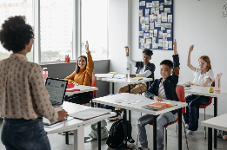 | Education and Awareness  Promote gender-sensitive education to challenge traditional gender norms and stereotypes. Raise awareness about the harmful effects of unequal power relations from an early age. This will foster a more inclusive and equitable society.
 | Legal Reforms  Advocate for and implement legal reforms that promote gender equality, protect individuals from discrimination, and ensure equal opportunities in all aspects of life, including the workplace and family. This will provide a basis for addressing and preventing discrimination.

 | Workplace Gender Policies  Encourage workplaces to adopt and enforce gender-inclusive policies, such as equal pay measures, flexible working arrangements, and anti-discrimination policies. This will foster a culture of fairness and equality.
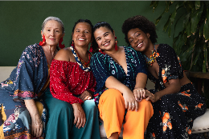 | Empowerment Programmes  Develop and support programmes that empower women economically, socially, and politically. This includes initiatives to enhance women's education, job skills, and leadership capabilities. This will lead to a more balanced distribution of power, and also support diversity in thoughts, experiences, knowledge, ideas and perspectives.
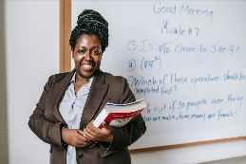 | Representation in Leadership  Actively work towards increasing the representation of women in leadership positions across various sectors, including government, business, and academia. This will reflect a broader range of perspectives and experiences which challenges existing power imbalances.
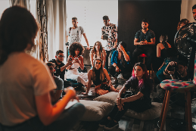 | Community Engagement  Engage communities in conversations about gender equality, encouraging dialogue that challenges traditional beliefs and promotes inclusive attitudes. This will create a supportive environment for change at both individual and community levels.
 | Media Literacy  Promote media literacy programmes that teach individuals, especially young people, to critically analyse and challenge gender stereotypes portrayed in the media. This will lead to more informed and conscious media consumption.
 | Support for Male Allies  Encourage the involvement of men and boys as allies in the fight for gender equality. Programmes that promote positive masculinity and challenge toxic masculinity can contribute to changing societal attitudes. This can lead to a collaborative environment where men contribute to dismantling gender stereotypes and advocating for gender equality.

Reduction and Prevention of Gender-Based Violence
GBV awareness campaigns play a crucial role in reducing and preventing GBV by addressing various aspects of the issue, such as:
- Educating the public about different forms of GBV, to provide them with the skills to them to recognise and respond to GBV when it happens.
- Highlighting consequences to create an awareness of the impact of GBV.
- Challenging traditional gender stereotypes, social norms and discriminatory beliefs.
- Advocating for gender equality attitudes and beliefs.
- Empowering survivors by providing information about health and legal support services and encouraging them to seek help.
- Engaging communities to collectively address the issue, fostering a sense of responsibility and solidarity.
- Leveraging various media platforms, including social media, to reach a wider audience and disseminate information effectively.

GBV Awareness Campaigns
There are several international and South African GBV awareness campaigns that you can participate in. It is important to do research about local awareness campaigns that are being driven in your community. Scan the QR-codes to learn about a few of these campaigns. Alternatively, you can type the link into your browser.
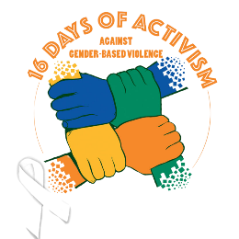 | 16 Days of Activism for No Violence Against Women and Children  This is a global campaign that takes place annually from November 25 to December 10. South Africa actively participates in this campaign, using the 16 days to raise awareness about GBV and advocate for its elimination.  Link: https://bitly.ws/3eTp8 | 

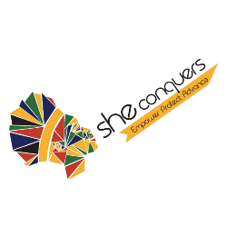 | She Conquers Campaign  Focused on young women and adolescent girls, the She Conquers Campaign aims to address issues such as HIV/AIDS, teenage pregnancy, and gender-based violence. It encourages empowerment and education.  Link: https://bitly.ws/3eTpn | 

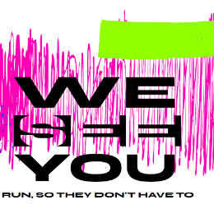 | WeSeeYou  Trulife, a KwaZulu-Natal non-profit organisation (NPO), is on a mission to increase awareness of gender-based violence (GBV) and to encourage a shift in the attitudes toward this ongoing plague in South Africa. With its "WeSeeYou" awareness campaign, runners worldwide sign up to complete 100km in 10 days.  Link: https://bitly.ws/3eTpy | 
GBV Education and Support Programmes

Comprehensive Sexuality Education
Comprehensive Sexuality Education (CSE) was introduced in South Africa in 2000. The aim of the programme is to ensure that learners do not get confusing and misleading messages on sex, sexuality, gender and relationships. CSE programmes plays a crucial role in the reduction and prevention of GBV by providing individuals with knowledge, skills, and attitudes that contribute to healthier relationships, communication, and understanding of consent. Here are few ways in which CSE helps address GBV:

- CSE teaches individuals about the importance of consent in any sexual activity. It helps individuals recognise and establish healthy boundaries in relationships, fostering respect and communication.
- CSE challenges traditional gender roles and stereotypes that contribute to power imbalances and violence in relationships. By promoting gender equality, it works to prevent harmful behaviours associated with rigid gender norms.
- CSE emphasises effective communication skills, teaching individuals how to express themselves, listen actively, and resolve conflicts peacefully. Improved communication can reduce misunderstandings that may lead to violence.
- CSE educates individuals about their sexual and reproductive health, including information about anatomy, contraception, and sexually transmitted infections. Knowledge in these areas contributes to healthier sexual relationships and can reduce the vulnerability of individuals to coercion or violence.
- CSE aims to build self-esteem and empowerment by providing individuals with the knowledge and skills needed to make informed decisions about their bodies, relationships, and sexual health. Empowered individuals are less likely to tolerate or engage in abusive relationships.
- CSE helps individuals recognise signs of abusive behaviour and understand the impact of GBV on physical and mental well-being. It equips them with the knowledge to seek help and support if they or someone they know is experiencing abuse.

Organisations that Provide Social and Legal Support to GBV Survivors
There are numerous organisations in South Africa that provide individuals with resources, assistance, and a network of people who can offer emotional, practical, and legal support. Scan the QR code to visit the Government's Landing page, where you can find contact information about organisations offering such assistance. Alternatively, you can type the following link into your browser: https://bitly.ws/3eTp3 | 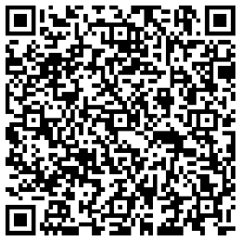

Emergency Contact Numbers
South African Police Service | 10111
Gender-Based Violence Command Centre | 0800 428 428
STOP Gender Violence Helpline | 0800 150 150 / *120*7867#
Human Trafficking Helpline | 08000 737 283 / 082 455 3664
A Closer Look at POWA
To gain a better understanding of the support provided to GBV survivors by the organisations mentioned above, Let us take a closer look at the functions of People Opposed to Women Abuse (POWA).

POWA is a South African, feminist, women’s rights organisation established in 1979. They provide free counselling, sheltering, skills development opportunities, legal services, sector capacity building and strengthening as well as public awareness and education to assist abused women. POWA also engages in advocacy to ensure the realisation of women’s rights and thereby improve women’s quality of life.

POWA provides the following services, which are all free of charge, to women who have experienced violence:

Counselling Support
- Individual Face-to-Face Counselling
- Group Counselling
- Telephonic Counselling (011 642 4345/6)
- E-mail Counselling (counselling@powa.co.za)
- Social Media Counselling (Sending a DM to POWA’s social media platforms)

Sheltering
POWA’s two shelters, based in Johannesburg’s East Rand and West Rand, offer a place of safety for GBV survivors and their children. The shelter’s objectives are to provide a supportive and therapeutic environment that enables them to deal with the trauma of domestic violence. Residents are accommodated for a month up to a year, depending on their circumstances. For example, in exceptional cases, where their children attend schools in the area, women can extend their stay and then leave after the child’s final year exams.

Legal Support
- Court preparation for women due to act as witnesses in cases of abuse.
- Court support which includes accompanying women to court and assisting them to fill out court documents as required.
- Maintenance, divorce and protection order application assistance.
- Legal advice on various GBV matters.
- Joining as a friend of the court on pressing matters.
- Collaborating with other strategic partners in realising women’s rights by assigning legal volunteers at various courts and police stations.
- Knowledge on how the justice system works to enable women to better navigate it.

Additional Information: Providing Support to Victims of GBV
 | Educate Yourself
 | Learn about what constitutes GBV and the different forms it can take (physical, emotional, sexual). Understand the impact of GBV on survivors' mental and physical well-being.
 | Be Aware of Warning Signs
 | Recognise signs of abuse, such as unexplained injuries, changes in behaviour, withdrawal from friends and activities, or signs of controlling relationships.
 | Be a Supportive Friend
 | If a friend confides in you, listen without judgment. Let them share their experiences at their own pace. Believe their story and validate their feelings. Avoid blaming or questioning their choices.
 | Encourage Open Communication
 | Ensure your friend feels safe talking to you. Emphasise your support and confidentiality. If you suspect abuse, gently ask if they are okay and if they need help. Encourage them to share their feelings.
 | Offer Resources
 | Share information about local support services, helplines, or organisations that can assist survivors of GBV. Encourage your friend to seek professional help from counsellors, therapists, or support groups.
 | Respect Their Choices
 | Recognise that survivors may need time to make decisions about their situation. Respect their autonomy and choices. Avoid pressuring them to take actions they are not comfortable with.
 | Promote Healthy Relationships
 | Talk about the importance of consent and boundaries in relationships. Emphasise the value of equal and respectful relationships, and discuss the impact of gender stereotypes.
 | Don’t Be a Bystander
 | If you witness abusive behaviour, intervene safely. This may involve calling for help, distracting the aggressor, or seeking assistance from others.
 | Report Concerns
 | If you believe your friend is in immediate danger, don't hesitate to involve trusted adults, teachers, or authorities.
 | Self-Care
 | Supporting survivors can be emotionally challenging. Make sure to take care of your own mental health and seek support if needed.

