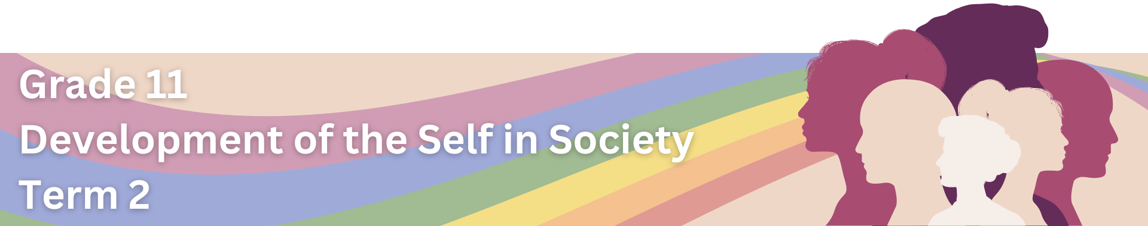

Lesson 4 – Worksheet
 | Activity 1: Strategies to Address Gender-Based Violence  Complete the following activity individually.

1.1. List EIGHT strategies that could be used to promote gender equality and reduce power imbalances.

Strategies to Promote Gender Equality and Reduce Power Imbalances

1.2. State FOUR roles that Awareness Campaigns play in addressing GBV.
- ____________________________________________________________________________________
- ____________________________________________________________________________________
- ____________________________________________________________________________________
- ____________________________________________________________________________________
1.3. Mention FOUR ways in which Comprehensive Sexuality Education (CSE) helps in addressing GBV.
- ____________________________________________________________________________________
- ____________________________________________________________________________________
- ____________________________________________________________________________________
- ____________________________________________________________________________________

Activity 2: Informal Assessment
Complete the following informal assessment questions using your Content Summary.

Question 2.1
Choose the correct answer and write only the letter (A-D) next to the question number (2.1.1 to 2.1.4), for example 2.1.5 D

2.1.1. Examples of psychological violence:
A Slapping in the face, hitting, and murder
B Manipulation, intimidation, and constant criticism
C Sexual comments, advances, and requests
D Limiting financial independence and autonomy

2.1.2. Patriarchy can be defined as:
A A social structure where men and women have equal power and influence.
B A system that promotes equality across the gender spectrum.
C A term describing the absence of gender-based norms and expectations.
D A system where men hold unequal power, influence and authority.

2.1.3. Gender-base violence is often not reported because:
A Victims want to keep the violence a secret to protect their privacy.
B Victims are not sure where to report incidents of GBV.
C Victims are often blamed for the occurrence of the incident.
D Victims don't want to place a burden on the judicial system.

2.1.4. Children who witness domestic violence may …
A become stronger and wiser people as a result.
B have less employment opportunities in the future.
C form stronger relationships with their parents.
D repeat similar behaviours in future relationships.
(4x1) (4)
(Lower Order)

Question 2.2
Study the extract below and answer the questions that follow.
24 Years Ago Nobody Would Listen
A Cape Town woman is pursuing justice 24 years after she suffered years of sexual abuse from her biological father. In May 2023, the 38-year-old woman gathered the courage to open a rape case against the man who was supposed to love, care for and protect her. Many years later, the woman said she still suffered from the trauma of the abuse. "I cannot show affection toward my husband and children as my guard is always up. My defences are always on high alert. I realise that it is hard to understand something if you have not gone through it yourself," she said.

[Adapted from https://www.news24.com/news24/southafrica/news/24-years-ago-nobody-would-listen-now-a-cape-town-woman-says-her-rapist-father-must-face-justice-20230529. Accessed 30 January 2023]

2.2.1. Give TWO examples of psychological trauma that could be experienced by a GBV survivor. (2x1) (2)
(Lower Order)

2.2.2. Describe ONE long-term effect of psychological trauma on an individual's well-being. (1x2) (2)
(Middle Order)

2.2.3. Explain ONE reason why survivors of GBV find it difficult to build trust in a romantic
relationship. (1x2) (2)
(Middle Order)

[6]

Question 2.3
Study the cartoon below and answer the questions that follow.
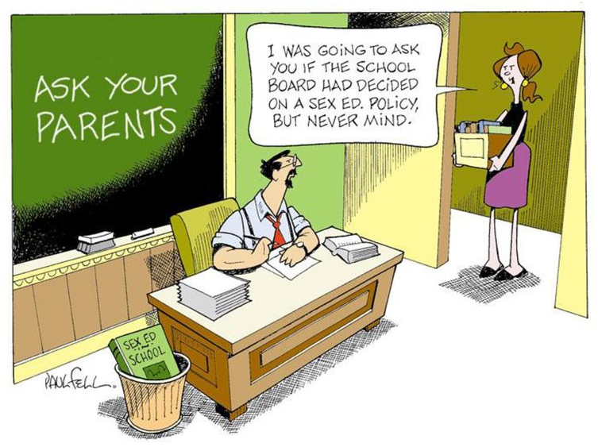
I was going to ask if the school board has decided on comprehensive sexuality education, but never mind.
[Adapted from https://slideplayer.com/slide/17239806/. Accessed 2 February 2024]

Write paragraphs on strategies to address gender-based violence.

Use the following as a guideline:

- State TWO aims of Comprehensive Sexuality Education (CSE) in South Africa. (2x1) (2)
(Lower Order)

- Analyse ONE way in which Comprehensive Sexuality Education can help address GBV. (1x4) (4)
(Middle Order)

- Critically discuss ONE strategy that could be used to promote gender equality in workplaces.
(1x4) (4)
(Higher Order)

[10]

[Grand Total: 20]

