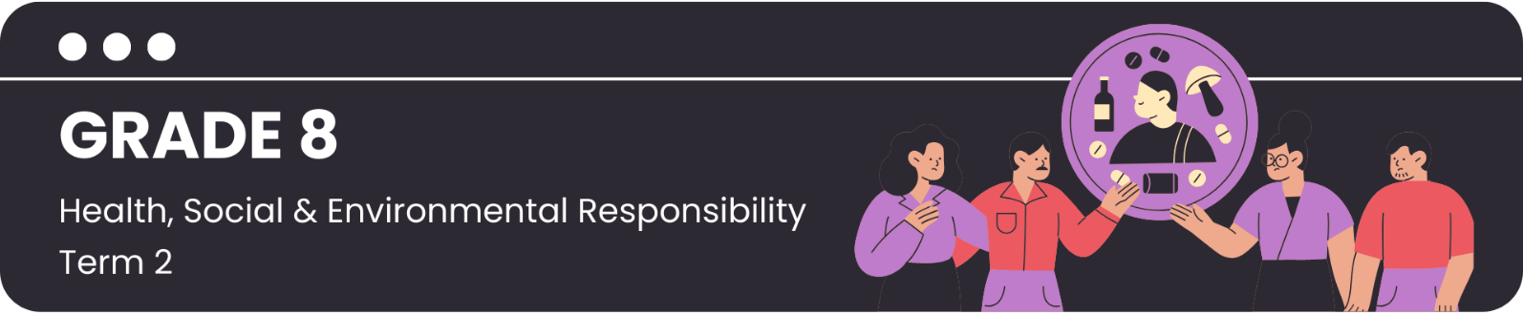

Lesson 2 – Worksheet MEMO
 | Activity 1: Brainstorming  Complete the following brainstorming activity in pairs.

Question 1
Study the following statistics from a recent study done by Equal Education and answer the question that follow.
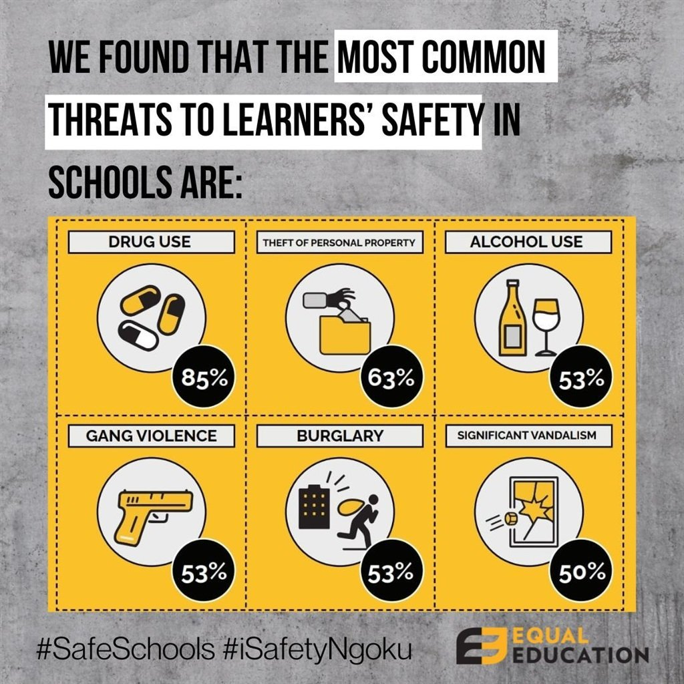

[Source: https://www.news24.com/news24/southafrica/news/drugs-alcohol-and-gang-violence-make-western-cape-schools-dangerous-places-for-pupils-20230920 Accessed: 13 November 2023]

1.1 Brainstorm FOUR ways in which SCHOOLS can stop or prevent substance abuse amongst
teenagers.

- Teach health and life skills.
- Have mental health support available.
- Have and enforce policies around substances.
- Offer extracurricular activities to keep learners busy.

Question 2
Read the following extract and answer the question that follow.
UNENGAGED AND UNINVOLVED
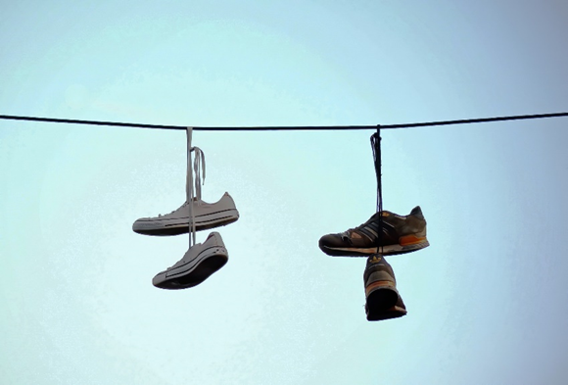

Studies in South Africa have repeatedly shown the link between young people who have nothing to do and troubled social behaviour, including drug abuse and violence.

A former gang member from Bophelong in Gauteng indicated:

“Our homes are too small; they are suffocating us. There are no facilities for young people in this area, young people have nothing to do … We need facilities or else we join gangs and do drugs just to forget about our circumstances.”

[Adapted from: https://bhekisisa.org/article/2022-03-09-unengaged-and-uninvolved-how-to-help-south-africas-youth-stay-off-the-streets-and-out-of-trouble/ Accessed: 13 November 2023]

2.1 Brainstorm FOUR ways in which the COMMUNITY can stop or prevent substance abuse amongst
teenagers.

- Community treatment and support facilities.
- Community policing and law enforcement presence.
- Empower and engage the youth.
- Offer support and education to parents.

Question 3
Read the following extract and answer the question that follow.
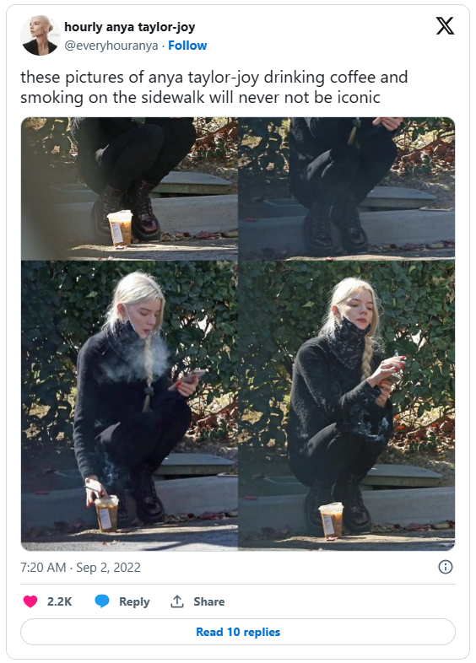
GEN Z MIRROR CELEBRITY SMOKING HABITS
The apparent increase in smoking among Generation Z is likely a combination of celebrity influence and a care-free outlook on life. Guardian writer, Alaina Demopoulos, recently wrote about the increasing number of young celebrities photographed smoking.

She noted one photo of actress Anya Taylor-Joy (from the Netflix series, The Queen's Gambit) drinking coffee and smoking on a footpath, which was described as "iconic". Another Tweet featuring influencer Kylie Jenner said, "heroin chic and skinny is back in".

Young fans now want to "project this sort of party girl, early 2000s image".

[Adapted from: https://www.newstalk.com/news/vapes-arent-as-cool-are-gen-z-bringing-back-cigarettes-1492544 Accessed: 13 November 2023]

3.1 Brainstorm FOUR ways in which the MEDIA can stop or prevent substance abuse amongst
teenagers.

- Create campaigns that spread awareness.
- Promote positive role models.
- Social media must spread positive messages.
- Responsible advertising practices must be followed.

Activity 2: Reflection – Personal Plan to Avoid Substance Use
Complete the following activity based on your personal values.

Scenario: You're at party at a friend's house. Everyone seems to be having a good time. As the evening progresses, an older guy approaches you and invites you to join them in a more secluded area where they have some alcohol and cigarettes.
Decision-time
Think Before You Act:
What might happen if I drink alcohol or smoke cigarettes?

Gather Information:
YES / NO
YES / NO
Do I understand the effects of alcohol and cigarettes on my mind and body? | Is my knowledge 100% factual?
Identify Your Values:
Circle the things that are important to you:
Health & Well-being | Responsibility | Respect for Others | Self-Control
Integrity | Safety | Academic Success | Sport Success
Family | Relationships | Religion | My Future
Friendship | Perseverance | Ambition | Honesty
YES / NO
Does drinking alcohol and smoking cigarettes align with my values and morals?

Set Goals:
Name three goals that you have set for yourself this year.

Does drinking alcohol and smoking cigarettes align with my goals?
YES / NO

Refusing the invitation:
Write down ONE assertive refusal response you would use in this situation:

Learners will have personal responses to these questions.

