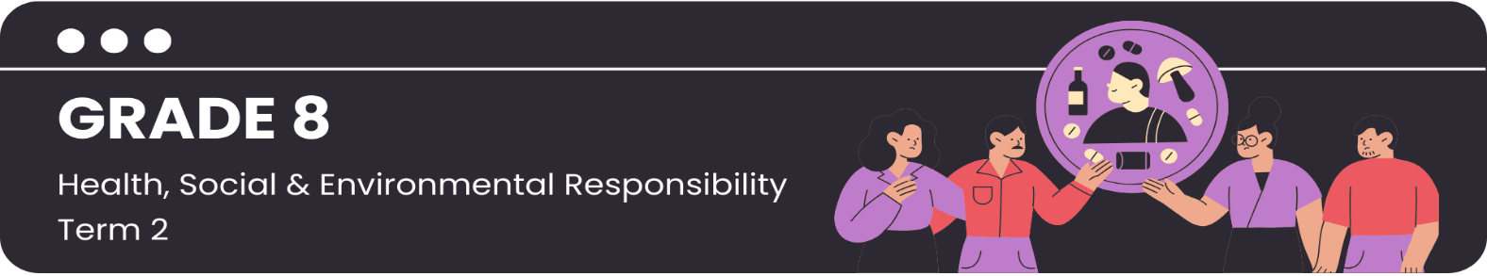
Scenario 1: School Community
Read through the following scenario. Identify the social factors that contribute to substance abuse and complete the mind-map in (Activity 2) Lesson 1 – Worksheet. You may add any social factors you can think of that are not in the scenario.
AMY NAVIGATES HIGH SCHOOL

Amy found herself navigating the complex social factors within her school community, while trying to make the right choices regarding substance use. Take a look at the day-to-day challenges that she faces.

As Amy walks home from school, she walks past an empty building on the far end of the school field. This area is never supervised by teachers. Every day, she sees some older learners are meeting up with strangers who are selling them substances. She also recognises some of her classmates using the substances being sold. She keeps her head down and walks past quickly, pretending not to notice them.

Amy has been feeling a little down lately. She is facing increasing academic demands and the stress that comes with it. She overhears some learners discussing using substances to cope with the pressure. The same group of learners have been bullying Amy about her interests and appearance. This has taken a toll on her emotional well-being. She is starting to wonder if using substances might help her cope with the stress. She has never used substances before, and she has no idea what effect they will have on her. She has not learnt much about substance use in school, and none of the adults in her life are talking to her about it.

One day, Amy is invited to a party by one of her classmates who is part of the "cool crowd". She has heard rumours that substances will be available at the party. She feels pressure to attend the party so that she can fit in and feel better about herself. She decides that this might be the perfect opportunity to experiment with substances. Will Amy give in to the social pressures she is facing?

Scenario 2: Broader Community
Read through the following scenario. Identify the social factors that contribute to substance abuse and complete the mind-map in (Activity 2) Lesson 1 – Worksheet. You may add any social factors you can think of that are not in the scenario.
JACOB NAVIGATES HIS COMMUNITY


Jacob lives in a community where various social factors play a role in influencing teenagers' use of substances. His experiences shed light on these factors and how they impact his choices and decisions.

In the area where Jacob lives, it's easy for teenagers to find drugs and alcohol. There are always older kids hanging around who have access to these substances and sell it to others. He is focussed on making the community rugby team, and he knows that using substances might stop him from getting there. However, he is facing some challenges, which are making him contemplate using drugs and alcohol.

Jacob's family struggles financially, and his parents have a hard time finding stable work. This leads to stress and tension at home. On top of that, his older brother struggles with substance abuse, and his parents often have arguments about it. Jacob doesn't feel like he has the support he needs at home. Some of his friends who are in similar situations have started using substances to try and cope with their situations.

Jacob's school doesn't have many resources, and they don't teach much about the dangers of using drugs and alcohol, which means that he and his friends aren't really aware of the risks involved in using these substances.

He sees many adults and older kids around him who use drugs and alcohol, and he starts to believe that it's a normal part of growing up and coping with life. Will Jacob give in to the social pressures he is facing?

Scenario 3: Media Influence
Read through the following scenario. Identify the social factors that contribute to substance abuse and complete the mind-map in (Activity 2) Lesson 1 – Worksheet. You may add any social factors you can think of that are not in the scenario.
ANDY NAVIGATES THE MEDIA


Andy is a high school learner who finds herself navigating the complex and often conflicting messages about substance use portrayed by the media. Take a look at how Andy deals with these influences.

Andy loves spending time watching series and movies. She knows that her parents won't approve of everything she's watching, but she believes it's making her more informed about the world. She often watches shows where teenagers are using and abusing substances. She thinks that they are cool and live glamorous lives. She sometimes wishes that she could also have such an interesting life.

While watching TV with her parents, Andy sees many advertisements that feature young people enjoying alcohol. She doesn't know this, but many of these advertisements are designed to attract young people and make substance use appear normal and appealing.

On social media, Andy's friends and even some celebrities showcase their partying experiences, including where they are using substances. When she sees people she looks up to engaging in these behaviours, she feels a sense of peer pressure and curiosity about trying it herself.

Despite the media's mixed messages, Andy knows that the same media can provide valuable information about the risks associated with substance abuse and where to find help if needed. She often needs to remind herself to stay determined to achieve her academic goals and make smart choices. Will Andy give in to the social pressures she is facing?

