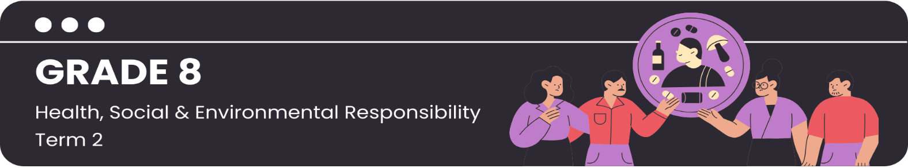

Lesson 1 – Worksheet MEMO
 | Activity 1: Intro Quiz and Knowledge Recap  Complete the following quiz to see how much you know about substance abuse.

Read the statements about substance abuse and indicate whether you think they are "true" or "false" by marking the appropriate box with a tick ().

Statement | True | False
1. Drinking alcohol will make you cool or popular. | □
2. You can get addicted to drugs after just one use. |  | □
3. Vaping is not addictive. | □
4. One in two teenagers in the average SA home is a user of alcohol. |  | □
5. Using drugs makes you more creative. | □
6. More than 60% of teenagers in SA have been drunk by the age of 18. |  | □
7. Vaping has no long-term effects. | □
8. Beer is less harmful than spirits. | □
9. Teenage brains are more sensitive to alcohol than adult brains. |  | □
10. Alcohol makes you a better dancer. | □

Read the statements in the first column and match them with the correct term in the last column. Fill the correct letter (A-G) in the blank centre column.

Statement |  |  | Answer | Term
1 | Using substances in a harmful way. |  | E | A | Withdrawal Symptoms
2 | Needing more of a substance to get the same effect. |  | G | B | Types of Substances
3 | Unpleasant physical reaction when you stop using an addictive substance. |  | A | C | Interpersonal Risk Factor
4 | Family history of alcohol abuse, for example. |  | F | D | Symptoms of Abuse
5 | Peer pressure, for example. |  | C | E | Substance Abuse
6 | Alcohol, illegal drugs, prescription medication, cigarettes, inhalants. |  | B | F | Intrapersonal Risk Factor
7 | Red eyes, lack of attention, weight changes, mood swings. |  | D | G | Tolerance
Activity 2: Scenario Answers
Complete the following mind-maps while you are working through the scenarios.

Note: Complete ONLY the mind-map that corresponds to your group's scenario. You will complete the rest while the other groups are giving feedback.

Scenario 1: School Community

- Negative peer pressure
- Accessibility
- Social events and parties
- Bullying and victimisation
- Curiosity and experimentation
- Academic pressure
- Lack of supervision
- Lack of education

Scenario 2: Broader Community

- Easy access to substances
- Lack of money and/or jobs
- Lack of education
- Community norms
- Family dynamics

Scenario 3: Media Influence

- Portrayed as cool or normal
- Advertising and promotions
- Peer comparison
- Information and awareness

Activity 3: Reflection
Complete the following questions to reflect on the content you have covered today.

Which social factors that contribute to substance abuse are present in your own life or the lives of people you know?
__________________________________________________________________________________________________________________________________________________________________________________________________________________________________________________________________

What are some of the misconceptions about substance abuse that you were unaware of, and how has this awareness changed your perspective?
__________________________________________________________________________________________________________________________________________________________________________________________________________________________________________________________________

Have you experienced or witnessed any situations involving substance use and its effects on individuals or communities? How did it impact you or those involved?
__________________________________________________________________________________________________________________________________________________________________________________________________________________________________________________________________
Learners will have personal responses to these questions.

