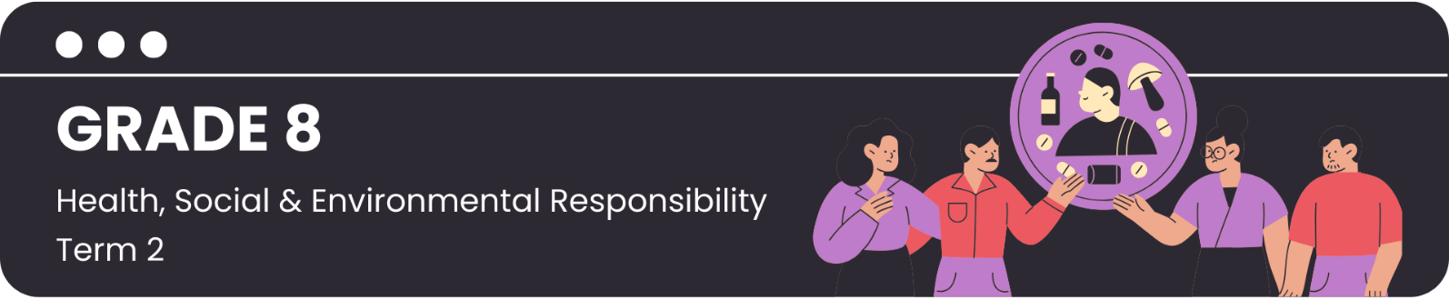

Lesson 3 – Worksheet
 | Activity 1: Group Discussion  Complete the following activity in groups.

- Your group will receive THREE scenario cards that describe situations involving crime, violence and unfavourable educational outcomes due to substance use.
- In your groups, read the scenario aloud and discuss the prompt on the card.
- Use the space provided below to make any notes you wish to remember regarding your discussion.
Discussion Notes:
____________________________________________________________________________________________________________________________________________________________________________________________________________________________________________________________
____________________________________________________________________________________________________________________________________________________________________________________________________________________________________________________________
____________________________________________________________________________________________________________________________________________________________________________________________________________________________________________________________
____________________________________________________________________________________________________________________________________________________________________________________________________________________________________________________________






Activity 2: Revision Questions
Complete the following revision questions using your Content Summary.

Question 1.1
Choose the correct answer and write only the letter (A-D) next to the question number (1.1.1 to 1.1.4), for example 1.1.5 D

1.1.1 Which of the following is a short-term consequence of substance abuse related to crime?

A. Increased community involvement
B. Engagement in stealing or shoplifting
C. Decreased aggression
D. Enhanced problem-solving skills

1.1.2 What is a crucial step in supporting a friend dealing with substance abuse?

A. Ignoring the situation
B. Encouraging them to continue harmful behaviour
C. Talking openly, encouraging honesty, and suggesting seeking help
D. Tell everyone you know about their situation

1.1.3 Aggressive behaviour resulting from substance use can lead to:

A. Improved relationships with family and friends
B. Physical health improvements
C. Fights and strained relationships with others
D. Becoming more popular in school

1.1.4 Which of the following is an appropriate behaviour to stop and avoid substance abuse?

A. Take up hobbies and sports to find friends that uses substances.
B. Using substances only once a week to find a good balance.
C. Do volunteer work to feel a sense of purpose and accomplishment.
D. Using small amounts of substances with friends to feed your creativity in music.
(4 x 1) (4)

Question 1.2
Complete the following sentences by filling in the missing word(s).

1.2.1 _________________ is when your body obsessively craves a substance. (1)

1.2.2 People who struggle with addiction can go to a ________________________ to find support
and treat their addiction. (1)

1.2.3 Needing more of a substance to get the same effect is referred to as ____________________. (1)

1.2.4 Having strong family support, positive friendships, and effective techniques to deal with stress
and problems are known as ______________ factors. (1)

(4 x 1) (4)

Question 2
Study the extract below and answer the questions that follow.
SOCIAL FACTORS THAT CONTRIBUTE TO SUBSTANCE ABUSE

Teens often use drugs to generate good feelings and avoid or escape bad ones. In today’s world, not only are these substances readily available, but adolescents also see substance use on social media and in their homes. They are aware that drugs exist and they know how they can obtain them.

[Adapted from: https://isminc.com/advisory/publications/the-source/understanding-substance-use-and-how-it-impacts-student-well-being Accessed 10 November 2023]

2.1 Name TWO social factors within a school community that can contribute to teenagers using substances. (2 x 1) (2)

2.2 Define the term 'negative peer pressure'. (1 x 2) (2)

2.3 Provide TWO reasons why a teenager could get involved in substance use within their
broader community. (2 x 1) (2)

2.4 Discuss TWO ways in which the media contributes to substance use amongst teenagers. (2 x 2) (4)
[10]

Question 3
Study the extract below and answer the questions that follow.
CRIMES RELATED TO SUBSTANCE ABUSE
According to SAPS figures, 60% of crimes nationally were related to substance abuse. In the Western Cape, the figure was closer to 80%. The perpetrators of these crimes are either under the influence of substances, or trying to secure money for their next fix.

[Adapted from www.onlinerehab.co.za Accessed 10 October 2023]

Write paragraphs on consequences of alcohol abuse.
Use the following as a guideline:
3.1 Define the term 'substance abuse'. (1 x 2) (2)
3.2 Discuss ONE short-term consequence and ONE long-term consequence that
substance abuse can have on your education. (2 x 2) (4)

3.3 Recommend TWO ways in which you can help a friend who is struggling with
substance abuse. (2 x 2) (4)
[10]

