

Lesson 1 - Worksheet

Activity 1:

Douglas Barton made some strong statements in “What the top students do differently?” (https://www.youtube.com/watch?v=Na8m4GPqA30). The aim was to help learners reflect on what the top students across different countries are doing that gives them the top results. In your groups, discuss what you have learnt from this clip by discussing the following questions.

- Burton said, “Self-discipline trump's IQ”. Discuss this statement by referring to TWO healthy examples of study habits.
________________________________________________________________________
________________________________________________________________________
________________________________________________________________________

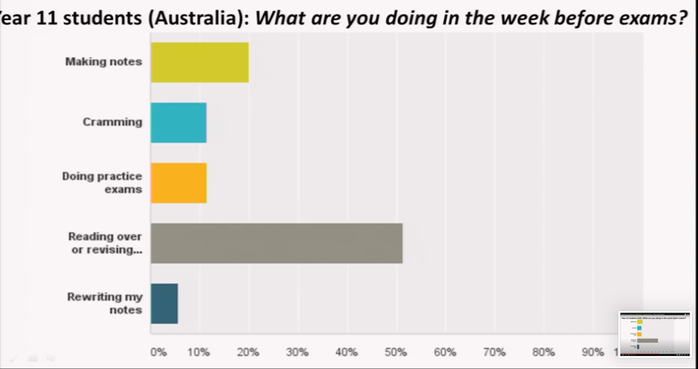
- Identify which of the following study techniques (see below graph) you would have used the week before your exams last year.

________________________________________________________________________
________________________________________________________________________
________________________________________________________________________

- State ONE skill you learnt from this clip that you would like to implement this year.
________________________________________________________________________
Activity 2:

Look back on yesterday, block out the hours in your day with the activities you were involved in. Use the following suggestions as a guide:

sport, meals, social media/ entertainment, studying, homework, chores, sleep
5-6 am |  | 15-16
6-7 |  | 16-17
7-8 |  | 17-18
8-9 |  | 18-19
9-10 |  | 19-20
10-11 |  | 20-21
11-12 |  | 21-22
12-13 pm |  | 22-23
13-14 |  | 23-24
14-15 |  | 24-5 am

How many hours did you spend on each activity during the day?
________________________________________________________________________
________________________________________________________________________
________________________________________________________________________
________________________________________________________________________

Where can you make changes to allow 2 hours for studying?

________________________________________________________________________
________________________________________________________________________
________________________________________________________________________

Activity 3: Homework
Study the below image and answer the questions that follow.



[Accessed from: https://www.newframe.com/the-digital-learning-divide/ on 20 May 2021]

Write paragraphs on studying in a South African context.

Use the following as a guideline.

- Define the term ‘study plan’ and state TWO reasons why it is important for South African
learners to develop a study plan. (1+2)(3)

- Explain FOUR ways in which impoverished learners may struggle to study due to their circumstances. (4x2)(8)

- Recommend THREE study strategies which South African learners could put in place if they struggle to learn at home. In your answers, also indicate how EACH strategy could help learners be prepared for their exams. (3x3)(9)

(20)

Activity 4:

As we come to the end of this lesson. Reflect on your understanding of the content covered.
- In the table below, rate your level of understanding in the study skills content covered:
(1 - Absolutely not!, 2 - Still feeling unsure, 3 - Totally aced it!)
Rate
1 or 2 or 3
1.1 | I would confidently be able to put together a realistic study plan that I can stick to.
1.2 | I feel that I can manage my social media habits so that I do not waste time when I should be studying.
1.3 | I am able to evaluate my study plan and make the necessary changes for it to run effectively.
1.4 | I have identified the most effective learning style and know how to make changes to my study habits to implement these skills.
1.5 | I intend to practice past papers in my study of future tests/ exams.
1.6 | I tend to blank out in my exam because of lack of sleep or lack of preparation.
1.7 | I know I need to make changes to my examination writing skills.

- Based on your rating in the above table, which area of study did you rate the lowest in?
Which aspect of this section do you need to revise?

