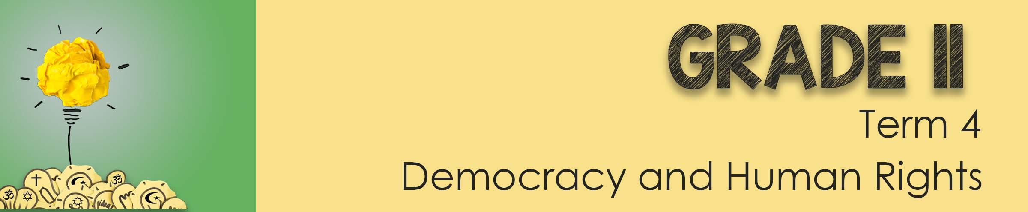
Lesson 2 – Scenario 1 - 4
In the next lesson you will have the privilege of being interviewed by a panel of “wise advisors. These groups will be made up of people from different religious backgrounds and moral values. They will need to consider those values and beliefs when proposing a solution.
You will be allocated one of the scenarios below as a profile. Do some additional research before the next lesson so that you will be prepared for any questions the group might have. You can use some creative license when acting out your role but make sure you remain in line with the dilemma written in bold. Good luck and enjoy your moment of fame in the spotlight!

Scenario 1:
You are a qualified life saver and strong swimmer, often working on beaches over weekends. You and your family go on holiday to the beach for a weekend. Your younger sister often gets bored on family getaways, so your mom made plans to take her friend along. As soon as you arrive, a storm is looming on the horizon and the water looks rough. You overhear your mom tell the girls they can get ready to swim, but to come back and help unload the car. They are so excited, they do not pay attention to the last part of what your mom said and run down to the beach to swim. No one realises what they have done until you hear your sister scream. You realize they are both caught in a strong current and might be swept out to sea. Your mother is panicking and there are no life guards in sight. You are a good swimmer and know you can save one of them. You have a difficult choice to make. Do you:

- Save the best friend first because she is the weaker swimmer and struggling?
- Save your sister first because you don’t want to lose her and you’re not sure if she’ll hold on until you get back to her after saving her friend.
- Do nothing as you fear getting caught in the strong current and you might drown yourself.

Scenario 2:
You have worked years to be successful in your father’s business. You felt you were obligated to take over as he worked his whole life to build the business left to him by his father. However, the large businesses in town have seriously cut into profits and for several years you and your family have just managed to scrape by.
Your father’s health has declined and he has been hospitalized. He has a substantial life insurance policy that expires at midnight. If he dies before midnight, you will inherit enough money to pursue a career you have always dreamed of and provide adequately for your family. Do you:
- Pinch the oxygen line making it possible for your dad to die or smother him with a pillow?
- Tell your dad the problem and let him suggest a solution and go by what he says?
- Do nothing as you cannot imagine living with yourself if you terminate your dad’s life?

Scenario 3:
You are in your last year of varsity, studying to be an accountant. On your way back from an evening lecture you were violently raped 3 months ago. You went to the doctor straight away and they treated you with the morning after pill straight away. You wanted to forget about the situation so tried to move on with your life. You recently found out that you fell into the 1% that the morning after pill did not stop the pregancy. You are now 3 months pregnant. The doctors have also told you that this will probably be your only pregnancy ever as your reproductive organs were irreperably damaged when raped.
- Do you keep the baby because this could be the only child you ever have?
- Do you have an abortion because you can’t handle carrying the child of a rapist and a baby would destroy your future?
- Do you give the baby up for adoption because you can’t morally kill the child, but you can’t imagine looking into the face of the child whose father raped you?

Scenario 4:
You are a young final year medical student working in the emergency casualty ward at a public hospital. A mother is rushed in bleeding out from an accident in the kitchen with her 1 year old child on the bed. The paramedics said that she begged them to save her life because she was the single parent of the little girl. You begin to arrange for a blood transfusion but in pulling up her records you see that she has a notice “No blood transfusions for religious reasons”. You know without the blood transfusion she will die and the little girl will end up in the system.

- Do you ignore that you discovered this information and save her life because she voiced this desire to the paramedics?
- Do you honour the request on the medical records because you know that she could sue you and you would never get your medical licence?

These are the questions the others will be answering in response to your story.

- Descibe the moral dilemma of the actor/ actress

- Identify if there are any laws impacted by the decision making?

- How does religion impact this dilemma?

- Vote on how many in the group are FOR or AGAINST ………… motivate whether you agree or disagree.

