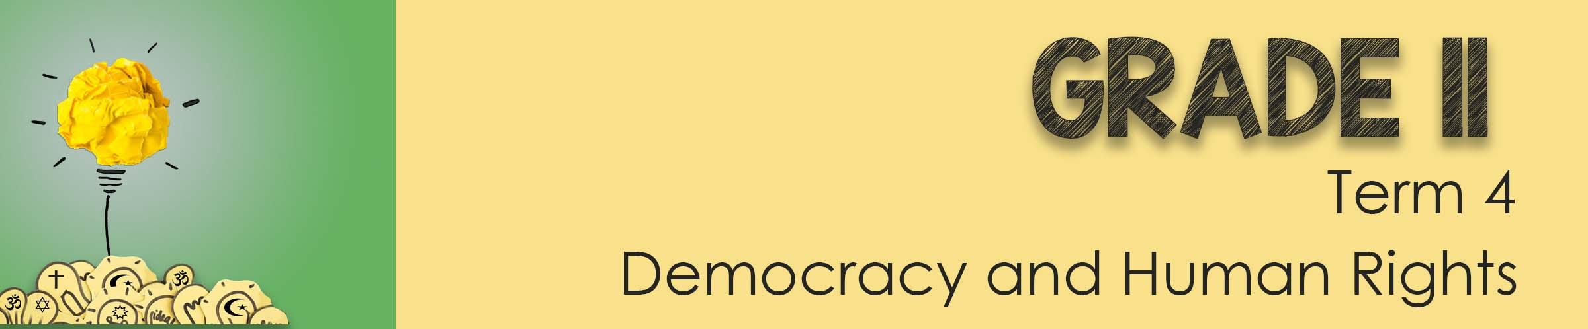
Lesson 2 - Worksheet MEMO

Activity 1: Explain each of the following terms in your own words
DILEMMA
A dilemma means that there are valid reasons for two opposing actions.

RIGHT-TO-LIFE
In South Africa according to the Bill of Rights, everyone has a RIGHT TO LIFE. This is the right not to be killed.

EUTHANASIA
EUTHANASIA is the act of killing someone who is very sick or injured in order to prevent any more suffering.

Activity 2:
“Today you are going to get a chance to respond to these difficult situations. Imagine that you are a group of the wisest advisors in the world and this person has sought you out to solve their dilemma. Your group is made up of people from different religious backgrounds and moral values. You must consider those values and beliefs when proposing a solution. Each group will move FOUR times this lesson, collecting information on the different situations.
Record your findings below:

Scenario 1:
- Descibe the moral dilemma of the actor/ actress
- Which person to save first – your sister or her friend (who is the weaker swimmer).
- Do you risk trying to save either of them with the current being very strong.

- Identify if there are any laws impacted by the decision making?
In terms of the law, there is no obligation to help … especially as you are off-duty and the conditions could potentially become dangerous (strong current).
However, as a qualified lifesaver and good swimmer, you would probably be expected to make an effort to assist despite being on holiday.

- How does religion impact this dilemma?
Your religion would impact your worldview in such a situation. Many faiths encouage their believers to put other’s needs first and sacrifice for the benefit of others.

- Vote on how many in the group are FOR or AGAINST ………… motivate whether you agree or disagree.

Scenario 2:

- Descibe the moral dilemma of the actor/ actress
Right to life for your father (irrespective of the health implications going forward) vs your financial freedom if he were to die before midnight and leave you with a substantial life insurance policy (that would otherwise lapse)

- Identify if there are any laws impacted by the decision making?
Murder and Life insurance fraud

- How does religion impact this dilemma?
Your religion would impact your worldview in such a situation. All faiths believe that human life is sacred. That it would be wrong to take the life of another person (except in certain circumstances such as war, defence etc).

- Vote on how many in the group are FOR or AGAINST ………… motivate whether you agree or disagree.

Scenario 3:
- Descibe the moral dilemma of the actor/ actress
- Having the baby from a violent rape (esp as cant have any future children)
- Abortion
- Having the baby and giving it up for adoption

- Identify if there are any laws impacted by the decision making?
Abortion in South Africa is legal on request during the first 12 weeks of pregnancy, and under certain conditions afterwards.
Since it is beyond 3 months, special permission would most likely be required to have an abortion now.

- How does religion impact this dilemma?
Certain faiths are against abortion, some make allowance for abortion under certain circumstances.

- Vote on how many in the group are FOR or AGAINST ………… motivate whether you agree or disagree.

Scenario 4:
- Descibe the moral dilemma of the actor/ actress
- Administering the blood transfusion – that will save the mother’s life.
- Respecting the mother’s prior decision (since its in her medical records) that for religious reasons – she wants no blood transfusion.
- Aware of the little girl who will be an orphan if her mother dies.

- Identify if there are any laws impacted by the decision making?
Malpractice or negligence as a doctor
Only if a patient repeatedly, explicitly and freely refuses treatment with blood and blood-derived products in a life-threatening situation is the doctor obliged to respect the patient’s wishes, which in the case of refusal should preferably be given in writing.
Although the patient previously refused a blood transfusion (based on her medical records), it cannot be assumed that her choice on the matter has not changed since then. Given that she wants to live (begged paramedics to save her life) means that its likely she would accept a blood transfusion – should that be necessary to save her life.

- How does religion impact this dilemma?
Most faiths permit blood transfusions.
A small group of people belonging to a certain religion, called Jehovah's
witness do not accept blood transfusion or blood products, based on biblical
readings.

- Vote on how many in the group are FOR or AGAINST ………… motivate whether you agree or disagree.

Activity 3: Reflection Activity
Being confronted with difficult real life situations can make you feel a bit overwhelmed. Take the last few minutes and reflect on the two questions below:
- What have you learnt about yourself and your beliefs regarding “the right-to-life”?
- What advice would you give a friend on the decision making process when encountering a dilemma? Each learner will have their own response

