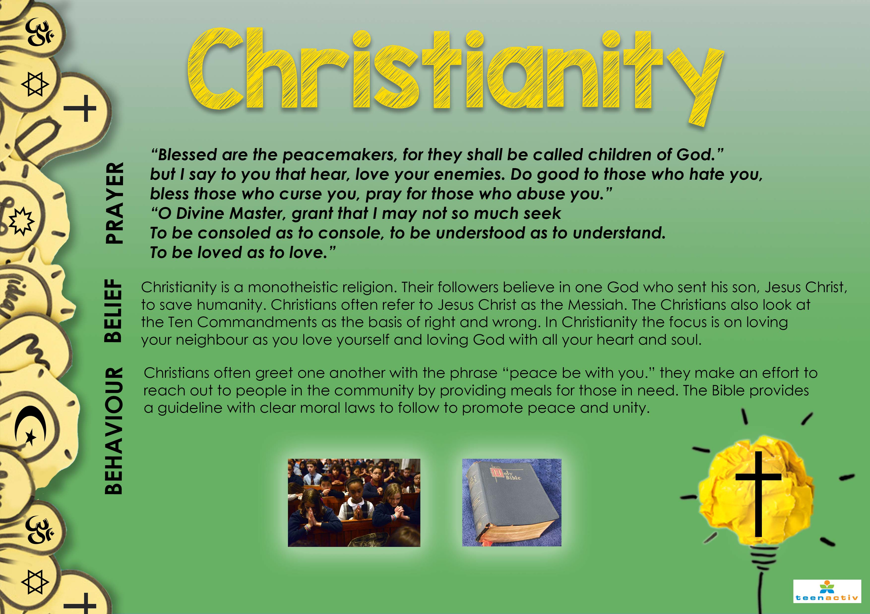
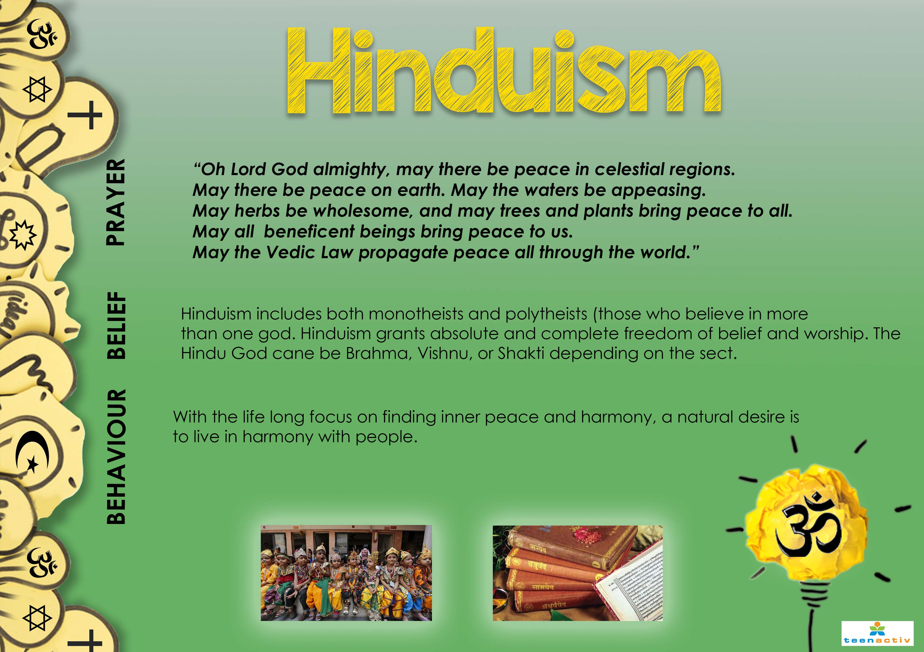
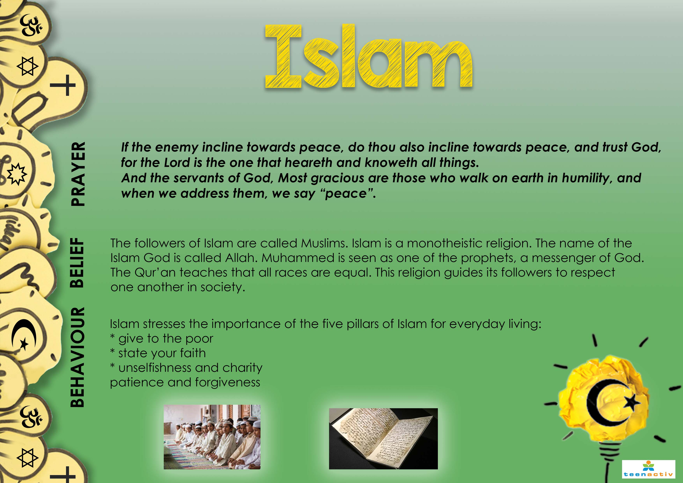
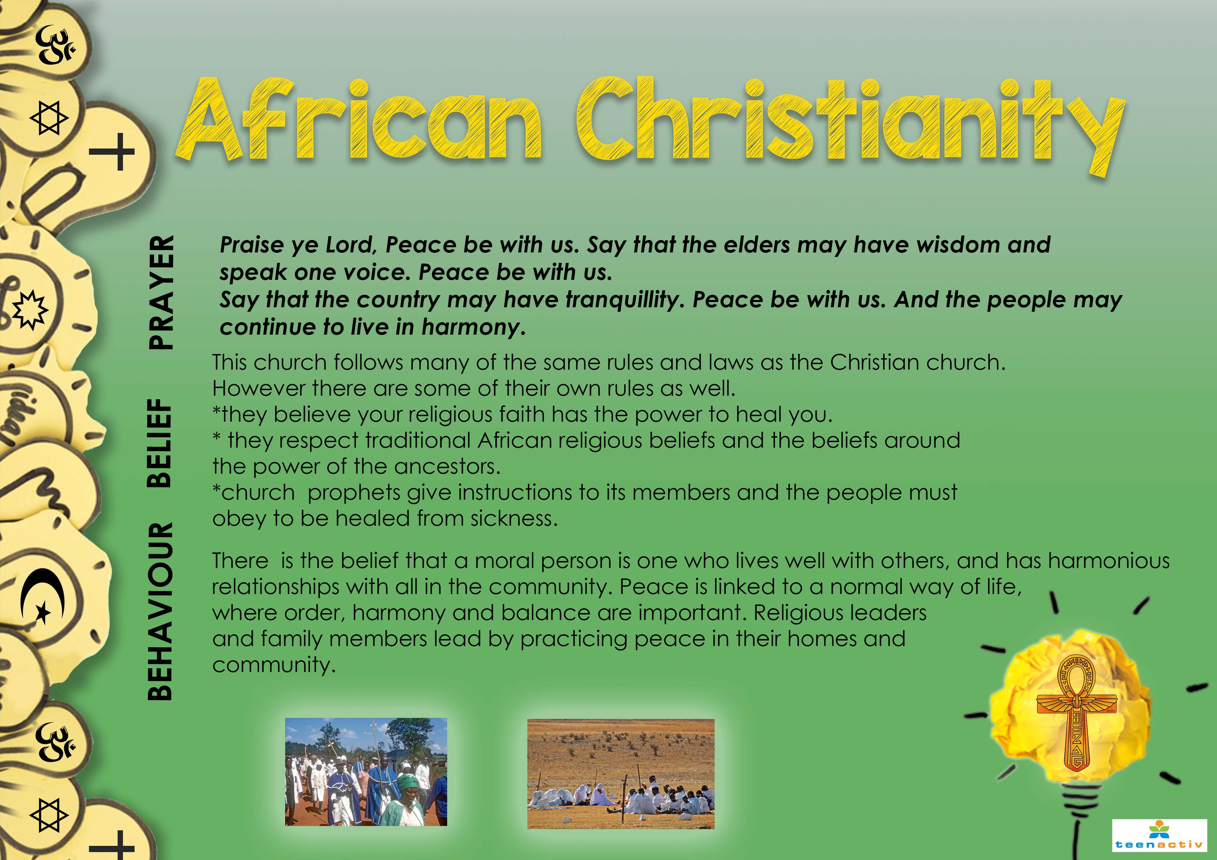
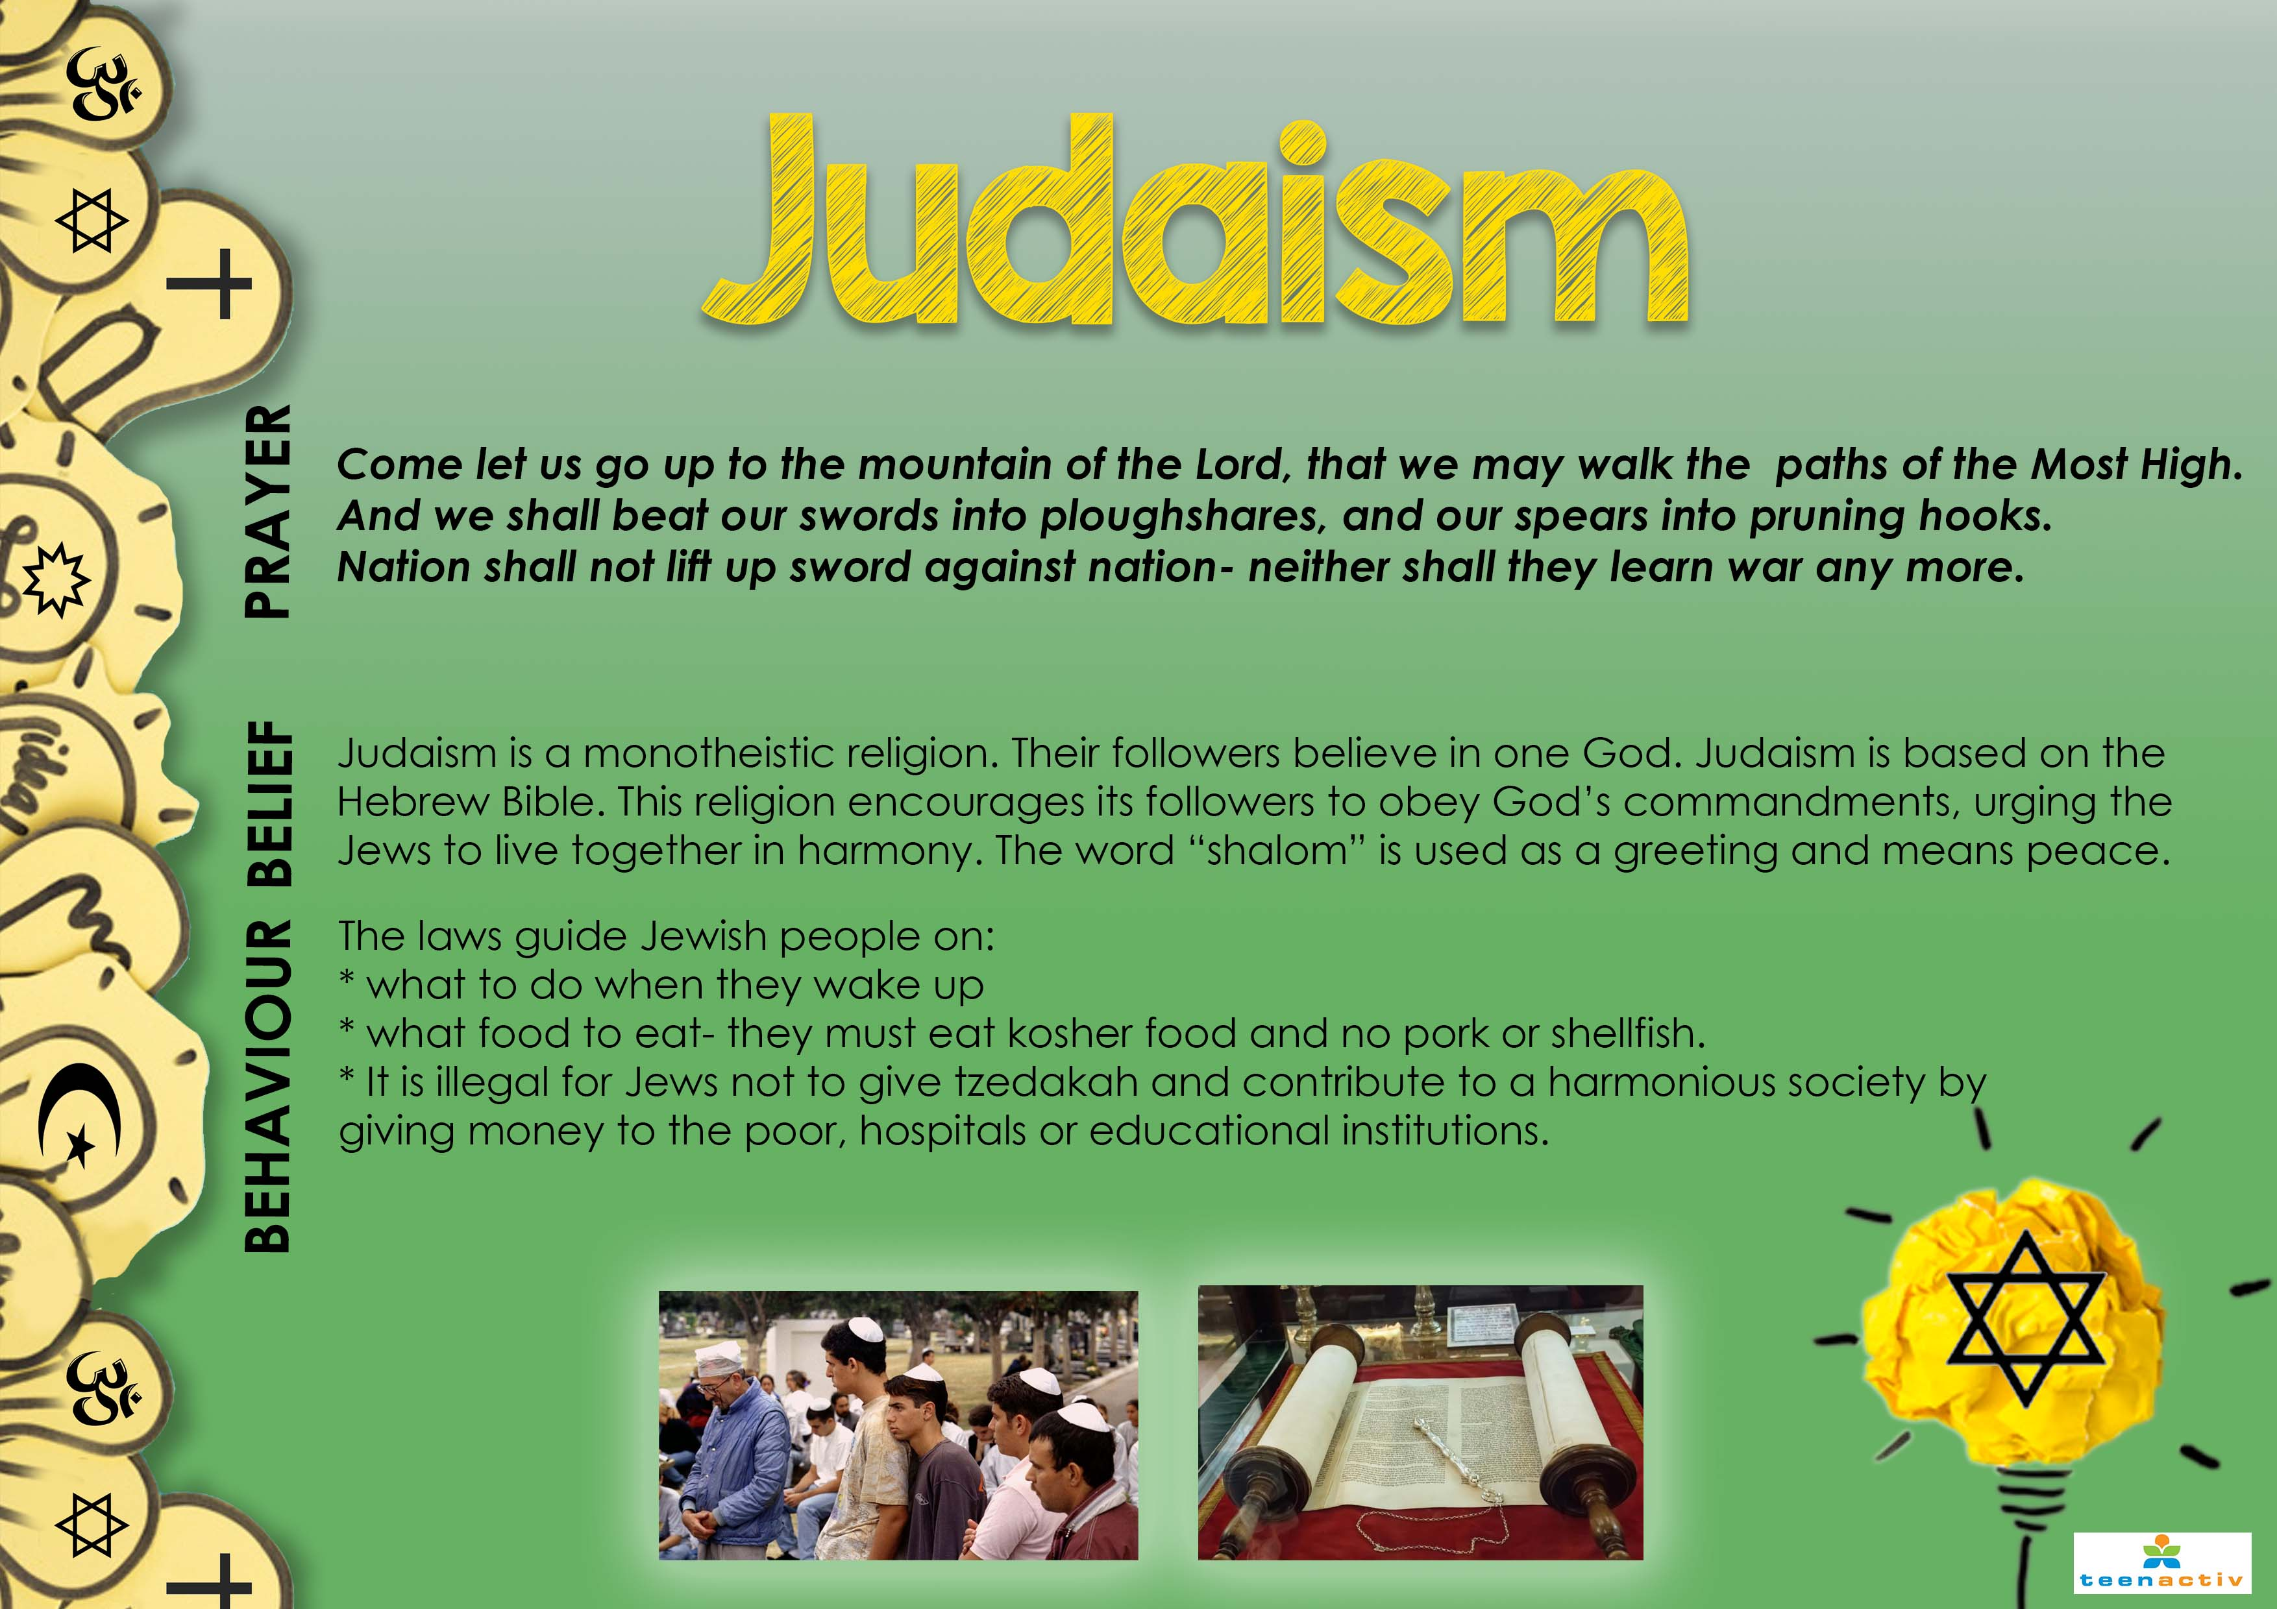

African Tradition Religions
Belief:
African Tradition Religions believe that those who passed on (ancestors) guide them. Thus, they acknowledge them with certain rituals such as: slaughtering of cows/goats for certain times or the drinking of Umqombothi. They often seek guidance and spiritual healing/cleansing from Sangomas. If one feels there are evil spirits or an individual / family is often unwell or has some bad luck, then they seek healing from the Sangoma. To do so, various herbs could be consumed, or certain rituals performed to banish the bad luck or poor health.

Behaviour:
- Respect of elders.
- Always cover yourself (modesty, men and woman)
- Males cannot speak to the ancestors without wearing a jacket/blazer
- Females always wearing a scarf (also called “doek”)
- Before any ceremony one must be pure: No eating of pork, drinking of alcohol or engaging in sex are some examples.


