Lesson 1 – Worksheet MEMO

Activity 1:
Complete the below table:
 | Education | Lifelong Learning
Gain knowledge through: | Educators | Own individual experiences
Formal / Instinctual: | Formal (Acquired) | Instinctual
Where does it typically take place: | During a class lesson at school or tertiary institution | Through our own experiences, when reading, watching videos, YouTube etc  i.e. what we pick up and remember while doing these activities
When does it end: | Finish school or tertiary studies | Never stop learning – hence the term Lifelong learning

Activity 2:
In your groups, discuss TWO of the various occupations and life role listed below.
 | Need for continued, informal, lifelong learning?  Yes / No | Examples of possible lifelong learning activities  (if relevant)
Professional Athlete | Yes | - Read up on new exercise / training techniques or latest advancements in equipment.  - Learn about nutrition and how the body’s needs change as get older for best performance.  - Keep up to date on rule changes (e.g. rugby) or banned substances
Sports Coach | Yes | - Keep up to date on rule changes (e.g. rugby) or banned substances  - Read and research latest training techniques or advancements in equipment.  - Read books on leadership, sports psychology, communication, people management etc  - Be a student of the sport – constantly searching for new strategies and learning from other teams / coaches / sports
New Parent | Yes | - Read books on parenting, nutrition, baby development  - Learn about sleep cycles, feeding, infant medication, where to find support etc
Chef | Yes | - Read books or watch shows about latest food trends and popular meals  - Attend advanced chef courses  - Learn about new cooking equipment and best practices  - Read books on people management and leadership
Programmer | Yes | - Read re programming updates, latest plug-ins,  - Explore / expand knowledge of other programming languages  - Read latest hardware and software trends and advances.
Musician | Yes | - Read up on latest trends in the industry  - Explore ways to develop new sounds / expand skills / / learn new instrument, improve music  - Read about marketing, communication, finances, touring, presentations, filming, recording, stage performance, funding models
Accountant | Yes | - Attend Continued Professional Development (CPD) Courses  - Familiar with latest laws regarding tax, labour, business etc  - Up-to-date regarding accounting software and regulations

Teacher Note: The above list of possible answers is not exhaustive. Merely trying to demonstrate to learners that we should never stop learning – in all areas of life, we should try to keep accumulating knowledge and better ourselves.

Activity 3:
Watch: https://www.youtube.com/watch?v=cqRoGpSGFwk&t=3s
(only from 3min 40s – 6min 42s)

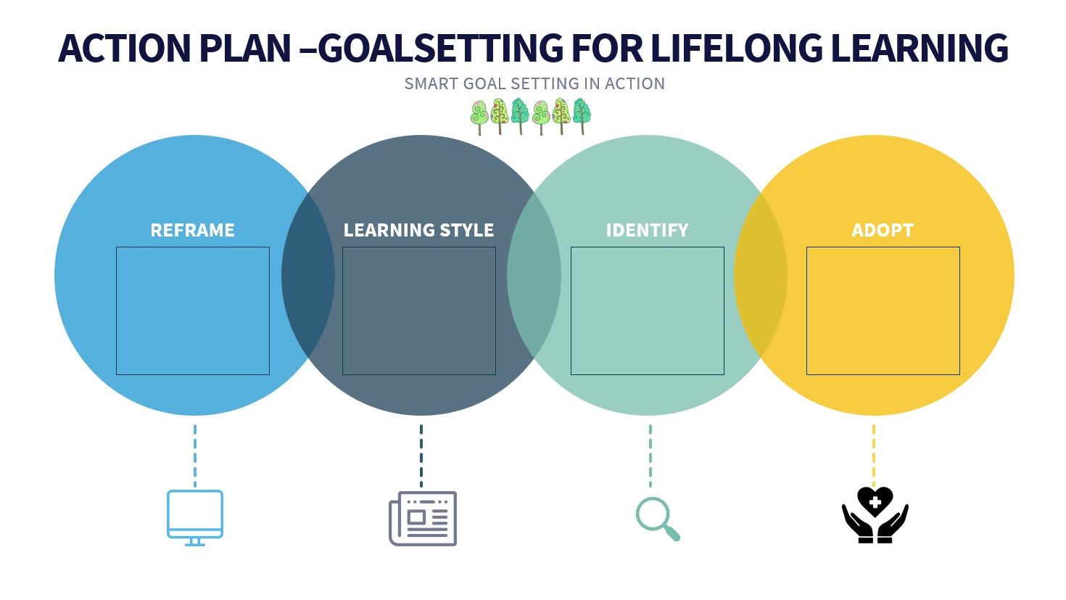
Information provided in the Content Summary

Activity 4:
What is your lifelong learning goal?
Short term:

Medium term:

Long term:

How are you going to go about trying to reach them?

Learners will have personalized responses for this activity

Activity 5:
Model Answers provided in the Content Summary
Work -


NSFAS Financial Scheme -

Scholarship -

Loan -

Bursary -

Activity 6: Informal Assessment

Question 1
Various options are provided as possible answers to the following questions. Choose the correct answer and write only the letter (A-D) next to the question number (1.1 to 1.2), for example 1.3. D
1.1. Money borrowed from the bank to fund your studies is referred to as:

A. A loan
B. A bursury
C. A scholarship
D. A bond (1)

1.2. A government scheme that provides financial assistance to students
is called

A. NSFAN
B. NFSAN
C. NSFAS
D. NFSFF (1)

Question 2
Complete the following sentences by filling in the missing word(s).
Write only the word(s) next to the question number (2.1 to 2.5)

2.1 A / An _________ is the financial assistance that is given to a student in order to further
his or her studies. BURSARY (1)

2.2 ________ learning is the attitude towards life whereby you are continuously learning
towards a more meaningful life. LIFELONG (1)
2.3 _________ gives you a clear idea of what you want to achieve, keeps you motivated
and helps you track your progress. GOAL-SETTING (1)

Question 3
Explain TWO reasons why lifelong learning is important. (2x2)(4)
(Middle Order)
Any TWO of the below or any relevant answer for TWO marks each
(i.e. ONE mark for statement and ONE mark for qualifier / explanation)
- By constantly learning and growing ✓ it can prevent us from becoming stagnant and ignorant ✓
- The world is constantly evolving and changing so fast ✓ and so we need to stay with the times ✓
- It helps keep you updated and upskilled ✓ so that you are more employable in the long run ✓
- People who hire you / future employers✓ want to see that you have the ability to keep up with the ever-changing work environments ✓

Queston 4

Read the extract below and answer the questions that follow.
Most people receive their education through formal schooling and career training programs, which prepare them for jobs and real-world situations. Some people choose to take their educational experiences further by pursuing learning opportunities throughout their lifetimes. Adopting lifelong learning habits may help you reach your personal and professional goals by teaching you academic and social skills that can lead to success.

[Adapted https://www.indeed.com/career-advice/career-development/adopting-lifelong-learning
Accessed on 06 Aug 2023]
Write paragraphs on lifelong learning.
Use the following as guideline:

- Define the term lifelong learning (2x1)(2)
(Lower Order)
Any valid answer for TWO marks.

Lifelong learning: refers to the process of gaining knowledge and learning new skills throughout your life. ✓ ✓
Many people continue their education for personal development and fulfillment, while others see it as a significant step toward career advancement.

- Discuss TWO benefits to lifelong learning in your personal future learning journey.
(2x2)(4)
(Middle Order)
Any TWO of the below or any relevant answer for TWO marks each
(i.e. ONE mark for statement and ONE mark for qualifier / explanation)

- It keeps the mind in shape ✓ Research has suggested that continued cognitive activity has a positive effect on brain cells and helps promote mental sharpness✓
- Lifelong learners tend to keep themselves motivated ✓ with the desire for more knowledge and self-improvement, or there may be career aspirations in mind ✓
- It helps keep you updated and upskilled ✓ so that you are more employable in the long run ✓
- People who hire you / future employers✓ want to see that you have the ability to keep up with the ever-changing work environments ✓

- Lifelong learning is not just about the formal learning at your school. Recommend TWO other ways how you can start and engage in your lifelong learning. (2x2)(4)
(Higher Order)

Any TWO of the below or any relevant answer for TWO marks each
(i.e. ONE mark for statement and ONE mark for qualifier / explanation)

- Join a sports club where you can engage in leadership opportunities and learn people skills ✓ that will be help you later when working in groups or teams. ✓
- Develop interests and hobbies ✓ as furthering these often leads to learning new skills and engaging with others who have the same passion (i.e. people skills) ✓
- Read the news ✓ this will help you to keep up with current events and what is happening in the rest of the world. ✓
- Take advantage of free courses offered online ✓ as this would be an inexpensive way of learning new skills ✓
Take part in school clubs that are interesting to you ✓ as you might be exposed to other learners your age who could teach you things ✓

[10]

Question 5

Refer to the article below and answer the questions that follow.
In South Africa, the cost of tertiary education has been a hot topic of debate for many years. There have been numerous protests by students, who argue that the prices are too high and are preventing them from getting a higher education. This is placing a significant financial burden on students and their families.
In an article published by the South African Journal of Higher Education, they found that a BCom degree in 1970 cost around R20 000 whereas in 2019, a BCom degree cost around R80 000. That’s an increase of 400% in tuition fees over the last 50 years compared to the previous 50 years, where prices remained fairly consistent. Not only has the price increased, but the rate at which it increases has accelerated significantly since 2000.
This is a worrying trend for many students and their families, as it indicates that tertiary education is becoming increasingly unaffordable for many students in South Africa. With the current rate of inflation, tertiary education is likely to become even more expensive in the next few years.
[Adapted from https://www.citizen.co.za/business/tertiary-education-costs-in-south-africa-on-the-rise/.
Accessed on 06 Aug 2023]

NSFAS is an acronym for which entity? (1x1)(1)
(Lower Order)
The National Student Financial Aid Scheme ✓

Discuss the importance of further education and training, even though it can
become costly? (1x2)(2)
(Middle Order)
Any ONE of the below or any relevant answer for TWO marks
- Learning new skills through continuing education ✓ is key to being prepared for future potential career changes (transitions). ✓
- You will stand out not only because of your additional qualifications ✓, but employers will recognize that you have the determination to take on a challenge and succeed ✓
- Further education and training is that people with college or university training earn far more than those who do not have further training after school ✓ and thus it gives you a better future ✓
- Further education and training opens up doors and opportunities ✓ that you may not have had without this training ✓

Evaluate student loans as an option for funding tertiary studies. (1x2)(2)
(Higher Order)
Any ONE of the below or any relevant answer for TWO marks
(i.e. ONE mark for statement and ONE mark for qualifier / explanation)

- The money is available immediately for things like deposits to secure placement ✓
However the interest accumulates and you have a bigger amount to repay at the end of your studies ✓
- You can budget carefully and plan because you know the total amount you get from the bank which comes in a lump sum ✓ however, because you receive one lump sum, it might be hard to be disciplined and use it for studies in particular ✓
[5]

