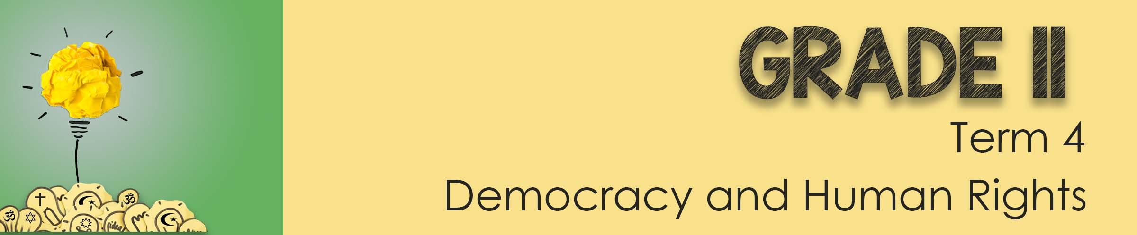

Lesson 1 – Worksheet MEMO

Activity 1: Complete the phrase below by explaining each letter:

Promoting tolerance

Experience belonging in a society by sharing rituals and practices.

Code is given of a moral standard that people respect and choose to live by

Acts of kindness- helping others

Encouraging one another to learn about their own religions as well as those of the people around them.

Activity 2:
“You are on the school RCL and have been asked to write a ½ PAGE proposal to amend the school’s Code of Conduct. This amendment is to promote peace and respect at school amongst learners of difference religions. This proposal should include a list of behaviours you believe would encourage peace in the school. “
Write your proposal in the space below:
Each learner will have their own response.
No MEMO available as each school’s Code of Conduct policy is unique
Activity 3: Reflection Activity
What do you truelly believe about the following statements.
Explain why you agree or disagree in the space provided.
Each learner will have their own response
Activity 4: Homework
Complete further research on TWO of the religions covered in class today. Then write an essay in which you critically discuss how these religions contributed towards peace and harmony during the pandemic in South Africa. (2x4) (8)
Teacher Note: An example of a higher order question that could be asked in
Section C of the upcoming Controlled Test.
Marks should be awarded as follows:
FOUR () marks for a well explained response
A contribution towards peace and harmony during the pandemic was achieved by:
- many Christian churches conducted their services online as opposed to gathering in a physical venue () as a way to continue serving their community during the pandemic () as mass gatherings were prohibited () and that allowed people to still feel connected in community despite having restricted movement / being isolated. () [Christianity]
- faith based organization Gift of the Givers provided protective equipment to health care professionals at state institutions () as general supply thereof was severely limited () and the shortage increased the risk of health professionals contracting COVID () which would have placed severe strain on our state clinics and hospitals () . [Islam]
- the SAJBD was one of the first organizations in South Africa to provide medical information and advice on COVID-19 () as there was limited credible information available regarding the disease () without which people were potentially making poor decisions regarding their personal health () and this helped limit the spread of the disease. () [Judaism]

Any TWO of the above for FOUR marks each. (2x4) (8)
(i.e. To be awarded the full FOUR marks for a CRITICALLY DISCUSS
question: candidates must give a statement, () elaborate on the
statement, () qualify the statement () and give an outcome ())

