Lesson 1 – Worksheet

Activity 1:
Complete the below table:
 | Education | Lifelong Learning
Gain knowledge through:
Formal / Instinctual:
Where does it typically take place:
When does it end:

Activity 2:
In your groups, discuss TWO of the various occupations and life role listed below.
 | Need for continued, informal, lifelong learning?  Yes / No | Examples of possible lifelong learning activities  (if relevant)
Professional Athlete
Sports Coach
New Parent
Chef
Programmer
Musician
Accountant

Activity 3:
Watch: https://www.youtube.com/watch?v=cqRoGpSGFwk&t=3s
(only from 3min 40s – 6min 42s)

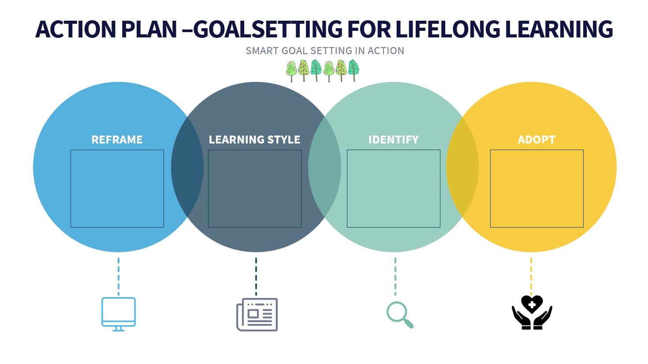
Activity 4:
What is your lifelong learning goal?
Short term:

Medium term:

Long term:

How are you going to go about trying to reach them?

Activity 5:
Work -


Bursary -

Loan -

NSFAS Financial Scheme -

Scholarship -

Activity 6: Informal Assessment

Question 1
Various options are provided as possible answers to the following questions. Choose the correct answer and write only the letter (A-D) next to the question number (1.1 to 1.2), for example 1.3. D
1.1. Money borrowed from the bank to fund your studies is referred to as:

A. A loan
B. A bursury
C. A scholarship
D. A bond (1)

1.2. A government scheme that provides financial assistance to students
is called

A. NSFAN
B. NFSAN
C. NSFAS
D. NFSFF (1)

Question 2
Complete the following sentences by filling in the missing word(s).
Write only the word(s) next to the question number (2.1 to 2.5)

2.1 A / An _________ is the financial assistance that is given to a student in order to further
his or her studies. (1)

2.2 ________ learning is the attitude towards life whereby you are continuously learning
towards a more meaningful life. (1)
2.3 _________ gives you a clear idea of what you want to achieve, keeps you motivated
and helps you track your progress. (1)

[5]

Question 3
Explain TWO reasons why lifelong learning is important. (2x2)(4)

[4]
Queston 4

Read the extract below and answer the questions that follow.
Most people receive their education through formal schooling and career training programs, which prepare them for jobs and real-world situations. Some people choose to take their educational experiences further by pursuing learning opportunities throughout their lifetimes. Adopting lifelong learning habits may help you reach your personal and professional goals by teaching you academic and social skills that can lead to success.

[Adapted https://www.indeed.com/career-advice/career-development/adopting-lifelong-learning
Accessed on 06 Aug 2023]
Write paragraphs on lifelong learning.
Use the following as guideline:

- Define the term lifelong learning (2x1)(2)

- Discuss TWO benefits to lifelong learning in your personal future learning journey.
(2x2)(4)

- Lifelong learning is not just about the formal learning at your school. Recommend TWO other ways how you can start and engage in your lifelong learning. (2x2)(4)

[10]

Question 5

Refer to the article below and answer the questions that follow.
In South Africa, the cost of tertiary education has been a hot topic of debate for many years. There have been numerous protests by students, who argue that the prices are too high and are preventing them from getting a higher education. This is placing a significant financial burden on students and their families.
In an article published by the South African Journal of Higher Education, they found that a BCom degree in 1970 cost around R20 000 whereas in 2019, a BCom degree cost around R80 000. That’s an increase of 400% in tuition fees over the last 50 years compared to the previous 50 years, where prices remained fairly consistent. Not only has the price increased, but the rate at which it increases has accelerated significantly since 2000.
This is a worrying trend for many students and their families, as it indicates that tertiary education is becoming increasingly unaffordable for many students in South Africa. With the current rate of inflation, tertiary education is likely to become even more expensive in the next few years.
[Adapted from https://www.citizen.co.za/business/tertiary-education-costs-in-south-africa-on-the-rise/.
Accessed on 06 Aug 2023]

NSFAS is an acronym for which entity? (1x1)(1)

Discuss the importance of further education and training, even though it can
become costly? (1x2)(2)

Evaluate student loans as an option for funding tertiary studies. (1x2)(2)

[5]

