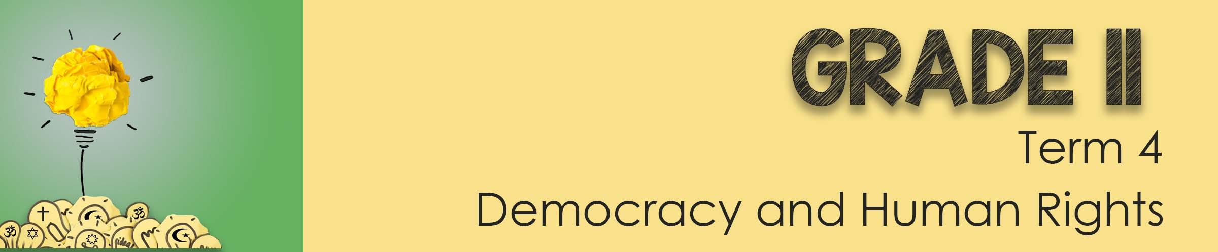
Lesson 3 - Worksheet

Activity 1: Write an article for your school newspaper on
“How to create a culture of respect in your school”
Make sure you include the following in your article:
- Describe what you believe a culture of respect looks like.
- Provide FOUR examples of situations/ scenarios where you could see respect modelled at school.
- Propose another FIVE tips for the school community on how to communicate respectfully.
Activity 2: Read through the news headline below and then discuss the
different questions in your groups. You will have an opportunity to give
feedback to the class.

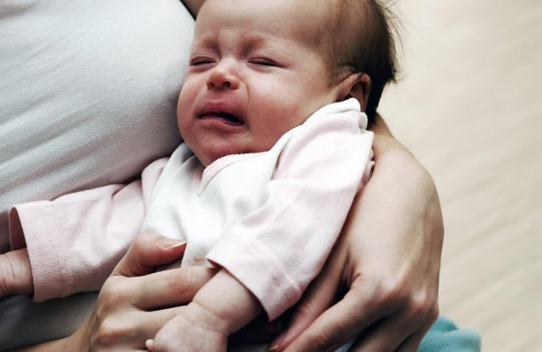
“15 year old teenage girl drowns her newborn baby”.
A young woman gave birth to a baby who was born brain-damaged and paralysed. The baby could not even move his mouth. She understood her baby would never recover and drowned her baby in the hospital bath.

In your groups discuss the following questions about euthanasia and moral dilemma. Make notes to provide feedback to the class.
- Explain the different types of euthanasia. What is your opinion about the acceptability of euthanasia.
__________________________________________________________
__________________________________________________________
__________________________________________________________
__________________________________________________________

- Provide THREE reasons why this woman may feel the need to kill her child.
__________________________________________________________
__________________________________________________________
__________________________________________________________
__________________________________________________________

- Critically discuss what might be the possible psychological consequences for a person who chooses to use euthanasia to end the life of a loved one.
__________________________________________________________
__________________________________________________________
__________________________________________________________
__________________________________________________________

__________________________________________________________
__________________________________________________________
__________________________________________________________
__________________________________________________________
__________________________________________________________
__________________________________________________________

Activity 3: Reflection Activity
Take a moment to reflect on what you have learnt about yourself in class today by answering the following two questions:

• Write a short paragraph on what you have learnt over these three lessons
about respecting someone with a different religion to you.
__________________________________________________________
__________________________________________________________
__________________________________________________________
__________________________________________________________

• How social media negatively impacts communication of different opinions?
__________________________________________________________
__________________________________________________________
__________________________________________________________
__________________________________________________________

