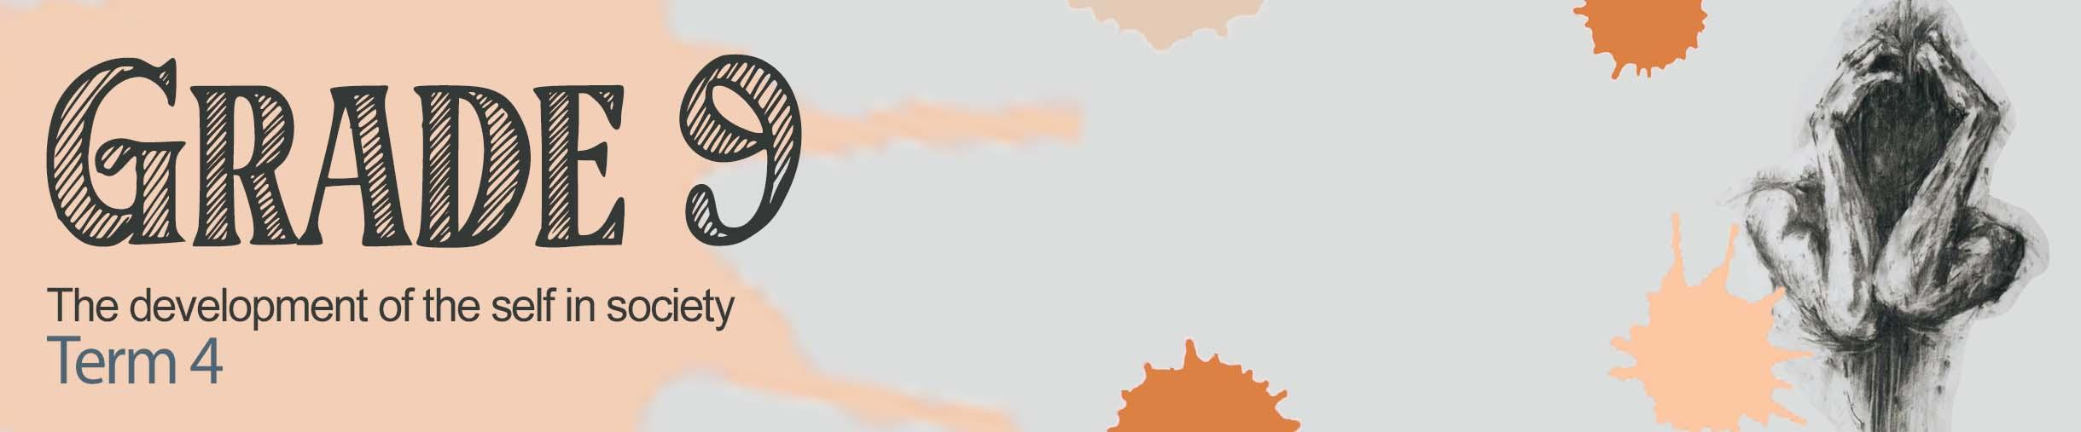


Lesson 3 – Worksheet MEMO

Activity 1:
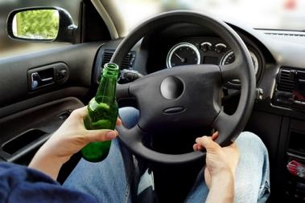
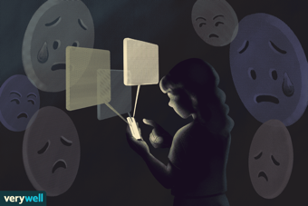
Identify the counterproductive techniques below from the list of terms in the box.

Self-harm Risky behaviour Fighting
Drug abuse Social media abuse Teen suicide

1.1 Drug abuse 1.2 Self-harm
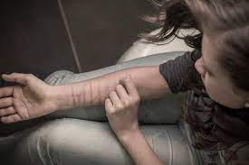
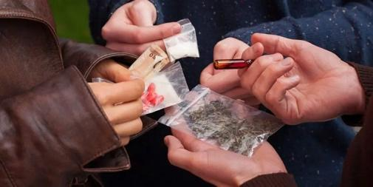

1.3 Fighting 1.4 Teen suicide

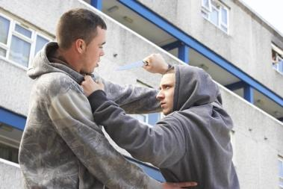

1.5 Risky behaviour 1.6 Social media abuse
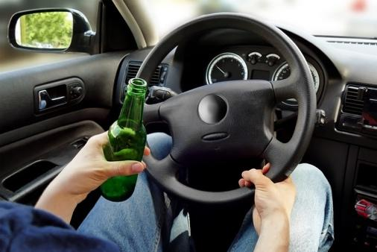
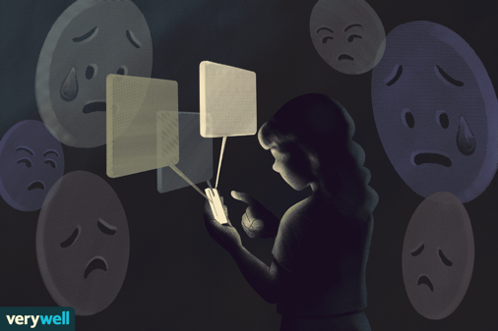

Activity 2:
Read the article below and answer the questions that follow.
Self-harm growing among teens in SA, warns expert

Self-harm, the act of deliberately inflicting pain and damage to one’s body by means of cutting, burning, scratching and self-poisoning through medication or substances to relieve emotional distress, is a growing concern among teenagers.
A 2021 UNICEF report found that more than 65% of South African young people have had some form of mental-health issue, but have never sought help.
Dr Terri Henderson says self-harm is a cry for help and should never be ignored.
“Contributory and co-occurring challenges for a teen, such as depression, anxiety, post-traumatic stress disorder, ADHD, and substance misuse often lead to self-harm, as one of the methods teenagers engage in to cope with their undiagnosed and untreated mental health conditions.”
“The age of onset is approximately 12 years, although there is a stronger association with puberty rather than chronological age.” Henderson says research shows 50% of teens who self-harm will do so repeatedly. She attributed the high rate to depression, ongoing physical, verbal and sexual abuse.
Why teens use self-harm to cope
Adolescents who self-harm externalise their pain in a physical and real form that makes it less abstract and easier to understand in order to release anxiety or emotional stress.
“More specialist support and intervention is required for severe or recurring cases.”
[Adapted from https://www.news24.com/news24/community-newspaper/districtmail-helderberggazette/self-harm-a-growing-phenomenon-among-sa-teens-unicef-20230330; Accessed on 10 June 2023]

2.1 Define the term coping techniques. (1x2) (2) (Lower Order)
TWO (✔✔) marks for a well-explained definition
Coping techniques are:
- an action/ behaviour/ thought (✔) used to deal with a stressful or unpleasant situation. (✔)
- the way/method one chooses to deal with a difficult situation (✔) in order to manage the unpleasant/or to relieve the stressful situation. (✔)
- what a person chooses to do when faced with a loss/grief (✔) to cope with the loss/grief. (✔)
- a way to adapt to the challenges that is based on conscious or unconscious choice (✔) and that enhances control over your behaviour / gives you psychological comfort. (✔)

2.2 Provide TWO physical symptoms of depression. (2x1) (2)
(Lower Order)
Physical symptoms are:
- sleep problems (✔)
- chest pains (✔)
- headaches (✔)
- fatigue (✔)
- body pains (✔)
- stomach aches (✔)
- changes in appetite (✔)
Any TWO of the above for ONE mark each

2.3 Give TWO reasons why “cutting” can be defined as a counterproductive coping technique. (2x1) (2)
(Middle Order)
Two reasons include:
- Learners believe they are feeling better because it relieves the pain, but it is very dangerous and could lead to suicide. (✔)
- Cutting is an avoidance technique to not deal with the pain. Cutting will not make the pain go away. (✔ )
- This technique could develop into other unhealthy coping techniques like drug or alcohol addiction. (✔ )
Any TWO of the above for ONE mark each

2.4 Many teenagers do not seek help when struggling with self-harm. Explain TWO reasons why
you think that is. (2x1) (2)
(Middle Order)
Two reasons include:
- Some of them feel ashamed that they are doing it and can’t stop by themselves. (✔ )
- They’re afraid of what others would say if they heard that they are struggling with self-harm. ( ✔)
- They don’t know who to speak to that they can trust would actually help them. (✔ )
- Some have broken family relationships and fear that their parents would just say they are looking for attention. (✔ )
Any TWO of the above for ONE mark each

2.5 Recommend TWO ways in which you can assist a friend who is trying to cope with grief by
burning their upper legs. (2x2) (4)
(Higher Order)
Two reasons include:
A friend can assist by:
- trying to check in regularly (✔) as this will make your friend feel less alone and allow them to feel supported in their grief. (✔)
- researching the grieving process (✔) as it is important to have an understanding of grief so that you can provide the right / meaningful support. (✔)
- listening (✔) as your friend will benefit more from talking about their feelings than anything else. (✔)
- allowing them to cry (✔) as this shows them that you understand that crying is an important part of the grief and healing process. (✔)
- asking questions about their self-care (✔) as your presence and compassion can make a world of difference. (✔)
- being willing to sit in silence. (✔) By being there for your friend, you are showing your love and support. (✔)
- encouraging your friend to seek help for her self-harm (✔) by doing research or taking her to a teacher that can provide support/ guidance. (✔)

Any TWO of the above or any relevant answer for TWO marks each
(i.e. ONE mark for statement and ONE mark for qualifier / explanation)

Activity 3:
As we come to the end of this lesson on counterproductive coping techniques, maybe you feel that you know someone who might be depressed and you would like to help them. What could you do?
Firstly, remind them that they are not alone, and help is available. They can feel better.
To get help, call 0800 567 567.

Look at the below list of positive coping strategies you can do to overcome depression:
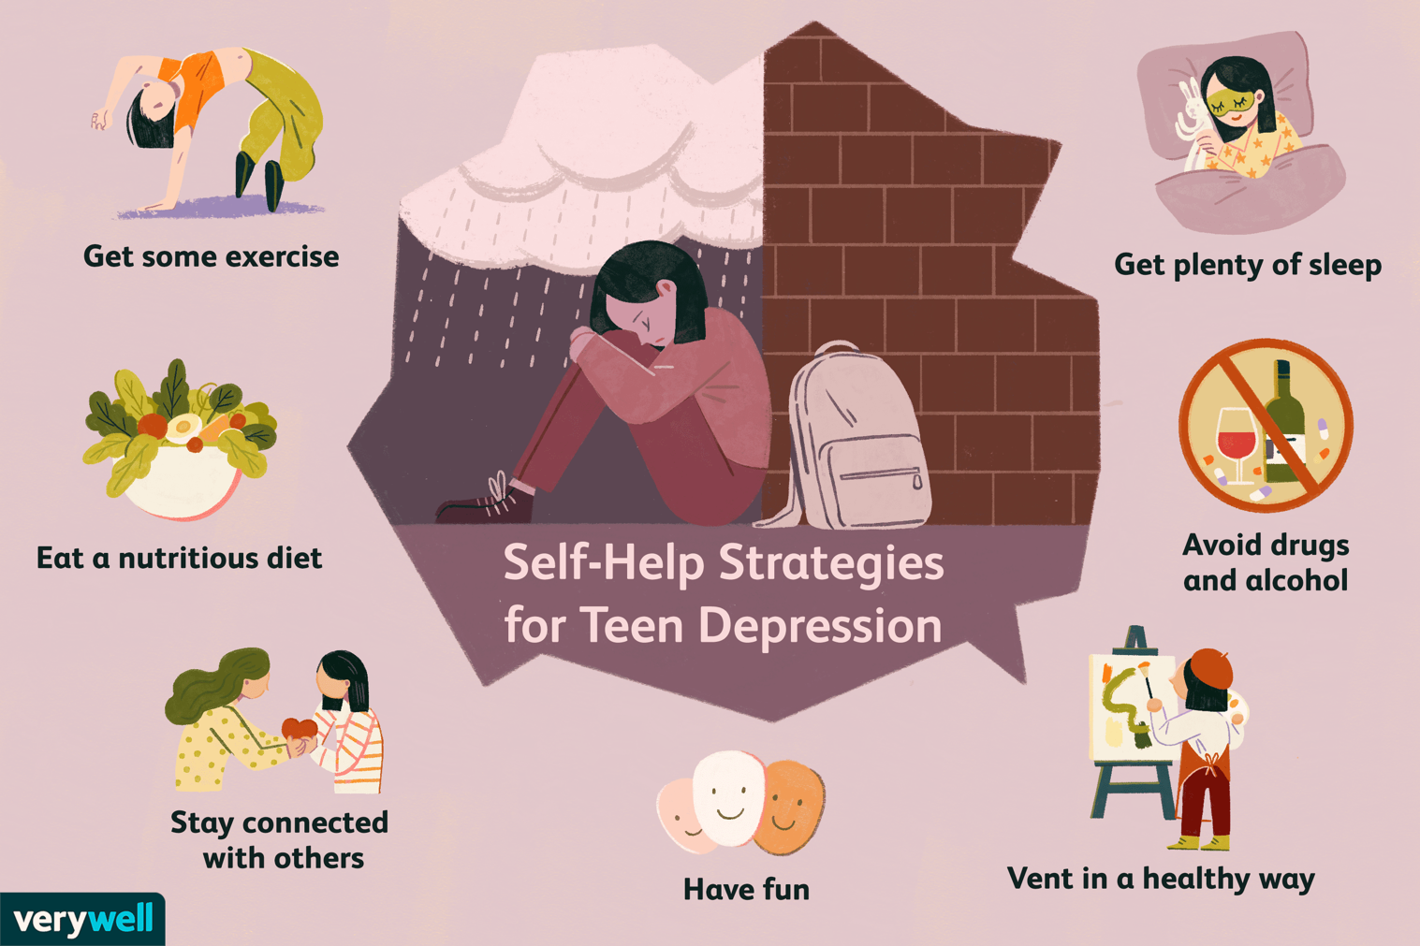
Choose THREE of these strategies and write down how you can include them in your everyday
life.

Learners will give personalized responses to this activity.

